Yusuf*
Author | Admin
Date | 2021-02-19 20:04:00
Categories | Articles COVID-19 Pandemic God at Work Indonesia Stories
Does anyone remember my stories about Yusuf* a few years ago (you can read Story #1 and Story #2 here)? He was one of our students for three years (two years of kindergarten and occasionally coming for after-school first grade lessons). He comes from a family that makes their livelihood from garbage collecting and scavenging for recycling. His mom is illiterate, using her thumbprint to sign her name. We were so happy that he did very well in first grade, ranking at the top of his class.
Then a year ago, the Global Pandemic started and schools shut down in Indonesia on March 16th, 2020. Suddenly, schools around the world scrambled to function through online learning. What does that mean for kids like Yusuf? His family does not have a Smart Phone. Even if they did, his mom cannot read- so how could she help him with school work? Yusuf was left to flounder, relying on the goodwill of neighbors who are financially a bit better off to tell him the assignments sent by the teacher that day.
Public schools and the cheap private schools that our neighbors are enrolled in do not provide any teaching online— school tasks are sent by WhatsApp and kids have to figure out the answers on their own and take a photo of the pages they have completed and WhatsApp it back to the teacher. For too many children like Yusuf, this means they are unable to participate. Unable to learn anything for the past year. Chances are that Yusuf will drop out, as he cannot complete assignments or tests.
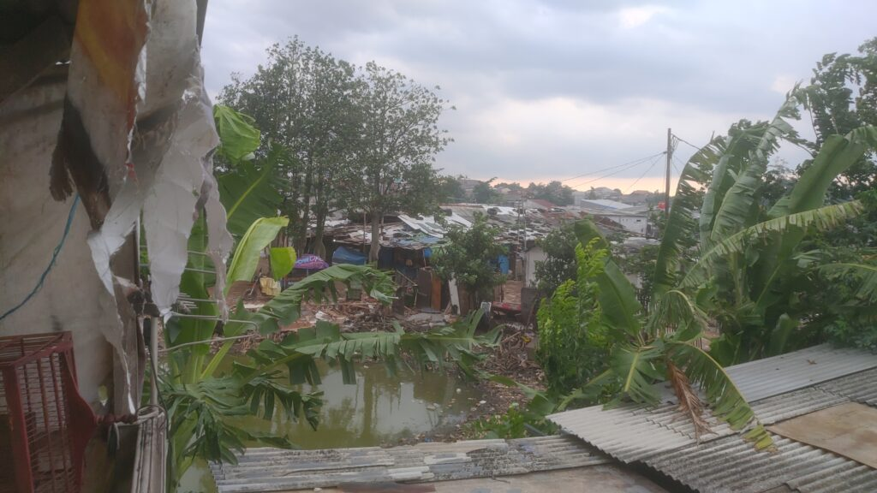
For children whose parents manage to find the money to have a Smart Phone and buy internet quota, the entire burden of teaching is on the parents’ shoulders. Too often parents or older siblings end up doing the school work for the younger students, as getting the right answer is more important than the student understanding the process.
We have no idea how much longer online learning will be for. But the effects are real and tragic for our neighbors, especially for the ones coming from the poorest, most vulnerable families. Too many children are going to drop out of school. Too many are failing, because the system is not set up to help them succeed.
Lord, how long? Have mercy.

Metadata
zn_page_layout | default
zn_sidebar_select | default
zn_show_social | default
zn_zn_disable_subheader
zn_subheader_style | zn_def_header_style
zn-custom-layout | 0

