When Silence is Betrayal - a Biblical Case for Civil Disobedience
Author | Anna
Date | 2009-03-19 14:07:59
Categories | Articles Formation
I strained my ears to hear the voicemail message. Would we help a family of asylum seekers needing a place of sanctuary to avoid deportation that day? Would we help? Would we break the law?
Roberto[1] had fled a war torn country where his job as a policeman had put him directly in the line of fire of some ruthless criminals.
Of course, helping Roberto and his family to avoid deportation would be considered illegal under the laws of the land we live in. On the other hand, when Jesus came to earth, he deliberately chose to be born under the most humble of circumstances, even becoming an asylum seeker himself when his family fled to Egypt soon after he was born[2]. His warning was pretty clear: when we refuse to welcome the needy foreigner, we are effectively rejecting Jesus himself[3].
It is at this point, the place where God’s law of compassion and justice comes into conflict with our human laws, that as Christians we find ourselves faced with a dilemma.
St Augustine said, “an unjust law is no law at all” and those of us who have chosen to stand alongside the poor on the margins of society witness more injustice than most. We inevitably find ourselves grappling with these questions because laws are often made to protect the interests of the rich and powerful[4]. So what should be our response? Is there a Biblical mandate to stand up and speak a powerful 'no' to the authorities that are pushing down on the bent and broken heads of the poor?
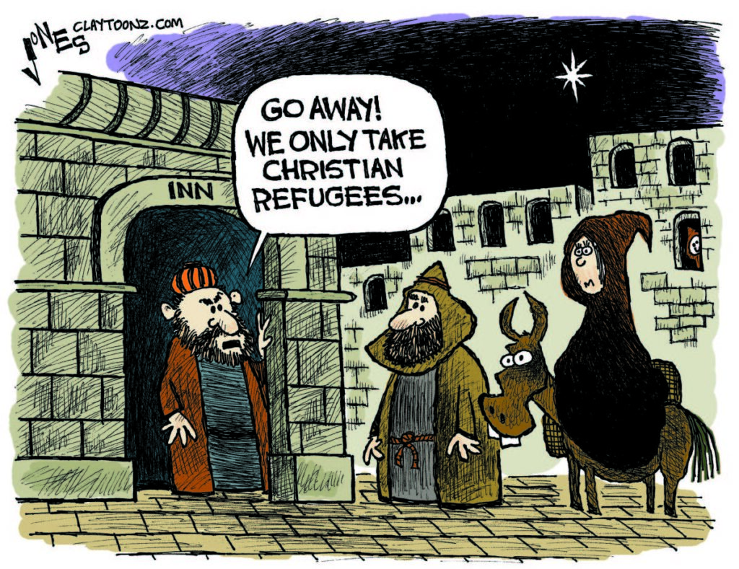

Civil Disobedience and Jesus
Believe it or not, followers of Jesus have a rich history of civil disobedience.
The first people who sought to worship Jesus, a trio of spiritual gurus from Asia, deliberately disobeyed the orders of King Herod, and refused to go back and tell the authorities where Jesus and his parents were camping out[5]. This was a criminal offence punishable by death.
At the end of his life, Jesus faced execution as a common criminal, on the Roman version of an electric chair. Clearly he did something to threaten the powers-that-be, and - here’s where it gets personal - he expected that WE would too. He promised his followers that when (not if) we were dragged into court, the Holy Spirit would give us the words to say[6]. Almost all his disciples went on to be executed or at least imprisoned for their faith.
All this is not to say that Jesus came to overthrow the government (or even get a Christian party elected into power!) No, these are the methods of a world that can only imagine change brought about by the use of power and strength and political influence. Jesus wanted us to imagine a different kind of revolution. A gentle revolution of love and courage and justice and kindness to the people least likely to be offered that kindness.
So Jesus inspired civil disobedience at the beginning of his life and was ultimately killed by the very same system that he railed against. What happened in between his birth and death that so threatened the powers-that-be?

Breaking religious laws
It is important to realize that while the Romans held the reins of ultimate political power in Judea in those days, they counted on local Jewish authorities - the leading priests and other religious leaders - to maintain public order. These religious leaders had no love for the Romans, but they too were wary of anyone who might give the Romans an excuse to clamp down.
Along comes Jesus, a controversial teacher and healer, who at times deliberately flouted the laws they had laid down.
One day, he went into the synagogue, and a man with a shriveled hand was there. The religious authorities were looking for a reason to accuse Jesus, so they watched him closely to see if he would heal the guy on the Sabbath. An illegal act. Jesus said to the man with the shriveled hand, 'Stand up in front of everyone.'
What was he thinking? Jesus clearly had compassion on the man and wanted to heal him. But was it really necessary to provoke the ire of the authorities? Wasn’t mercy enough? Wouldn’t it have been more prudent to usher the poor guy into a side room and heal him there? No, Jesus had to get the guy to stand provocatively right up the front. And then, as if this action weren’t enough, Jesus starts challenging the way the law in question had been interpreted to especially benefit the wealthy and disadvantage the poor.
"Jesus asked them, 'Which is lawful on the Sabbath: to do good or to do evil, to save life or kill?' But they remained silent. "He looked around at them in anger and, deeply distressed at their stubborn hearts, said to the man, 'Stretch out your hand.' He stretched it out, and his hand was completely restored. Then the Pharisees went out and began to plot with the Herodians how they might kill Jesus.[7]"

Ron Sider asks why do “we think it is more spiritual to operate “ambulances” which pick up the bloody victims of destructive social structures rather than trying to change the structures themselves?”
The gospels record a string of acts that can only be construed as civil disobedience, challenges to the structures, involving clashes between Jesus and his followers and the law-enforcers of the land:
- Jesus clears the temple of money changers (Mark 11:15-19)
- Jesus heals a crippled woman on the Sabbath (Lk 13:10-17).
- Jesus heals a man from dropsy on the Sabbath (Lk 14:1-6).
- Jesus heals a lame man at the pool of Bethesda on the Sabbath (Jn 5:1-18).
- Jesus associates with people the religious law said to avoid, such as sinners, Samaritan women and tax collectors (Mk 2:15-16; Jn 4).
- The disciples broke the laws of ritual washing – Jesus called the religious leaders hypocrites (Mt 15:1-14).
- The disciples picked grain to eat on the Sabbath – Jesus defends the breaking of the Sabbath law on the grounds that the needs of hunger outweigh legal strictures. (Mk 2:23-28).

Civil Disobedience in the early church
After Jesus was executed, his followers, inspired by his resurrection, went on to commit many more carefully considered acts of civil disobedience.
Peter and John, having been ordered by the local authorities not to speak about the alternative Kingdom that Jesus was ushering in, refused saying, "Judge for yourselves whether it is right in God's sight to obey you rather than God. For we cannot help speaking about what we have seen and heard.[8]"
King Herod also arrested some of the believers, including James and Peter and planned to put them on public trial. The night before the trial, an angel of the Lord woke Peter up, removed his chains, opened the prison doors and led him out the main gate of the prison[9]. James was executed.

Complexities and counter-arguments
But here is where it gets interesting. Peter, just escaped from jail for breaking the law, went on to write in a letter,
“Submit yourselves for the Lord’s sake to every authority instituted among men: whether to the king, as the supreme authority, or to the governors, who are sent by him to punish those who do wrong and to commend those who do right. For it is God’s will that by doing good you should silence the ignorant talk of foolish men.[10]”
Is this a case of do as I say, not as I do?
And what about Paul who while in Damascus runs afoul of the city governor who is trying to have him arrested[11]? Paul escapes arrest by concealing himself in a basket and being lowered down the city wall through a window. He then goes on to write these words:
“Everyone must submit himself to the governing authorities, for there is no authority except that which God has established. The authorities which exist have been established by God. Consequently, he who rebels against the authority is rebelling against what God has instituted, and those who do so will bring judgment on themselves.[12]”
Blatant hypocrisy?
These passages and a couple of others have been used to redefine the relationship between Christians and the government ever since Constantine became a Christian and made it the religion of the powerful, a tool to maintain the status quo. But clearly there is a disconnect between the way we have traditionally interpreted these words and the actions of those who wrote them, and even the Jesus they preach.

Subtleties of translation
The problem lies in translation. The same word is used repeatedly in this passage and in others, which has been translated “submit” or “be subject”. This would have been immediately clear and understood by the original readers but is obscured in the English. The Greek word is hupo-tasso[13]. In non-military use, it was a voluntary attitude of assuming responsibility, and carrying a burden. It literally means to arrange in an orderly manner underneath.
It is used to encourage husbands and wives to submit to one another in Ephesians 5:22 and reflects God’s concern for order. Governing authorities are necessary for keeping the peace.
In contrast, another word is used 21 times through the New Testament, which is best translated “obey”. This word, hupo-kouo[14] literally means to listen under, to hearken to a command, or to conform to an authority as a subordinate. It is always used in a hierarchical context, such as in Ephesians 6:1 and 6:5 for children and slaves to obey their parents or masters.
This is important to note: in the Greek, to submit does not always mean to obey!
John Howard Yoder writes,
“It is not by accident that the imperative of [Romans] 13:1 is not literally one of obedience. The Greek language has good words to denote obedience, in the sense of completely bending one’s will and one’s actions to the desires of another. What Paul calls for, however, is subordination. This verb is based on the same root as the ordering of the powers by God. Subordination is significantly different from obedience. The conscientious objector who refuses to do what his government asks him to do, but still remains under the sovereignty of that government and accepts the penalties which it imposes, . . . is being subordinate even though he is not obeying.”

In summary...
So, Paul and Peter and the other followers of Jesus who deliberately broke laws that were in conflict with God’s commands, were still submitting to the authorities by accepting the legal consequences of their actions.
Jesus himself, challenged the powers-that-be, but submitted to the law of the land when they chose to execute him, rather than raising up an army of angels to overcome them (he refused to use their methods).
And so must we, as followers of Christ, have the courage to stand up with a Holy No! when the time comes. And in humble submission to the government, we also stand ready to accept the consequences of our actions, which may include imprisonment or even death.
Aung San Suu Kyi, the Burmese democracy leader imprisoned in the early 90’s, said, “Use your liberty to promote ours.” Most of us, in the West, are blessed with freedom of speech and liberty to speak up for those who have been silenced around the world.
With that gift of liberty comes a great responsibility - to use it for God’s upside-down Kingdom.
[Craig Greenfield was the International Coordinator of Servants and part of the Servants Vancouver community. For more on the topic of Christian non-violence, see Jason Porterfield's book, Fight Like Jesus]
[1] Name changed for security reasons
[2] Mt 2:13
[3] Mt 25:43
[4] According to the Washington Post an estimated $10 billion is spent annually in the United States to influence legislation and regulations using lobbyists hired by corporations and wealthy interest groups. (http://www.washingtonpost.com/wp-dyn/content/article/2006/03/18/AR2006031801305_pf.html)
[5] Mt 2:8, 12
[6] Mark 13:9-11
[7] Mk 3:1-6
[8] Acts 4:19-20 see also Acts 5:18-21
[9] Acts 12:1-10
[10] 1 Peter 2:13-15
[11] 2 Cor 11:32-33
[12] Romans 13:1-2
[13] ὑπὸτάγη
[14] ὑπακούει

Metadata
zn_meta_elements | Array
zn_zn_disable_subheader | no
zn_page_layout | default
zn_sidebar_select | default
zn_page_builder_layout | default
zn_show_social | default
zn_subheader_style | zn_def_header_style
zn-custom-layout | 0

