Webinar Series: Knowing Yourself
Author | C Dee
Date | 2019-05-05 19:31:40
Categories | Events Linking Teams Past Events
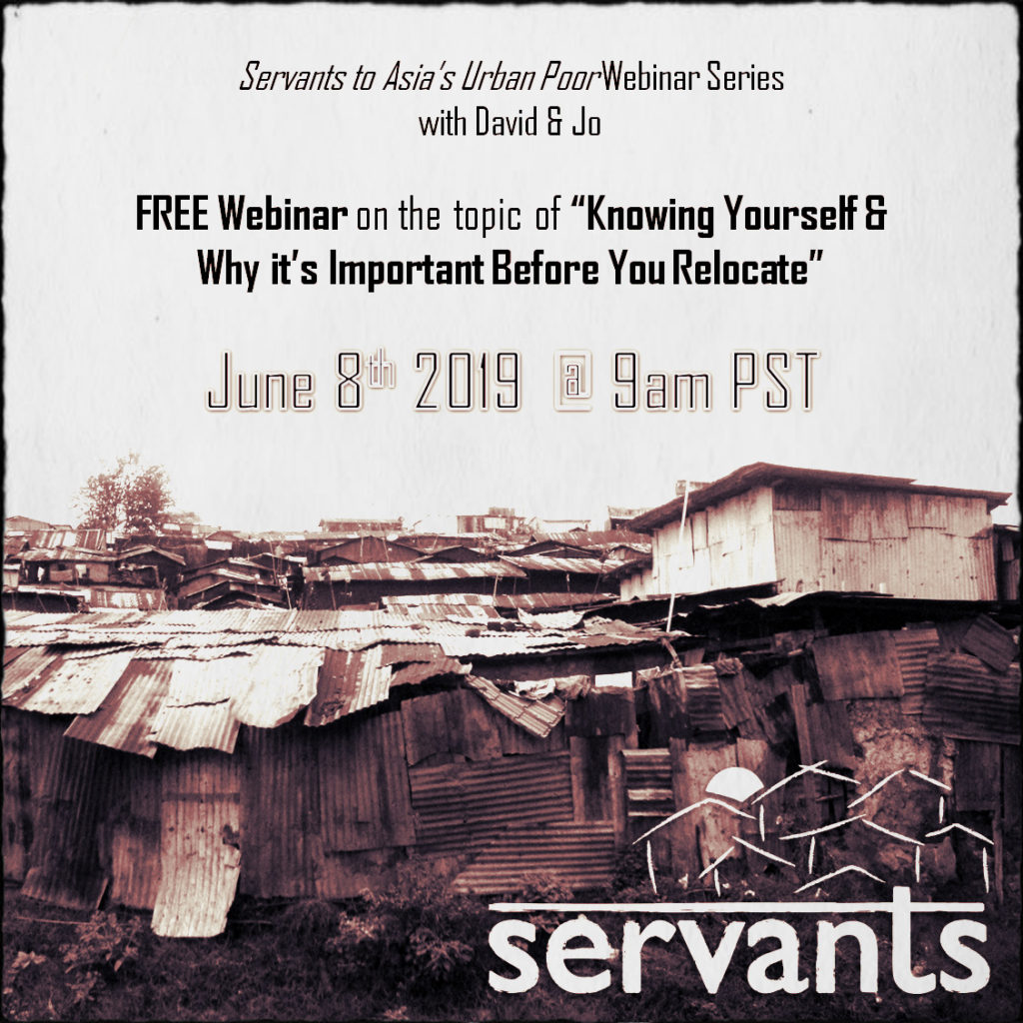
Servants USA team are hosting another webinar on the topic "Knowing Yourself... and why it's important before you re-locate". Anyone interested in learning more about mission, poverty and Servants is welcome to join.
Hosts: David and Jo
Date & Time: June 8th, 9am Pacific Time
Sign up: here (or click the image)

Metadata
zn_page_layout | default
zn_sidebar_select | default
zn_show_social | default
zn_zn_disable_subheader
zn_subheader_style | zn_def_header_style
zn-custom-layout | 0
zn_page_builder_status

