Urbana 2022: Time to Rise Up
Author | C Dee
Date | 2022-11-19 04:43:40
Categories | Events Indonesia North America Past Events

It's Time to Rise Up!
Urbana 2022 is a chance not only to dive into this theme, but also to meet some Servants people face to face, and hear their stories. Join thousands of other young Christians, at the 2022 Urbana conference, Indianapolis, December, 28th-31st.
Dare to come along, "to be shaped into a generation of whole-life, whole-world disciples."
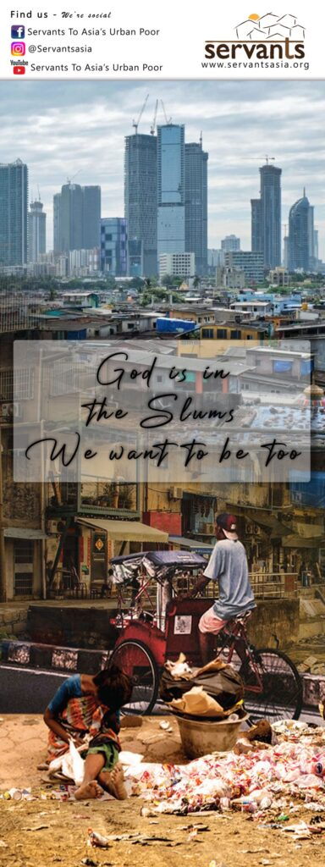

Find us at the Connections Hall
Jason, Anita and Josiah will all be hanging out at The Urban Collective stall, ready to chat with you, answer your questions, and hear your heart. They will have some free books to give away, brochures, and info about ways you can take steps towards a short-term internship with Servants or long-term involvement.
The Connections Hall at Urbana is the place to meet people who are keen to help you discern your place in God’s global mission. You will find people from almost 200 different missions organizations, seminaries, and schools! The hall is arranged into "neighborhoods" along different themes, and you will find Servants in the "Justice/Freedom" neighborhood. Servants has joined with other New Friars organizations to host The Urban Collective stall where you can chat with people from several like-minded organisations: Servants to Asia's Urban Poor (that's us), Servant Partners, Word Made Flesh, and INNERChange.

Find us Beyond the Walls
You can also meet Servants at Urbana by joining the Seminar Beyond Our Walls: Following Jesus into Urban Slums. Come to grapple with the global challenge of 1.4 billion people living in urban slum communities. How might followers of Jesus respond to this immense need?

The seminar is hosted by Yosiah and Anita Rahma, who have lived and served in a slum in Indonesia for the past 11 years, as part of the Servants Indonesia team. While Yosiah was born and raised in Jakarta, Anita is originally from Virginia. They are founders of House of Hope, a free kindergarten and afterschool program for children in their community. Anita is the author of Beyond Our Walls: Finding Jesus in the Slums of Jakarta.
Will we dare to venture beyond our walls of comfort, security, and control —to meet Jesus amongst the least of these? Come meet Yosiah and Anita and hear their stories from over a decade living in a slum community in Jakarta.

Seminar Details
Time: Friday December 30, 1:45 pm
Room: ICC 143-144

Metadata
zn_page_layout | default
zn_sidebar_select | default
zn_show_social | default
zn_zn_disable_subheader
zn_subheader_style | zn_def_header_style
zn-custom-layout | 0

