Update from Manila
Author | Admin
Date | 2022-09-05 22:58:53
Categories | Articles Philippines Stories
Update from Patrick in the Servants Philippines Team
I would like to share news, updates and reflections of the first half of year 2022 with you. Last February, due to a spike in Covid-19 cases, tighter restrictions were implemented in Manila for a short period. But since then, we are thankful for less restrictions. After a turbulent and emotional election season, the Filipinos elected a new president. We are now in June and the rainy season in the Philippines just started.
For the first time since the start of the pandemic, businesses can now fully operate again. In consideration of the current economic situation, this is highly appreciated. The government’s over-reliance on lockdowns and lucklustre support for fiscal stimulus were cited as the primary reasons for the worsening economic situation. In spite of the opening of the economy, schools are still closed. The Philippines amongst few other countries had the longest school closure due to the pandemic.
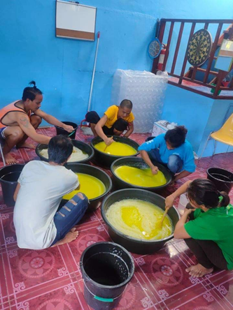
Even as we experience more personal freedom and a glimpse of pre-pandemic normality, we are waiting to see the long-term economic consequences. Mainly countries in the Global South will be more affected. Before the pandemic there were already an estimated 3 million people homeless in the metro Manila area. This is mostly the result of the global urbanization and the poverty caused by unemployment. Since 2010 for the first time in human history, more people in the world live in urban than in rural settings. As of 2020, 56.2 percent of the world population was urban. Better working conditions and better educational and health system are some reasons why people move into cities or rural areas get urbanized.
One essential historic event which changed the way we lived and worked was the industrial revolution which started at the end of the 18th century in England. There was a shift in manufacturing processes and where people lived and worked. Handmade works at home were replaced by machines and factories. Technical advances made life more comfortable. But like so many things in life, industrialization also had its downsides.
Urbanization works alongside many other aspects of our environment. Slums as a by-product of urbanization are born out of imbalanced outcomes. Production increase and profit maximizing also have negative effects for people, climate and our environment. But going back from the industrial revolution in England to the present time here in Manila, we are also experiencing the global inequality on our journey with the urban poor. The roots of Philippine underdevelopment and poverty are attributable to the extractive nature of its institutions, and in particular the widespread corruption, the inadequate protection of property rights and the lack of effective constraints on the elite.
Look! The wages you failed to pay the workers who mowed your fields are crying out against you. The cries of the harvesters have reached the ears of the Lord Almighty.
James 5:4
Laws are always useful to those with possessions and harmful to those who have nothing; from which it follows that the social state is advantageous to men only when all possess something, and none has too much.
Jean-Jacques Rousseau (Swiss philosopher)
In addition to these general realities, a lot of people lost their jobs due to the pandemic and with the social welfare department struggling to cope with the needs of the people, some ended up homeless. For a glimpse of the situation, here is a link to some personal stories of people who went homeless. https://www.theguardian.com/global-development/2021/oct/08/we-just-need-food-manilas-newly-homeless-tell-stories-of-survival-in-lockdown-photo-essay
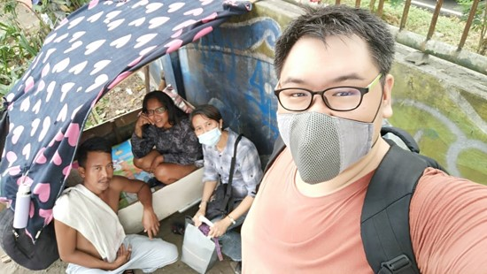
Street Visitation
Through these sad circumstances I started partnering with “Street Believers“, an NGO who addresses the problem of the homeless. Through street visitations first contacts are made and relationships are established. Since January, we have been renting a small property and use it as a drop-in center where they can have shower, a healthy meal and relationships can be deepened. We also offer them livelihood projects for a small income. A group of volunteer psychology students is gaining practical experience while offering free life counseling. Different volunteers, psychology students, and street dwellers lead to a group full of different people who usually do not interact with each other. With this we are not only preventing a top-down approach, but also psychology students, young volunteers and devoted churchgoers can learn and gain an understanding of the life experience from people’s hardships on the streets.
(You can see more about the work of Street Believers mission by viewing this video, and alsowatch a personal story about the work of this mission from Malvin, a person who experienced homelessness.)
But of course, the final goal is to find ways to help people out of their homelessness. Our main concern and focus is on the so-called “new homeless”, the ones who are living on the streets as a result of the pandemic. In some cases, we were able to help people to return to their provinces after staying in Manila without other options of transport. I am impressed by the engagement and passion of my co-workers who let themselves be touched by the sufferings and struggles of their fellow countrymen and actively search ways to help people in dire need. In our community, we also observed the negative impact of the crisis on people’s mental well-being.
Tight restrictions and limitations over the last two years led to more people experiencing depression and anxiety. Sadly, we also encounter behavioural disorders in some children, who were forced to spend most of their time at home without physical schooling and outdoor activities. That is why we are especially thankful that we can do camps and outdoor activities again.
Recently, we employed our longtime passionate co-worker, ate Nene (name changed) as community worker. She is involved in different projects from livelihood to youth work. Her following Christ in journeying through joy and suffering in the community is a great inspiration and example of somebody calling Jesus her Lord and Savior.

Metadata
zn_page_layout | default
zn_sidebar_select | default
zn_show_social | default
zn_zn_disable_subheader
zn_subheader_style | zn_def_header_style
zn-custom-layout | 0
zn_page_builder_status | disabled

