Tribute to Servants UK
Author | C Dee
Date | 2023-03-21 22:53:57
Categories | Articles History United Kingdom

Thanks and Goodbye to Servants UK
The volunteers currently involved in the UK team have moved into other areas of ministry and life. Thus their capacity to continue as a charity has reduced dramatically. After a period of discernment and discussion they decided to officially close the charity at the end of 2022.
So now we want to take a little time to reflect on and celebrate the Servants UK linking team, who for 30 years have beautifully contributed to the life of our community. We thank God for those who have given their time and abilities to share the Servants vision, principles, and way of life in the UK. We know they continue to embrace Servants and will always be part of our wider family.
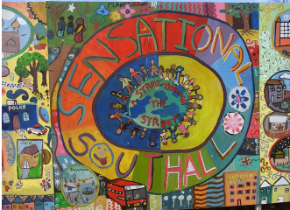

Southall Team
Servants UK, of course, had its very own Servants team in Southall from 2008-2016 – a terrific addition to Servants’ experiment at having a couple of teams in the west, both to act as an ‘on-ramp’ to workers going to Asia, and also as a valuable service to residents in those very marginalised places (like the remarkably south-Asian Southall). You can read more about the Southall team by clicking here.

Roll of Honour
At risk of leaving folk out, some of those who have played a key part in the UK team over the years have been:
Teresa Grant: was part of the team in the Philippines in the earliest years (1986 to 1989). She then kept the UK accounts 1990 to 1993. When the UK officially became a charity in 1993, Teresa served as a trustee from then right up to 2022.
Helen Sidebotham: worked tirelessly as the main face of Servants UK, from its inception in the 90s, and as the International Administrator for Servants for many years. Helen tragically died of a heart attack while on her way back from ILC in January 2012. Here’s our tribute to Helen.
Peter Sidebotham: Helen’s husband who together with Helen was involved in the Cambodia team in its early years. He was always very supportive of Helen and the work of Servants. Since Helen’s death he has continued to be a valued part of the Servants UK community, now with Lois too.
Sue & Hugh Davies: were earlier team centre hosts in Manila. Hugh then served on the Board of Trustees. After Hugh's death, Sue later became part of the UK Charitable trust from 2013 to 2022.
Glen & Siobhan Miles: were a part of the first team in Phnom Penh.
Janet Garley, (nee Cornwall): worked on the Phnom Penh team for many years (1995-2006), then on the UK charitable trust from 2011 to 2022.
Idina Dunmore: was part of the UK home team from 2001, and then led the Southall team from 2008 to 2016.
Kate Ingleby: was part of the Servants Kolkata team from 2006 to 2011.
Jenny Fawdry: joined the Vancouver team from 2006 – 2008 and there met and married a Canadian Priest.
Daniel Rutland: was part of the Southall team from 2008 to 2016.
Mary Bouillier: was a founding member of the Southall team and on the team 2008 – 12.
Claire Booth: was part of the Southall team from 2010 to 2015.
Colin Conroy: was part of the Southall team from 2011 to 2014 and then the charitable trust until 2022.
Ruth Crittenden: was part of the Southall team from 2011 to 2014.
Rachael Bee: was part of the UK Charitable trust from 2012 to 2022.
Tom Hazell, who was part of the Southall team from 2012 to 2014.
Emma Randall: was part of the UK Charitable trust from 2013 to 2022.
Emma will remain as a contact person for Servants in the UK.
Rachel Moore: was part of the Southall team from 2014 to 2016
Anna Wood: was sent by the UK team to play vital administrative and communications roles for Servants North America and internationally, and was also part of the Vancouver team from 2015-2018.
Sarah Kelly: was part of the UK Charitable trust until 2022
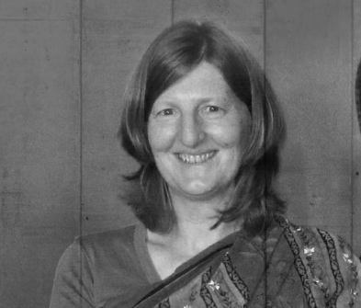

Other roles
Over the years, the UK team has also raised significant finances for our Asian teams; has prayed faithfully and consistently for our work; has been involved in supporting the Southall immersion team; has prepared workers to join other teams in Asia and Canada; and facilitated the International Administration, particularly through Helen.
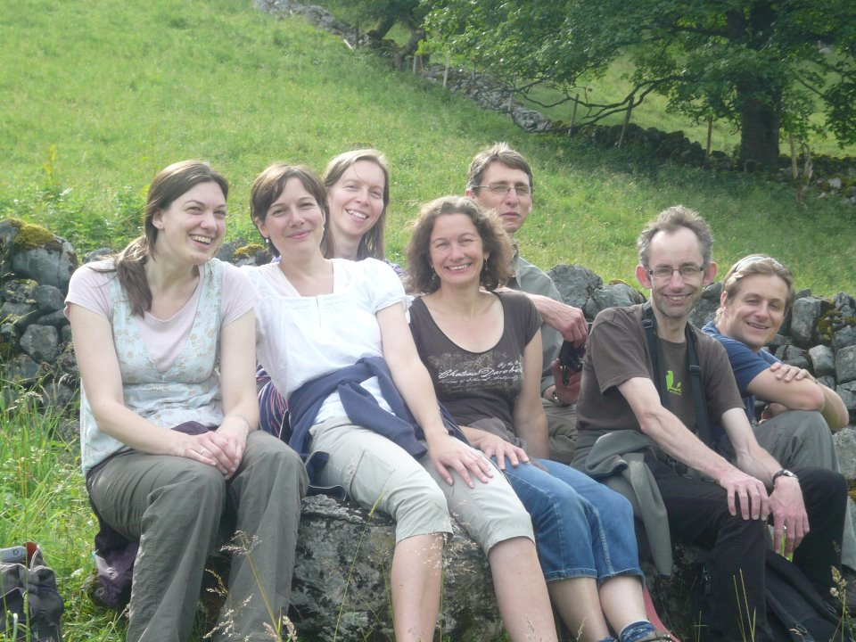

Still friends
The Servants UK Linking Team will still continue to exist, albeit more informally, and those who wish to stay in touch with the work of Servants, and to meet occasionally (either virtually or in the flesh) with other Servants people, will be welcome to do so. The first opportunity will be on the 25th of March 2023, at Breathing Space (the retreat centre run by Peter and Lois Sidebotham) in Coventry. See the event details here.
Again, we want to honour and sincerely thank everyone whose been a part of the Servants UK Linking Team over the last 30 years. Servants has been much the richer as a family because of you!

Metadata
zn_page_layout | default
zn_sidebar_select | default
zn_show_social | default
zn_zn_disable_subheader
zn_subheader_style | zn_def_header_style
zn-custom-layout | 0

