Transformation on the Margins
Author | C Dee
Date | 2021-03-25 11:48:00
Categories | Events Past Events

April - June 2021

Two Summer Courses with The People's Seminary
The People’s Seminary equips followers of Jesus to proclaim and embody liberating messages of transformation to the excluded. It has grown out of the decades of ministry of Servants Elder, Bob Ekblad - you can glimpse his amazing story in this brief documentary.
This summer, two courses are being offered, starting in April!

Hearing God’s voice for personal and social prophecy
How does God speak today? How can we discern God's voice? In this webinar we will draw from Scripture, and contemporary best practices to discern the Spirit's guidance, wisdom and revelation so as to more effectively practice the gift of prophecy for personal and social transformation.
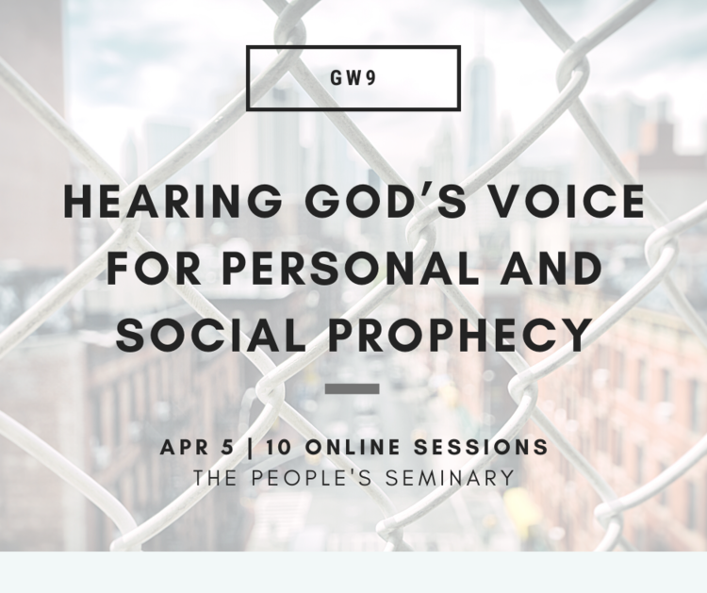

10 Sessions: Mondays, 11:30 AM - 1:00 PM (PST)
April 5-June 14, 2021
If that time doesn't work for you, the course is also offered for download at a discounted rate so you can complete the module at your own pace, at a time more convenient to you.
Click the image to see more details and register for the course.

Word on the street: transformational Bible study, social justice & peacemaking
Our Certificate in Transformational Ministry at the Margins (CTMM) is designed for those already serving (or feeling called to pioneer work) amongst poor and marginalized communities. In this training we seek to deliberately bring together Word, Spirit, and Street perspectives, in order to encourage and further equip practitioners wanting to live and share a liberating and empowering gospel in poor, marginalized, and under-reached communities.
People engaged in ministry encounter spiritual and structural obstacles to personal and social transformation. In this module we deepen our theology of holistic liberation and explore hands-on approaches to physical and inner healing, personal deliverance and other kinds of prayer ministry.
This is the third module in the Certificate of Transformatoinal Ministry at the Margins (CTMM). To take this unit you must have completed CTMM Module 1 and Module 2.
A self-paced CTMM Module 1 can be purchased by clicking here
A self-paced CTMM Module 2 can be purchased by clicking here
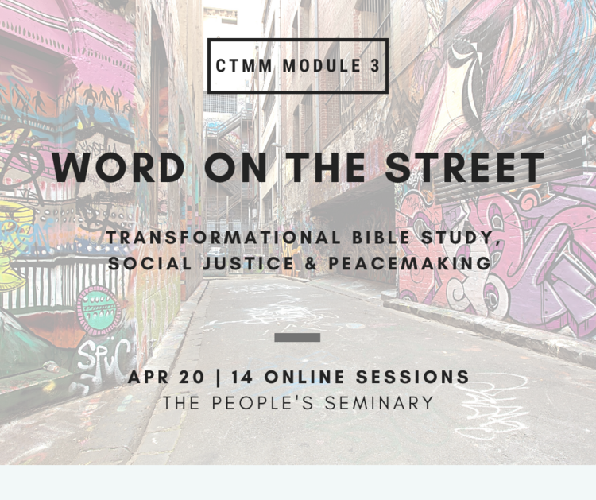

14 Sessions: Tuesdays and 3 Fridays, 12-1:30pm (PST)
April 20 to June 29
If that time doesn't work for you, the course is also offered for download at a discounted rate so you can complete the module at your own pace, at a time more convenient to you.
Click the image to see more details and register for the course.

Metadata
zn_page_layout | default
zn_sidebar_select | default
zn_show_social | default
zn_zn_disable_subheader
zn_subheader_style | zn_def_header_style
zn-custom-layout | 0

