Three Sketch Responses to the Refugee Situation
Author | Anna
Date | 2015-12-03 00:16:46
Categories | Articles Stories
[David Nagai spent 5 years in India with Servants, before moving to Japan to get married to his wife, Chami. Below are some sketches he did in response to the current refugee situation.]
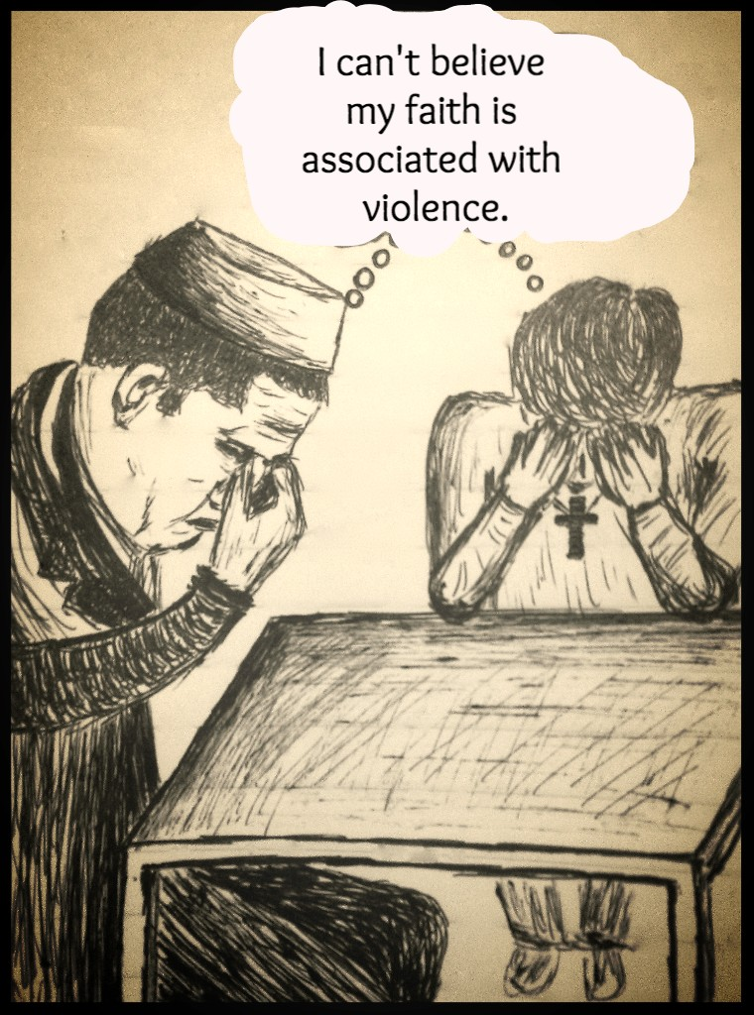

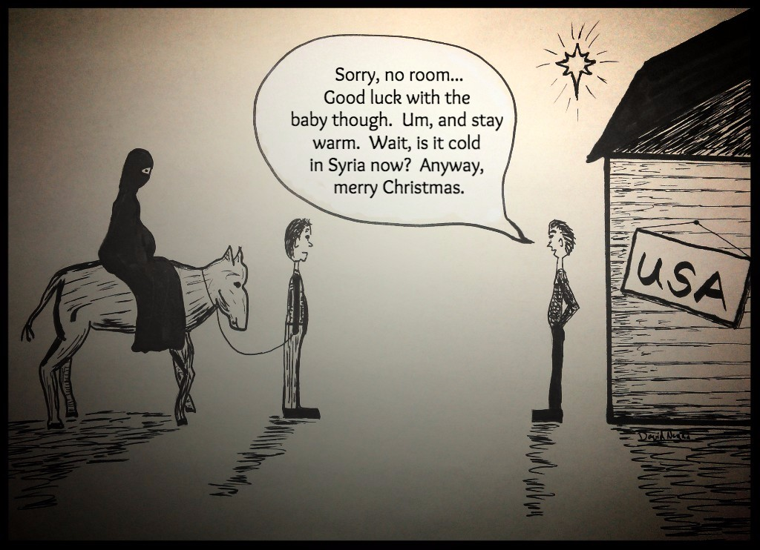

Metadata
zn_meta_elements | Array
dsq_thread_id
zn_zn_disable_subheader | no
zn_page_layout | default
zn_sidebar_select | default
zn_page_builder_layout | default
zn_show_social | default

