The infinite lockdown
Author | Admin
Date | 2021-02-12 19:35:53
Categories | Articles COVID-19 Pandemic Philippines Stories

The locked-in youth – minors in the Philippines
In the Philippines, a strict lockdown was imposed last March 15, 2020. Only one person per household was allowed to leave the house to buy food or medicine. This person had to have a quarantine pass to be shown on checkpoints, drugstores or entrances of markets.
In May and June, the restrictions were eased and adults didn’t have to show a quarantine pass anymore when going out. However, children were not allowed to go out, even after many months. There were regions in the Philippines where teenagers 16 years and above were allowed to go out, but in Metromanila, every minor has officially to stay inside his house 24/7 until now, almost 11 months after the start of the lockdown.
At one point, my wife and I realized that children have absolutely no lobby in this country and therefore will be the last to get back a certain normalcy, even though they are the least vulnerable in this Corona crisis. Nevertheless, the government has always related to the protection of the children when affirming the “going out” ban on minors.
Within our neighborhood, over the time kids started playing again on the street. When the local police passed by, the children just hid in the small alleyways. Kids accompanied their mothers to the market or went buying small things around the corner on their own. But restaurants, museums, malls and even parks and playgrounds are still closed for children.
As we live here with our two boys (8 and 6 years), we know how tight and full of tensions life can become when you’re always inside your house and have no possibilities for recreation, going into the nature etc. So, we planned a camp for teenagers on the Tanay farm (a beautiful retreat place that could start running again at half capacity) in order to process their experiences during this pandemic and the lockdown.
Unfortunately, before Christmas, the government reinforced the rule that minors have strictly to stay at home – and the president even recently said, 10 to 14 years old easily can watch TV the whole day. We heard from new checkpoints and postponed the teens’ camp.
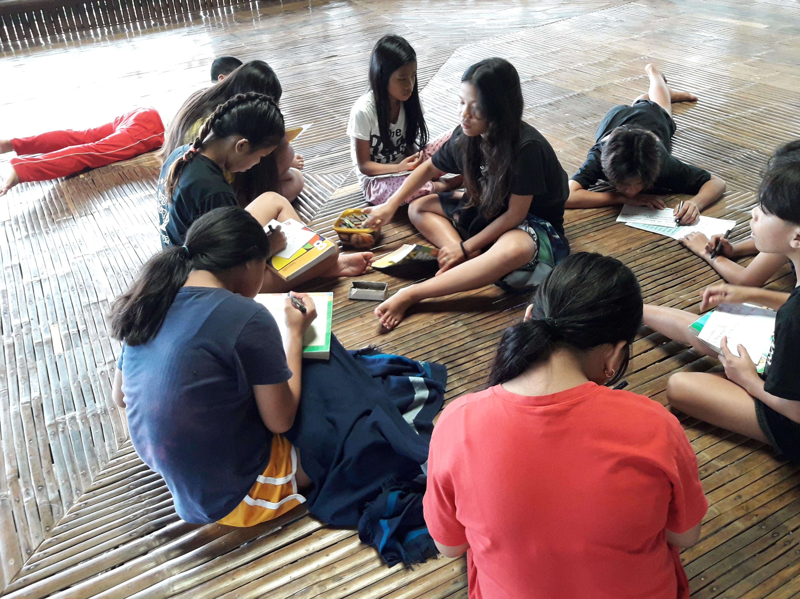
Mid-January, we were finally able to go to the Tanay farm with 12 teenagers and with support from Filipino friends and from Likhabi, an organization advocating for mental health among the youth. After some ice breaker games, we let the participants share their experiences in small groups. We heard about death in two families, severe sickness, not enough food, but also from real family time where everyone was at home together.
We all enjoyed the beauty of nature, the refreshing bath in the river, games, space to be, to relax, to play, and enough and delicious food. Filipino friends explained the importance of mental health and self-care, especially during an extraordinary time like this.
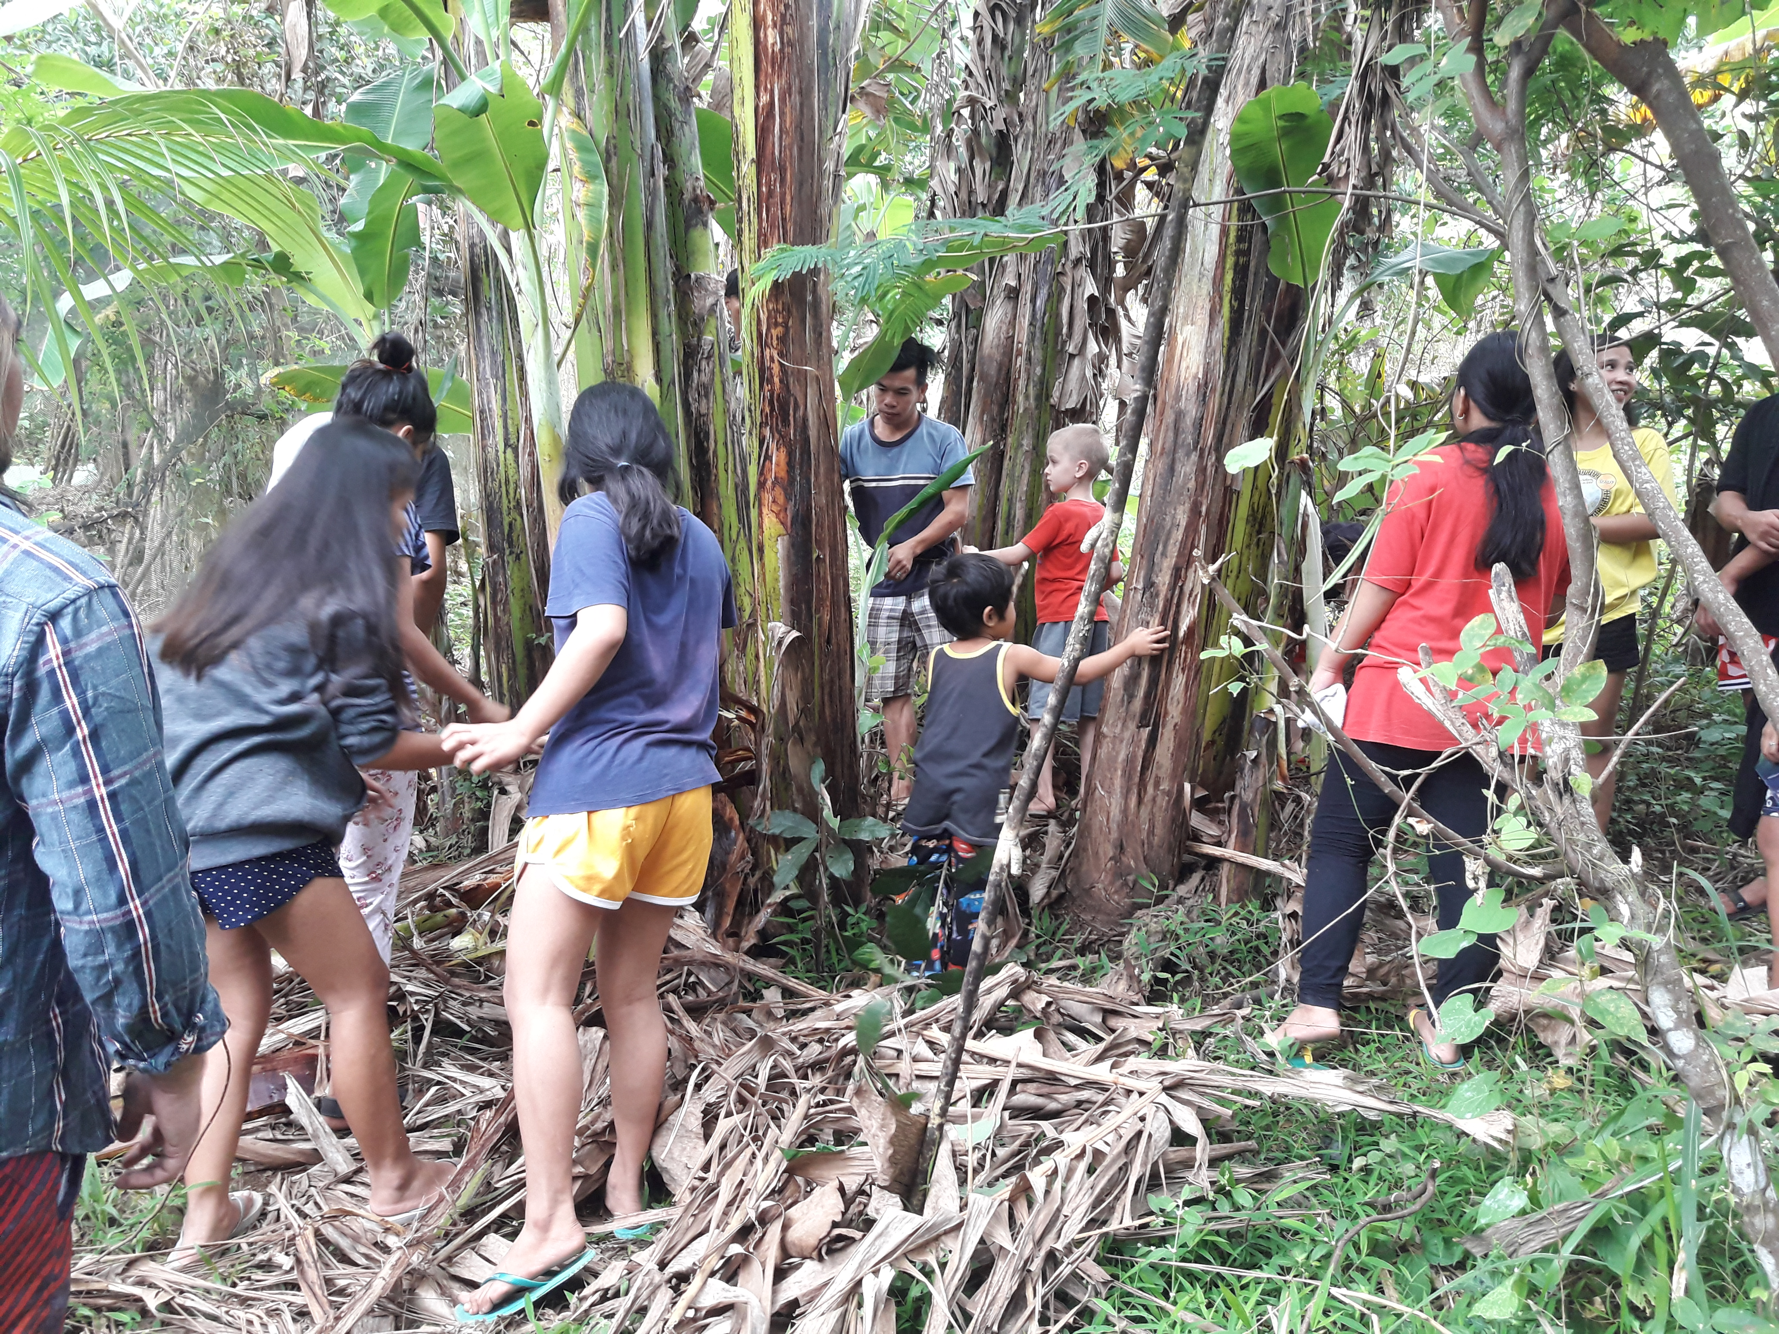
We weeded on the newly bought land adjacent to the farm in order to make space for new plants to be planted and to grow – a symbol of our inner work in these taxing times: weed the dead leaves, cut down the dead branches in order to make space for something new to grow out of the damages of this unhealthy and seemingly never-ending lockdown.
Refreshed, with new hope and plans, and touched by the openness and participation of these twelve teenagers, we went back to Metromanila, into our respective areas which most of the teenagers probably won’t leave for the next months.

Metadata
zn_page_layout | default
zn_sidebar_select | default
zn_show_social | default
zn_zn_disable_subheader
zn_subheader_style | zn_def_header_style
zn-custom-layout | 0

