The First School Day
Author | Admin
Date | 2022-09-13 21:02:47
Categories | Articles Philippines Stories
By Simon from the Manila Team
It’s two o’clock in the morning. Analea, an eight-year-old girl, is already awake. She is putting on her school uniform, even though school starts at 6am and it will only take her 10 minutes to get there. Today is her first day in school. She’s so excited, she can’t sleep.
Analea is a grade-3 student now, but this is the first time she’s going to school. During the last two years, schools in the Philippines have been closed due to Covid restrictions. So, Analea learnt grade 1 and grade 2 topics through printed modules her older sister picked up for her at school every week, while returning the finished modules to the teacher. So, Analea hasn’t seen her teacher for two years.
Learning with modules only or online lectures, and not being part of a learning group, with no interaction with the teacher is a huge burden for every learner, and for their parents. How can you keep your children motivated, how can learning be fun, how can you learn from your classmates while listening to online courses or working through your printed modules?
On August 22, 2022, the public schools in the Philippines reopened again after the shut-down in March 2020. So, after 2.5 years of pandemic, first, second, and third graders all had their first day ever in school. What an exciting moment! We live close to a public school. Out of the 5000 elementary students, about 2500 had their very first school day. But even children from higher grades said that it’s like being in school for the first time. Because the last time had been such a long time ago.
Each school has its own adaptations and measures regarding protection from the spread of the Corona virus. Our nearby school is open five days a week, but the school less than one kilometer away opens classes only for two days a week. They still providing online learning and homework for the other three days in order to have smaller in-person classes. Most private schools however are still running online classes, as middle class families are more anxious for their children not to contract Covid-19. They are also better equipped with gadgets and working spaces to provide a supportive learning environment at home. That’s why we stopped online learning for our two boys (7 and 9 years old). Instead, we do homeschooling. With this, they don’t have classmates either but at least they have in-person classes at home.
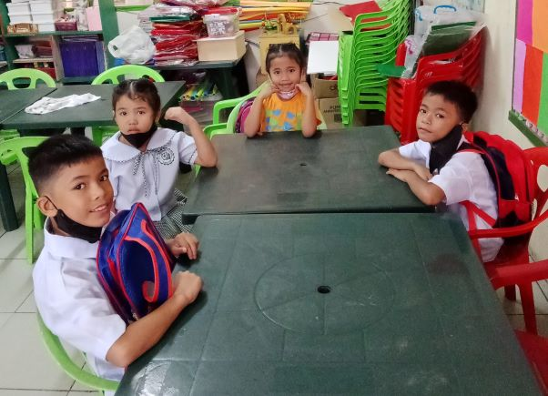
First day in school!
Going back to face-to-face classes is a big challenge for a lot of families. Because of inflation, school material for one child is now US$20, compared to US$10 before the pandemic. Additionally, students need new school uniforms and shoes as the ones from two years ago don’t fit anymore. Providing meals and transport fares are additional costs for the families, and both food and transportation is much more expensive than three years ago.
It's a brutal reality in the lives of the poor that after one problem is solved, the next problem is already waiting. The way they manage to deal with this and keep going is a miracle to us Westerners who struggle already with much smaller problems. We have so many resources to take care of ourselves and our families, to get things fixed, to take time out, etc. but we struggle so often with peanuts compared to the reality of the poor. Hopefully this makes us more humble.
It's a big joy that thanks to the efforts of our community worker Mani, several students can go to school even though they haven’t got their birth certificate. Mani asked the school council for exemptions which were granted. What a joy for these kids when they heard that they can go to school. Others were able to get valid birth certificates, some are still in the process. However, those who haven’t yet finished kindergarten have to start as a kindergarten student, regardless of their age.
Jeremy is 9 years old, the same age as our older son Noel. He now must go to kindergarten for one year together with 5-year-old children even though he’s able to read perfectly. There are acceleration exams to skip classes for older students, but you can only take them once you’re at least in grade 1. While we Westerners get upset at this kind of bureaucracy, our community worker Mani has already found encouraging words for Jeremy. “Don’t be embarrassed because you’re much older than your classmates. Become a good ‘Kuya’ (i.e., older brother) for them.” How right she is. My dream is that he can support his classmates and through this gain a lot of experience in helping and tutoring. And that this becomes a treasure and skills he’ll be able to use in his life. God is a God who is famous for using our difficulties to form and model us into these unique personalities he has designed.
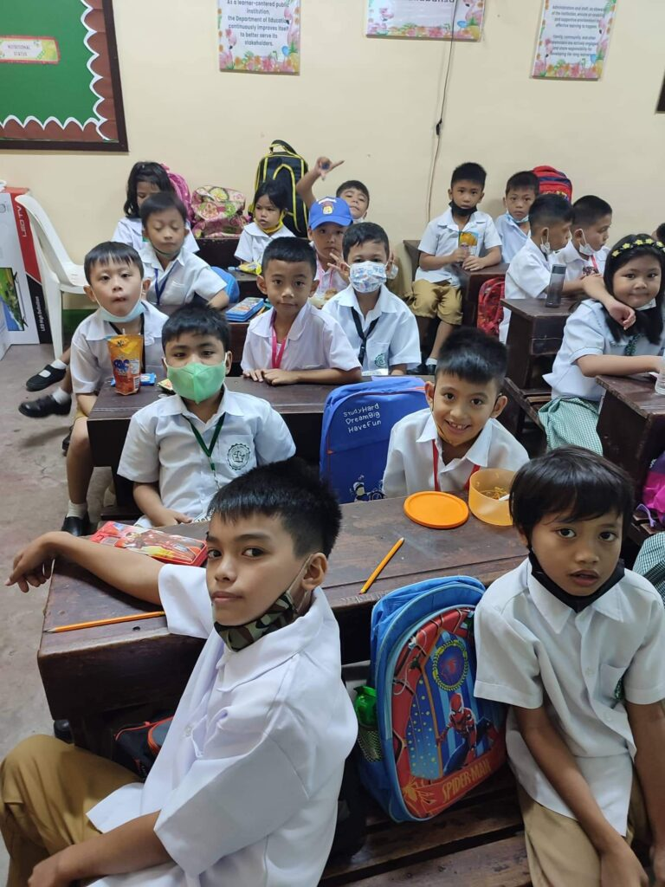

Metadata
zn_page_layout | default
zn_sidebar_select | default
zn_show_social | default
zn_zn_disable_subheader
zn_subheader_style | zn_def_header_style
zn-custom-layout | 0

