TASTE Mission Intensive
Author | C Dee
Date | 2022-12-06 01:44:12
Categories
Our next TASTE mission intensive trip will be held in Manila, 4-23 January, 2024.
Many of our workers initially lived with the poor for a few weeks and discovered God, themselves, and others in a new way. We invite you to do the same.
As you consider this trip tell us what you would like to learn. As much as possible we will include this in the experience. Here are some areas that other trips have explored:
- Language: Learn some Tagalog and see how language-learning is relationship-building;
- Community: Learn how Servants team members cope with each other when under stress;
- Simplicity: Be inspired to live more simply from the examples of people living in Manila slums, from the Servants workers who live alongside them, and the churches in the slum;
- Incarnation: discuss and discover how much like your neighbours you’re prepared to live so that the love of Christ might be communicated;
- Wholism: re-read the Gospel story so that it make sense of poverty, injustice, inequality and different religions;
- Slums: explore the data AND the experience. How important are slums in urban mission today?

PREPARATION
The beginning of your journey happens in your current context. You will join other TASTE participants, mostly online, to prepare for your time living with the poor. These monthly gatherings starting in March 2023 will develop you and your theology, grow the team, and be good fun!! (If you are reading this after March 2023, it is not too late to join us!!)

IMMERSION
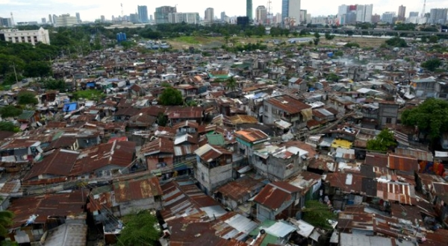
Then comes the trip in January 2024.
After a couple of days of orientation in Manila you will be hosted by a poor family for two weeks. There will be daily check-ins with the group facilitators who are there to support you. The final week will be at Forum. This is a gathering of anyone interested in Servants from around the world and a great place to meet our other teams, from India, Indonesia, and Cambodia.
Here are some estimated costs (participants only cover their own costs). These are likely to be around $2000 NZD (plus any spending money). This depends on where you live and which vaccinations you need:
- $1200 return airfares (from Auckland NZ)
- $50 carbon offset
- $400 for 3 weeks living expenses
- $100 internal travel costs
- passport (if you don’t have one)
- vaccinations
- travel insurance

INTEGRATION
Following our three weeks TASTE in Manila the journey continues as we integrate the experience, learnings and challenges via regular meetings, again mostly online.
For more information and to register your interest, email Shannon at nz[at]servantsasia.org.

Metadata
zn_page_layout | default
zn_sidebar_select | default
zn_zn_disable_subheader
zn_subheader_style | zn_def_header_style
zn_page_override_boxed_layout | def
zn_page_title_show | yes
zn_page_title
zn_page_subtitle
zn-custom-layout | 0

