Taste Thanks
Author | Anna
Date | 2017-08-10 11:50:43
Categories

Thank you for submitting the submission of interest form. Ralph will be in contact with you shortly. If you have any questions in the meantime, you can email him at ralph[at]servantsasia.org

TASTE: Mission Skills Intensive

India, 28th January to the 16th February 2018
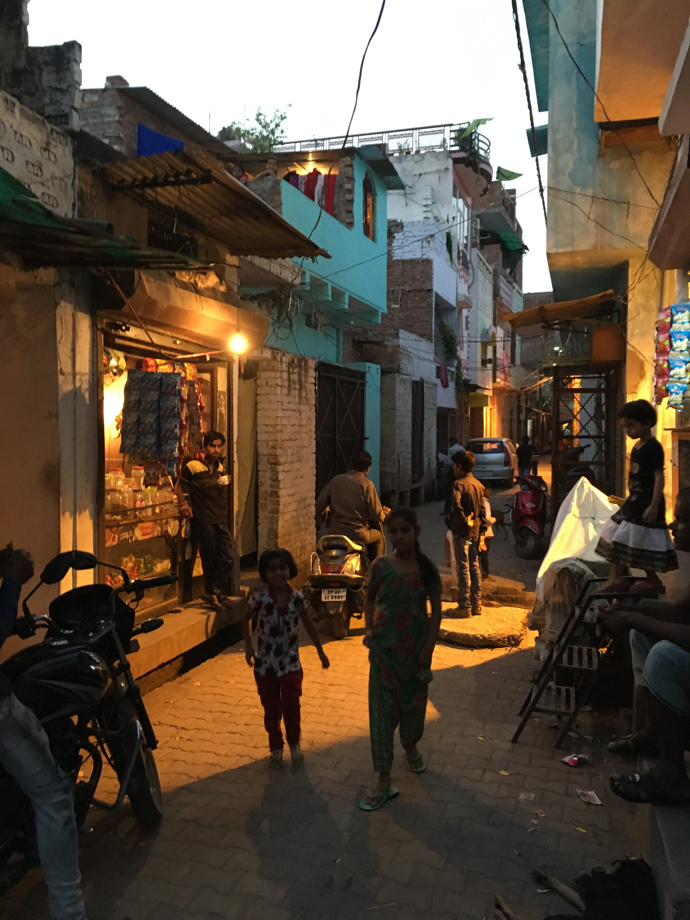

TASTE Missions Skills Intensive is a new course being offered by Servants Australia. In 2018, the course will be based in India and there will be space for up to 6 young adults to participate. It will give participants a three week taste of what life is like as Christian living among Asia’s urban poor...
Content: The content of the course is flexible so that it can meet you requirements. Select some or all of the options listed below.
- Language: Learn some Hindi and language-learning as relationship-building;
- Community: Learn how Servants team members cope with each other when under stress;
- Simplicity: Be inspired to live more simply from the examples of people living in Indian slums, and from the Servants workers who live alongside them;
- Incarnation: discuss and discover how much like your neighbours you’re prepared to live so that the love of Christ might be communicated;
- Wholism: re-read the Gospel story so that it make sense of poverty, injustice, inequality and different religions;
- Slums: explore the data AND the experience. How important are slums in urban mission today
- Got your own goals? Let’s talk about them! The content of the course can be tailored to help you meet your own learning goals.
Costs: Participants only cover their own costs. These are likely to be around $1500AUD (plus discretionary spending) depending on where you live and which vaccinations you need:
- $750 return airfares
- $50 carbon offset
- $75 visa
- $200 per week for 3 weeks living expenses
- $100 internal travel costs
- passport (if you don’t have one)
- vaccinations
- travel insurance

Make India's slums your classroom, your bible-reading-room, your discernment space:
30 years ago this slum was just a few simple, temporary shacks in a field between government buildings near a busy intersection. But more people came, and the city grew up around this make-shift community of squatters. Every day on the streets, the shack-owners gathered bricks and, over decades, put up brick walls, flat concrete roofs, then rooms on the roof, and in some cases third floors. A drain hole in one corner of each floor allows waste to pass down to the drain that runs along the street - simple, effective plumbing, but smelly. The “street” has now been paved in brick and concrete, but is rarely more than a metre wide. Pedestrians share the narrow roads and alleys with motorcycles, cows, ducks and plenty of dirty children who aren’t attending school. Sewerage and all waste water run through channels that are sometimes open and run beside the road, or covered with small, broken concrete slabs and run down the middle. Dirty concrete pretty much coverers every inch of ground except for the “maidaan” - a bare patch of dirt that serves as a carpark for one of the government offices and a cricket pitch or soccer ground for the children of the slum. As in any developed slum, there is significant diversity between the levels of wealth of the families living there. Most houses in this slum are now “owned” by the second generation: the children who grew up here. Shaila* and Safa* are sisters who grew up in the slum and were whose parents have died. Shaila has two children with her husband. Her husband is in Mumbai, hopefully for work. The children are staying with his parents who live in a nicer neighbourhood. Yalina*, Shaila’s aunty, has six children who live in the slum with the women. Imran* is about 20 and works in a spectacles shop grinding lenses, Naseem*, who is about 16, works in an embroidery factory. Alia (a 13 year old daughter, stays home to do the house work). Raheem* and Rahman*, twins, about 10 years old, work, or have worked, making chapels (sandals) but now work at a puncture repair shop. Rahman no longer works but studies in the madrassa and plays in the street), Khaleel* (about 6 and does not attend school). Khaleel* may have a speech impediment. Safa* is not married, and lives quietly inside the house. The family have opened part of their front room to the street so that they can operate it as a very small shop selling tiny packets of snacks, shampoo, laundry soap and henna. With the income that Yalina’s sons bring in, plus the income from the shop, the family survive.

As you enter the slum and hear it's stories, who will you meet?

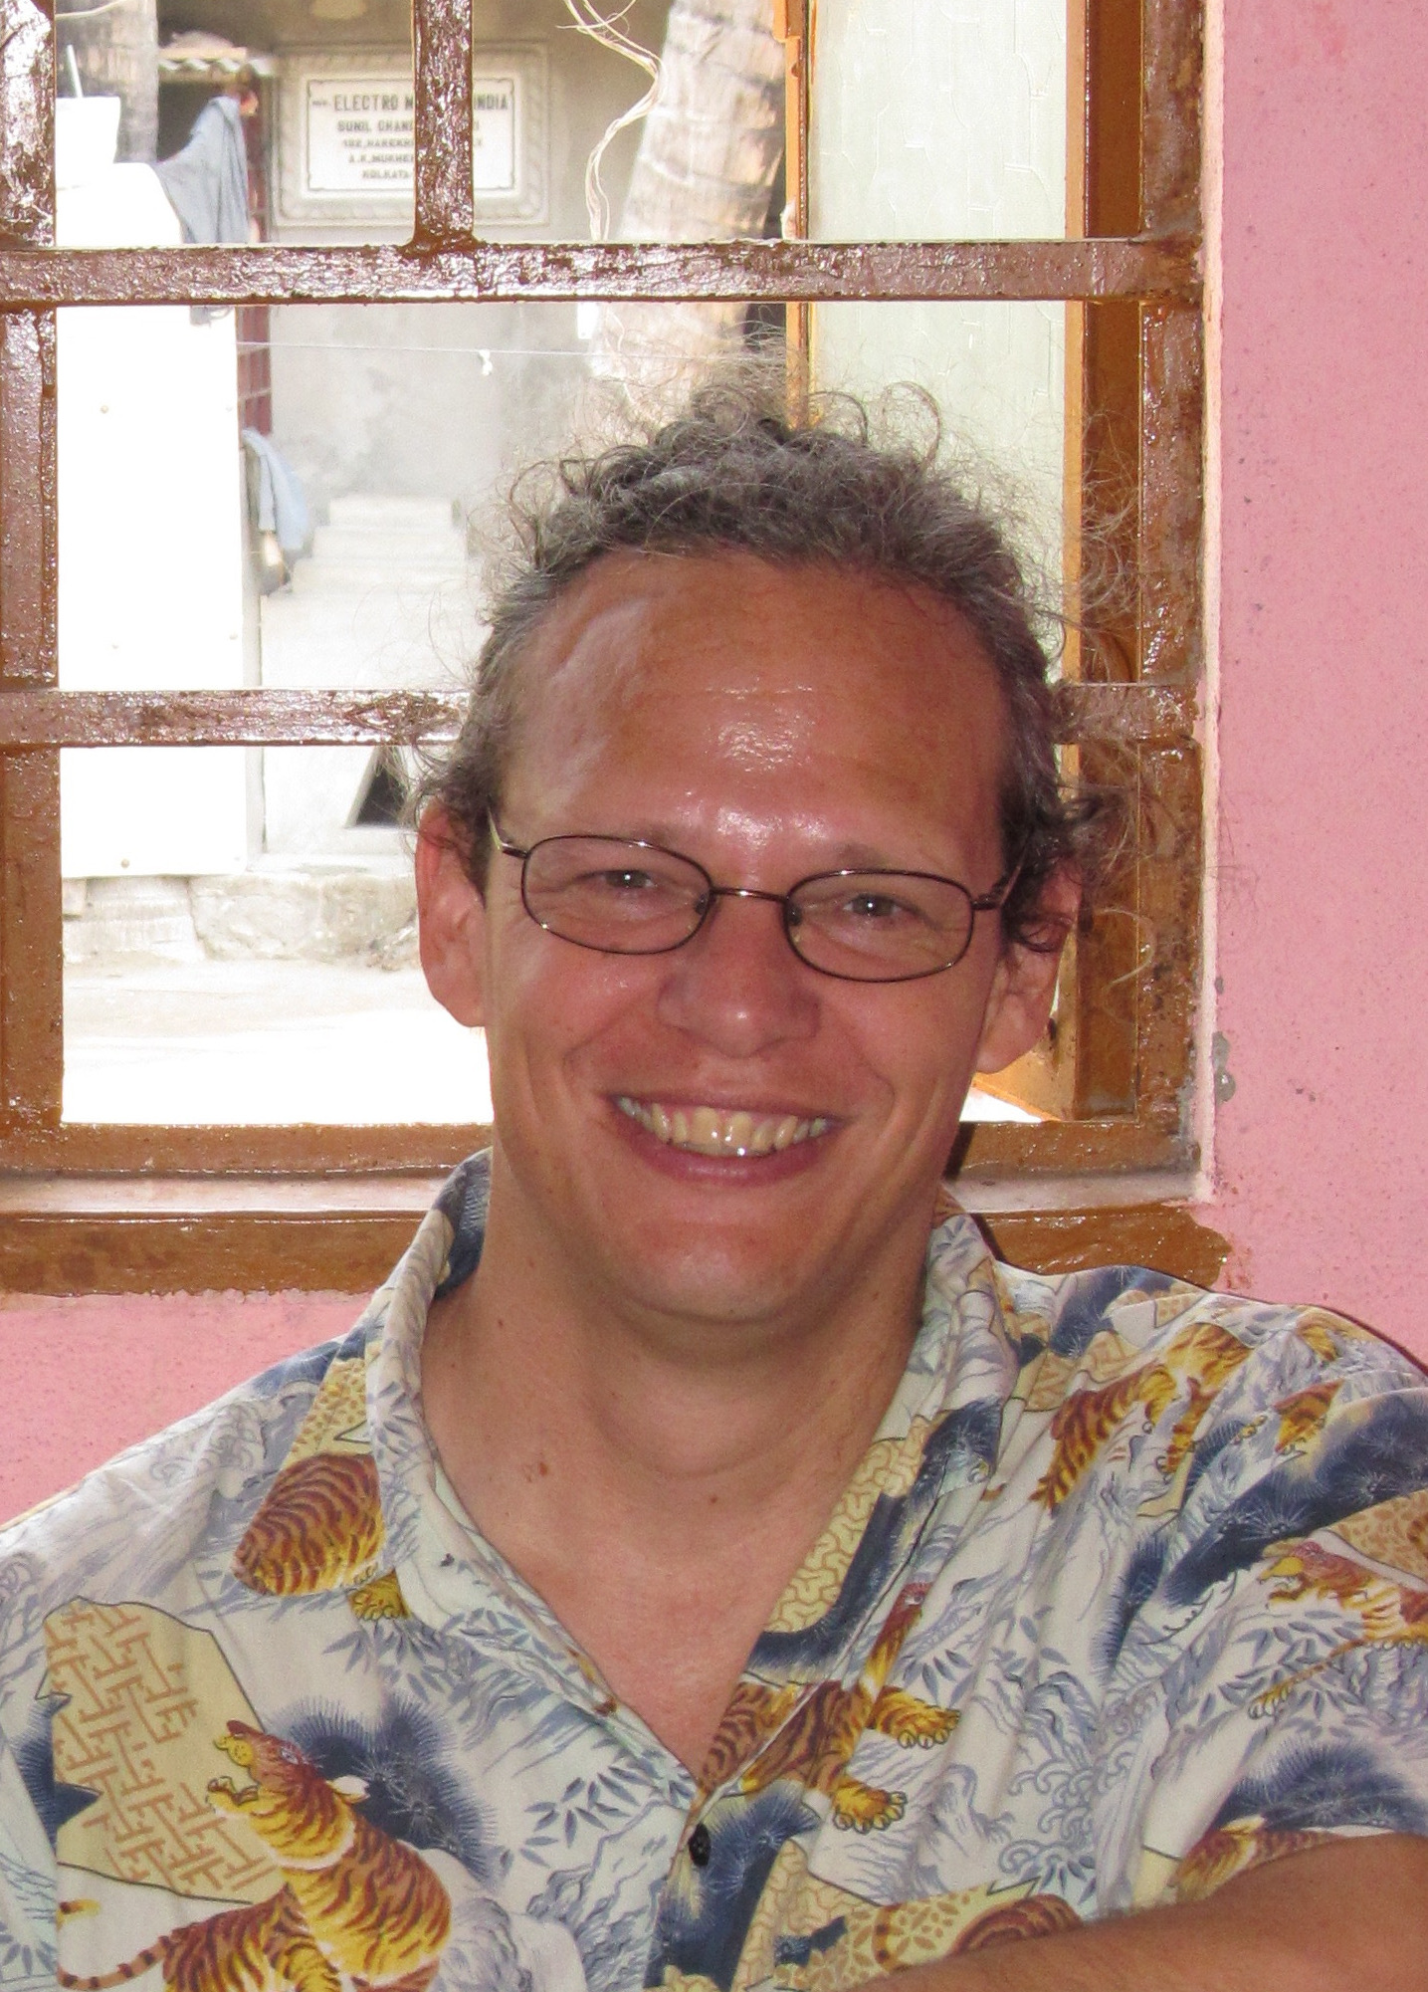 | Your mentor and guide for the course is Ralph. Ralph has been travelling to Asia regularly since 1993. He has worked with Campus Crusade for Christ and TEAR Australia. He has been the Australian Coordinator Servants to Asia’s Urban Poor since 2009 and loves walking with people who are exploring their faith.

If you are interested, please fill out the Expression of Interest Form found here.
The deadline for applications is the 6th October 2017.

Metadata
zn_page_layout | default
zn_sidebar_select | default
zn_zn_disable_subheader
zn_subheader_style | zn_def_header_style
zn_page_override_boxed_layout | def
zn_page_title_show | no
zn_page_title
zn_page_subtitle
zn-custom-layout | 0
zn_page_builder_status

