TASTE of a simple life of connection and love
Author | Admin
Date | 2020-03-02 01:32:43
Categories | Articles India Y Internships Stories
Contributed by Shannon Mawdsley, Servants NZ coordinator, who recently led the TASTE trip to India
We were here. On the edge of the slum, wandering past cricket players, smells and rubbish, dogs and goats, what would it be like within? Will I be overwhelmed?
The open path becomes narrow alley ways, a brilliant blue painted wall, twists and turns, watching my feet as I place them. How would we navigate this without our guide and long-term slum-dweller? A sharp left turn and we are through the metal door to his house, up the narrow brick staircase to an open landing. Separate bathroom and kitchen to the left, living space to the right and stairs up further to the roof. Oh the roof! How wonderful to look out over the homes to other rooftops and people atop them.
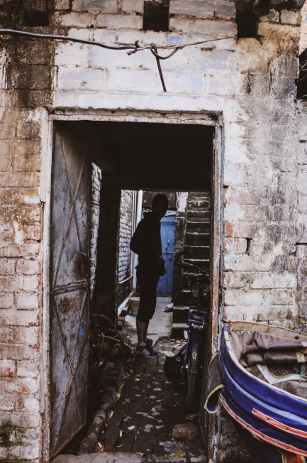
Cramped spaces
Spaces, initially seen as small and cramped, yet with everything that is needed to live quite comfortably. Maps on walls, the essential water filter, preparing food on the landing, sharing it within. Relationships begun, laughter had, and stories shared. A simple life of connection and love for others with less than. A desire to help and be Jesus amid the poverty and see where he already is. In the laughter of teenagers in the sun on the roof, playing with children. Hope and joy abound here.
The overwhelm never happened. Life here, while so different than mine in NZ, has so many of the same elements. Buying food, preparing food, sharing food, cleaning clothes, washing dishes, relaxing on the rooftop (did I say how wonderful that was?), caring for children, meeting new friends and hearing their stories and sharing mine. A give and take, finding a rhythm of being together.
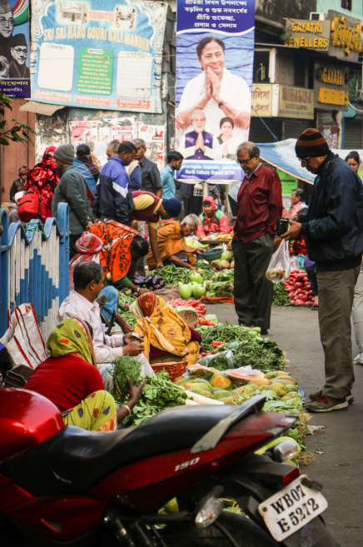
Street market
There is time here, to know and be known, to do life together, supporting, encouraging, going where the Spirit leads and joining in the work of God already in action. Helping the illiterate to read and write, helping the poor access government funds, helping neighbours connected to gas, helping girls in difficult circumstances. So many ways to show practical love and receive it from neighbours.
As I squat to wash dishes I glance up across the rooftops and feel content. This feels like home, and I am surprised. My new friends have welcomed me in, allowed me to help, and shared themselves and their world. They have shown me what is possible with a surrendered life, trust in God and a heart for the poor. I am forever changed.
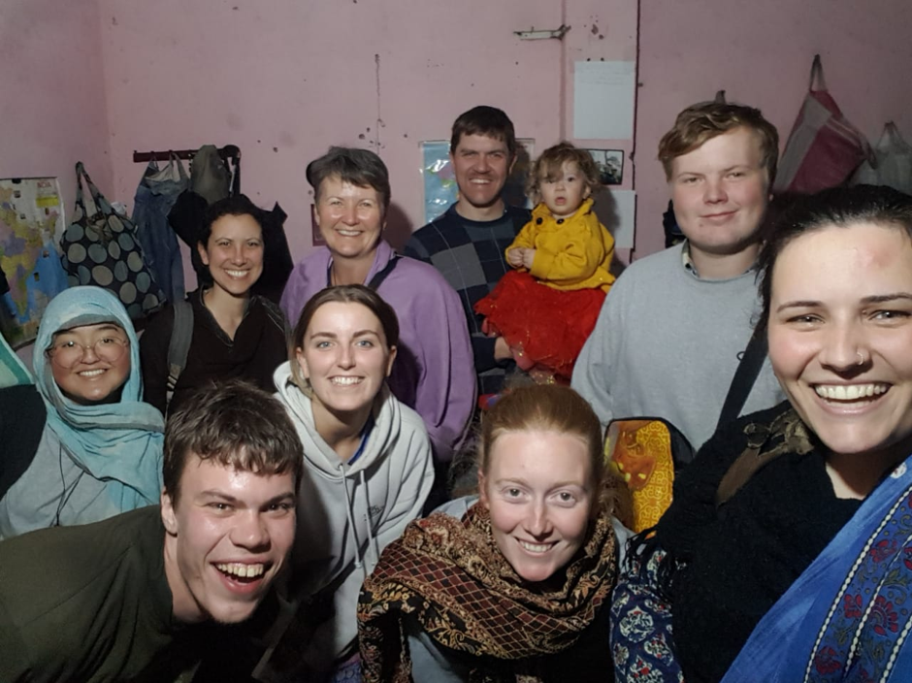
TASTE Team and friends

Metadata
zn_page_layout | default
zn_sidebar_select | default
zn_show_social | default
zn_zn_disable_subheader
zn_subheader_style | zn_def_header_style
zn-custom-layout | 0
zn_page_builder_status

