TASTE Mission Intensive
Author | Admin
Date | 2017-07-10 18:45:28
Categories | Internships Past Events

TASTE: Mission Skills Intensive

details of the next TASTE trip are yet to be announced...
See reflections from the 2020 course here.

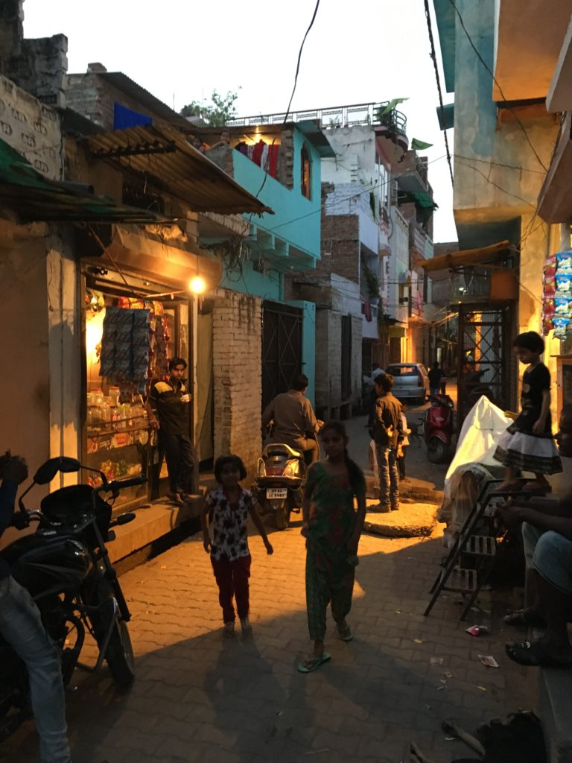TASTE Missions Skills Intensive is a course for up to 6 young adults, during the southern hemisphere summer (January-February). Participants will have a three week taste of what life is like as a Christian living among Asia’s urban poor. Below is a description of the 2020 program ...
Content: The content of the course is flexible so that it can meet you requirements. Select some or all of the options listed below.
- Language: Learn some Hindi and language-learning as relationship-building;
- Community: Learn how Servants team members cope with each other when under stress;
- Simplicity: Be inspired to live more simply from the examples of people living in Indian slums, and from the Servants workers who live alongside them;
- Incarnation: discuss and discover how much like your neighbours you’re prepared to live so that the love of Christ might be communicated;
- Wholism: re-read the Gospel story so that it make sense of poverty, injustice, inequality and different religions;
- Slums: explore the data AND the experience. How important are slums in urban mission today
- Got your own goals? Let’s talk about them! The content of the course can be tailored to help you meet your own learning goals.
Costs: Participants only cover their own costs. These are likely to be around $1500AUD (plus discretionary spending) depending on where you live and which vaccinations you need:
- $750 return airfares
- $50 carbon offset
- $75 visa
- $200 per week for 3 weeks living expenses
- $100 internal travel costs
- passport (if you don’t have one)
- vaccinations
- travel insurance

Make India's slums your classroom, your bible-reading-room, your discernment space:
30 years ago this slum was just a few simple, temporary shacks in a field between government buildings near a busy intersection. But more people came, and the city grew up around this make-shift community of squatters. Every day on the streets, the shack-owners gathered bricks and, over decades, put up brick walls, flat concrete roofs, then rooms on the roof, and in some cases third floors. A drain hole in one corner of each floor allows waste to pass down to the drain that runs along the street - simple, effective plumbing, but smelly. The “street” has now been paved in brick and concrete, but is rarely more than a metre wide. Pedestrians share the narrow roads and alleys with motorcycles, cows, ducks and plenty of dirty children who aren’t attending school. Sewerage and all waste water run through channels that are sometimes open and run beside the road, or covered with small, broken concrete slabs and run down the middle. Dirty concrete pretty much covers every inch of ground except for the “maidaan” - a bare patch of dirt that serves as a carpark for one of the government offices and a cricket pitch or soccer ground for the children of the slum. As in any developed slum, there is significant diversity between the levels of wealth of the families living there. Most houses in this slum are now “owned” by the second generation: the children who grew up here. Shaila* and Safa* are sisters who grew up in the slum and were whose parents have died. Shaila has two children with her husband. Her husband is in Mumbai, hopefully for work. The children are staying with his parents who live in a nicer neighbourhood. Yalina*, Shaila’s aunty, has six children who live in the slum with the women. Imran* is about 20 and works in a spectacles shop grinding lenses, Naseem*, who is about 16, works in an embroidery factory. Alia (a 13 year old daughter, stays home to do the house work). Raheem* and Rahman*, twins, about 10 years old, work, or have worked, making chappals (sandals) but now work at a puncture repair shop. Rahman no longer works but studies in the madrassa and plays in the street), Khaleel* (about 6 and does not attend school). Khaleel* may have a speech impediment. Safa* is not married, and lives quietly inside the house. The family have opened part of their front room to the street so that they can operate it as a very small shop selling tiny packets of snacks, shampoo, laundry soap and henna. With the income that Yalina’s sons bring in, plus the income from the shop, the family survive.

As you enter the slum and hear it's stories, who will you meet?
If you are interested in TASTE, please Contact Us

Metadata
zn_page_layout | default
zn_sidebar_select | default
zn_show_social | default
zn_zn_disable_subheader
zn_subheader_style | zn_def_header_style
zn-custom-layout | 0
zn_page_builder_status

