Talking Trash
Author | C Dee
Date | 2020-02-03 21:16:12
Categories | Articles God at Work Indonesia Stories

Piles of rubbish, new every morning, emitting plumes of smoke: the nonstop by-product of modern consumption. Yesterday the grove of banana trees in front of our house was felled to make room for a furniture workshop, the latest casualty in the steady advance of urbanisation.
Look what I found, written in October 2017, and somehow not published then ... now more relevant than ever.

Women's empowerment
As foreigners living in a slum, we are somewhat of a curiosity for everybody we meet. Recently our daughter’s school-teacher invited Annika to be the “creative parent teacher” on the theme of “women’s empowerment” to celebrate the birthday of a historic campaigner for girls’ education in our country. “You can talk about anything you’re doing,” he said, “the main thing is that you’re a woman.”
There are so many things we could say, given a platform, to these children of rich families, future leaders of this country. The rights of women. Life in a shack. Different religions living together. But we already knew what we needed to say. “Can I talk about rubbish?” she asked.
After all, our primary project has become an income-generating enterprise for women normally dependent on rubbish-picking, using sewing machines and a bit of handicraft to turn waste into items of beauty. As well as providing supplementary income for the women, it is one small way for people to think about the impacts of their lifestyle on the environment. We call it “Mutiara” (pearl), and involves about eight women working regularly from their homes around their other family commitments.

View from the bottom and from the top
Living where we do, squatting on illegal land, gives a unique perspective. A view “from the bottom”, if you like. Actually it’s not that unique, considering there are a billion others doing the same thing. But not many do it by choice, and not many with the benefit of higher education and experience “from the top”. (Yes, really, the top. Apparently you only need to earn NZ$51,000 (net) per year to be in the world’s top 1% by income. Find out if you are in the top 1% at www.globalrichlist.com).
And so these past few months have not allowed me the luxury of blinking and looking away from the issue of environmental devastation. It confronts me every day when I grab my towel off the balcony for my morning mandi. Piles of rubbish, new every morning, emitting plumes of smoke: the nonstop by-product of modern consumption. Yesterday the grove of banana trees in front of our house was felled to make room for a furniture workshop, the latest casualty in the steady advance of urbanisation. I know that what I see out my front door is merely a tiny manifestation of a repeated pattern at immense scale across our megacity of 30 million residents.
Viewed “from the top”, the problem of environmental limits fades behind glittering malls and air-conditioned vehicles on smooth-running new toll-roads. But it remains glaringly obvious when viewed “from the bottom”. As one of my neighbours put it: “where we could once enjoy rice fields, trees, nice and cool places, the rich buy the land and make a housing complex and the rest of us have to get out of the way, with no choice but to play in the smoke.”
If we can learn anything from history, it’s that the best of Christian missionaries have been instrumental in highlighting the “bottom-up” view, and thereby alleviating the worst excesses of their home society, whether regarding slavery, indigenous rights, or economic injustice. (Of course, many others showed blind allegiance to the cultural imperialism of their day, which we can also learn from).

Climate change and the poor
Today’s issue is climate change. We can’t help but notice that our own neighbours, already affected by regular flooding and sensitive to food price shocks, would face serious additional suffering under the impacts of a harsher climate, in spite of living in a country whose average annual emissions per-capita are less than 20% of New Zealand. Even though our neighbours are largely unaware of debates on global warming, they often comment that the weather has become significantly more erratic since their own childhoods. They should know: their families sensitive to rice harvests dependent on reliable weather patterns.
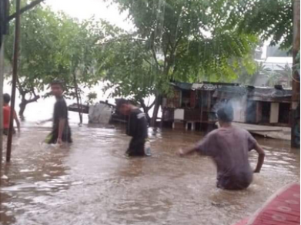
Extreme floods across greater Jakarta, January 2020
Last February our neighbourhood became a lake. Our own house was waterlogged 150mm deep for six hours. At first we evacuated the kids upstairs, but then we gave in and let them go swimming with their friends. Neighbours even took the opportunity to go fishing in the alleyways and streets! (Fish were escaping from nearby recreational fish farms). It was a fun day off school, if a rather exhausting cleanup.
Our work and school was interrupted when everybody else’s was too (our city experiences widespread flooding like this once every five years or so). I can only imagine what it must be like for our neighbours in the lower areas who suffer flooding every time it rains, and are expected to face the world as though it’s just another ordinary day. It is another obstacle that keeps them firmly trapped in poverty, and climate change will just make it harder.
Climate change is a phenomenon that connects us all in direct relationship, across seas and generations (see article from 2007). The sad reality is that those who are least responsible for climate change are hardest hit by its consequences. As an expression of Christian love and justice, this issue must be placed in the foreground of our thought and action in mission in today’s world.
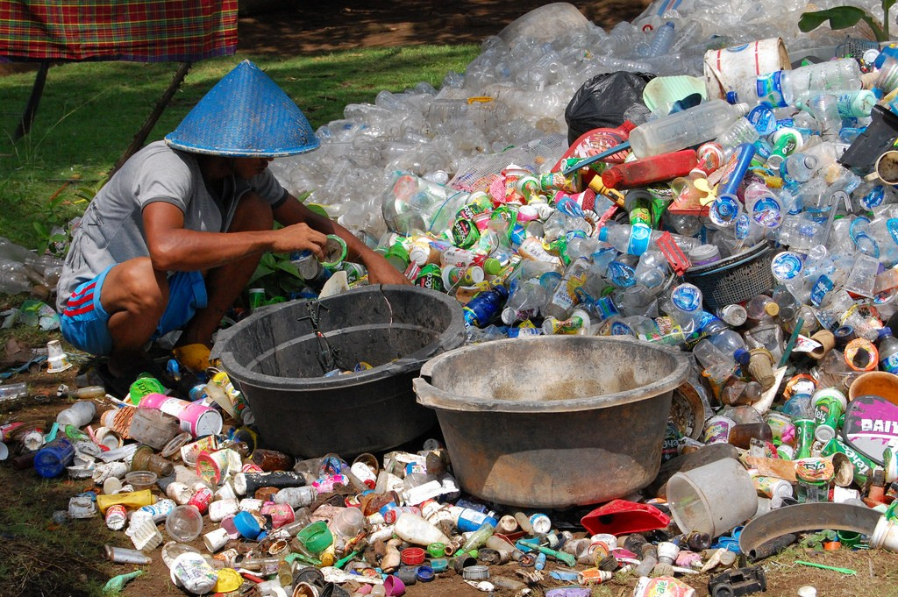
Collecting plastics for recycling

Eco-heroes
And so, for our daughter’s class, we began our series of presentations entitled “Living with rubbish”. Where does rubbish go? What animals are affected? What happens when you burn it? All novel questions, it seems, around here. Promoting the three “R” (reduce, reuse, recycle), we discussed alternatives to buying heavily packaged takeaways, which left parents and teachers in the audience challenged to change their consumption habits. “This is really important,” said one parent, “everyone should hear this”. After three years of living with the overwhelming reality of the rubbish around us, it is deeply satisfying to finally share meaningfully about this.
We have also done the presentation in our neighbourhood. As well as a platform to promote Mutiara products, it feels good to celebrate our rubbish-picking neighbours as eco-heroes. They are often regarded as dirty, impolite, unhealthy bottom-feeders. But without them, our city would have 30% more rubbish to deal with! It is our privilege to serve them.

Metadata
zn_page_layout | default
zn_sidebar_select | default
zn_show_social | default
zn_zn_disable_subheader
zn_subheader_style | zn_def_header_style
zn-custom-layout | 0
zn_page_builder_status

