Street Believers: New Life for Street Dwellers
Author | Admin
Date | 2023-02-25 01:21:12
Categories | Articles Current Immersion Teams Philippines Stories

From Patrick in Manila
Since November 2021 I have been part of a homelessness ministry named " Street Believers ".
Our mission works toward establishing trust with people who are homeless by meeting them where they are on the streets (Street Visitations). This is where we invite them to have a “Day off for the homeless” at our center. It is at our center where they can eat all their meals for the day (and even pack food for the road), rest, have fun, and share their stories with people who care.
Once they gain enough trust in us, we introduce our Tulay (bridge) program to give them the choice of newness away from street life. It is very important for us to see that they trust us enough to tell the truth and reveal their intentions. Lying and trickery (“Kapit sa Patalim”) can be 2nd nature to them as a means of survival and they often think it is the only way they can gain any form of acceptance. This means there is a lot of counselling involved in our work.
Once we see that they are sincere in their desire for new life and make the necessary assessments, we take them on a retreat called “Bagong Lakas para sa Bagong Buhay” (New Strength for New Life) to prepare them for their new journey . There is feasting, spiritual renewal, inspirational speakers, fun while being surrounded by nature, and encouragement as we let them experience how we want to companion with them.
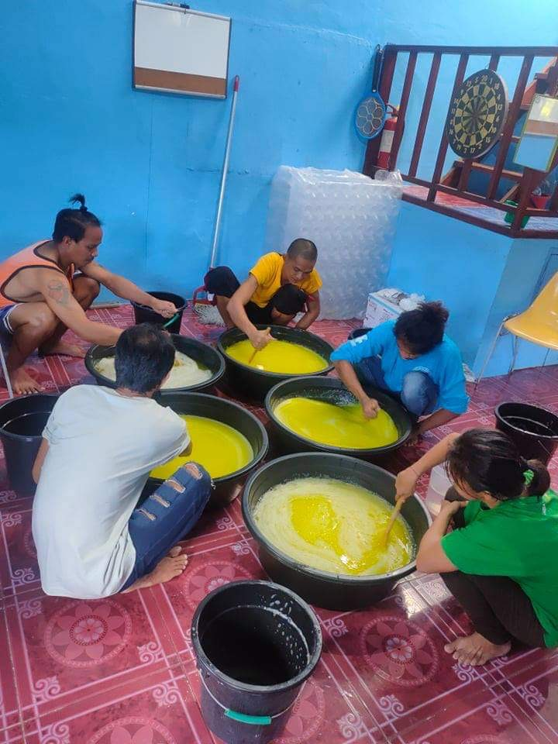
At the end of 2022 we had our first retreat with some of our beneficiaries. Relationships and trust were built so far that we took the chance and drove with eight street dwellers from our program to Tanay Sakahang Lilok Farm. (LINK) Workers and beneficiaries were equally excited, nervous, and expectant. Norma, one of the participants was fascinated and moved by the new surroundings she found herself in. The rural area reminded her of the home province she left years ago in hopes of finding work and a new life in the city. “New life” was also the topic of our camp.
We believe that the streets are not the final destination for people like Norma. Instead, new ways and outlooks can help to break the cycle of poverty. Big life changes do not happen overnight. It is a continuous process, improvement and relapse are part of it and we try to be in it for the long haul. There is not one unique approach or solution for the individual and complex problems of our street dwellers. Aside from our established programs like counselling and the livelihood program we are open in an exploratory stage of finding new ways to help our beneficiaries.
Support services like livelihood and savings, rehabilitation and pastoral support, and training for people skills and job search are currently in place. There are cases where more specialization is needed so we also refer some to boarding schools so children can properly finish their studies. Some have heavy addictions or mental health problems so they need the appropriate treatment and support.
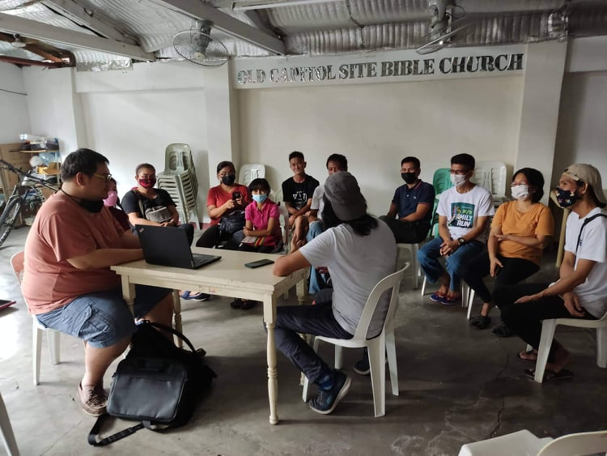
Our work does not only involve helping the homeless to be a part of society but also for society to value the dignity and the restoration of the poor as society plays a big part in the struggles and difficulties of these people. That’s why occasionally on Saturdays we have fellowships with the homeless where volunteer companions and churches get to connect with them. Through this connection they can be accepted by the “barangay” (community), find spaces for rent, find customers if they are to pursue their own livelihood, search for jobs, and more. Community is very much what they need. That’s why we aim to bring people together from different walks of life. We see the beauty of mutual benefits in these heterogeneous gatherings.
We have been struggling with understaffing recently. Next to our volunteers and 2 part-time workers we are looking to hire a house manager for our drop in center.
In all this we are thankful for your prayers.

Metadata
zn_page_layout | default
zn_sidebar_select | default
zn_show_social | default
zn_zn_disable_subheader
zn_subheader_style | zn_def_header_style
zn-custom-layout | 0

