Servants UK Thanksgiving Celebration
Author | C Dee
Date | 2023-03-09 13:00:00
Categories | Events Past Events United Kingdom
After decades of championing the cause of Asia's urban poor, supporting the work of Servants, and hosting Servants people and events with fabulous UK hospitality ... the Servants UK team is ending its time as a charitable trust. The team will continue to exist in more informal ways, as friends who continue to support the Servants dream, and live out our principles and values locally.
The first event in this new phase of the life of Servants UK will be a time of thanks and celebration. Have you been part of Servants UK at some time? Please join us to remember and celebrate all the joys, challenges, and wonderful people who have been Servants UK over the years.

25th March, 10am-4pm
The thanksgiving celebration will be held on the 25th of March 2023, at Breathing Space (the retreat centre run by Peter and Lois Sidebotham) in Coventry.
The day will start at 10am with tea and coffee and a chance to chat and catch up with old friends, moving into a time of story-telling and memory-sharing. We’ll then have a simple lunch together. In the afternoon Lois Sidebotham and Rev Idina Dunmore will lead us in a thanksgiving liturgy. The day will officially finish at 4pm but those who want to will be able to stay a bit longer to chat.
There is no charge for the day but if you would like to make a donation to Breathing Space to cover costs and support their work, there will be the opportunity to do that on the day.

RSVP to Colin
If you are interested in joining us please email Colin on colintheconroy[at]yahoo.co.uk . Limited overnight accommodation is available at Breathing Space for those travelling from a distance - please contact Lois via the Breathing Space contact form to request this. The address of the venue and directions for how to get there, where to park etc. can be found on the Breathing Space website.
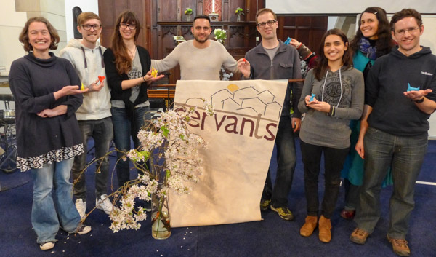
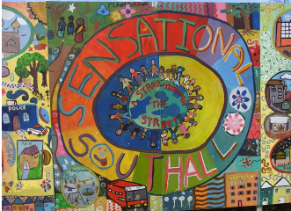

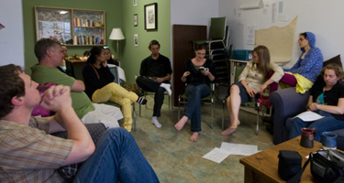

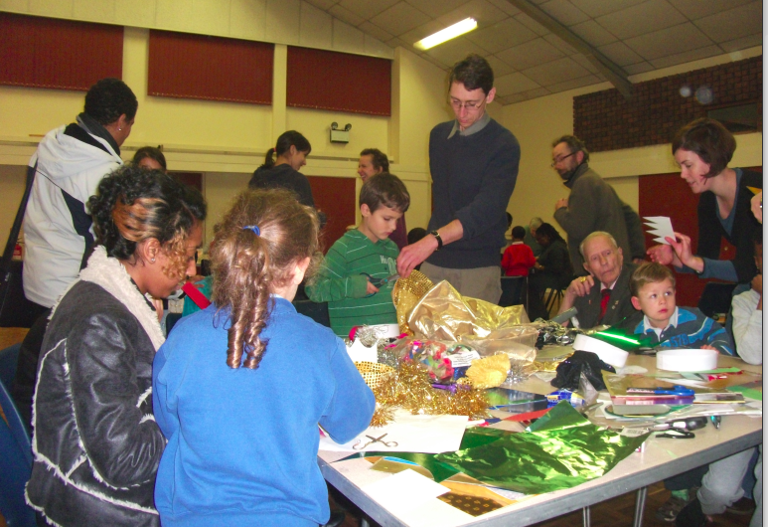
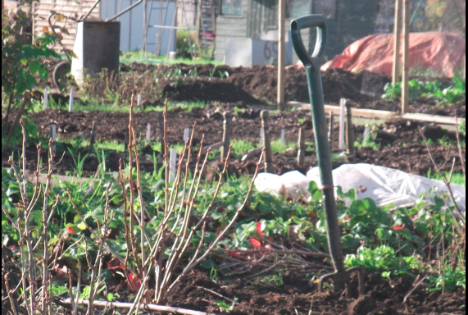
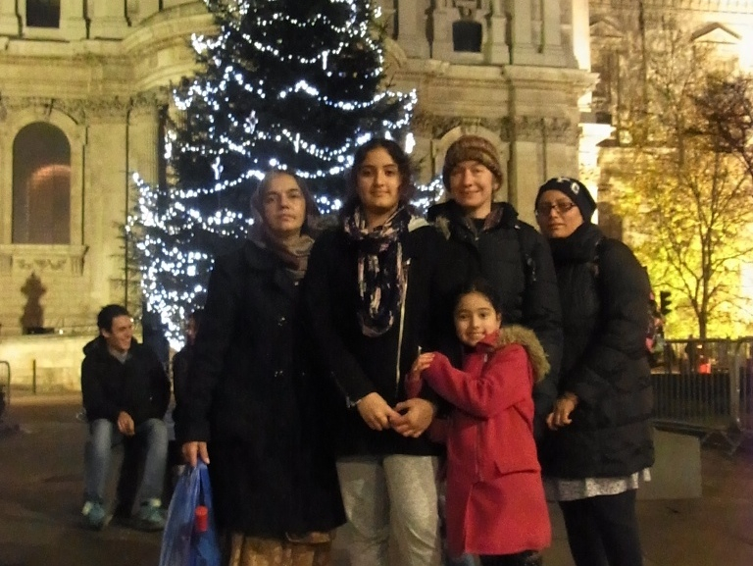


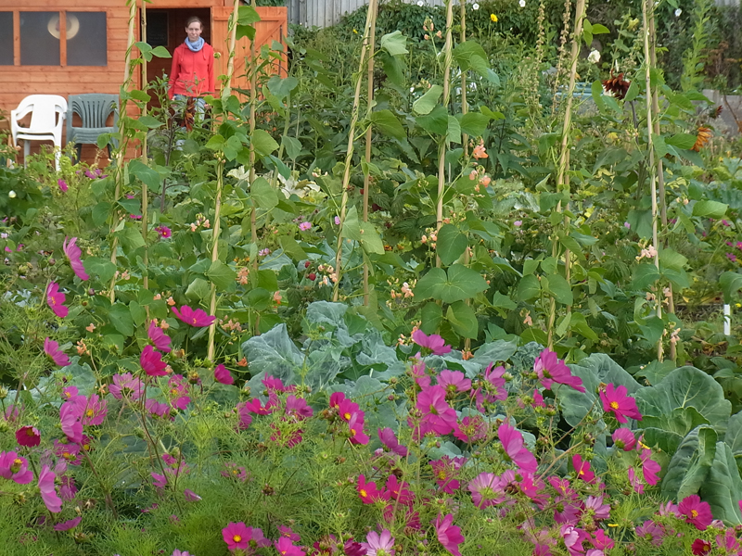
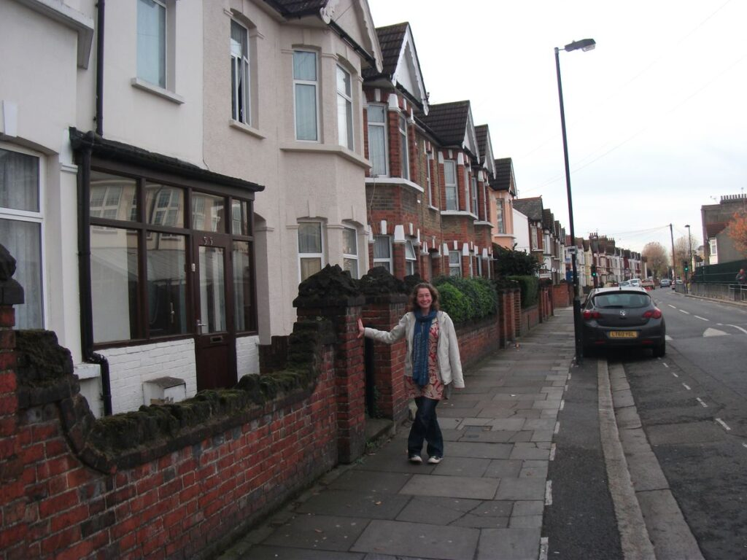
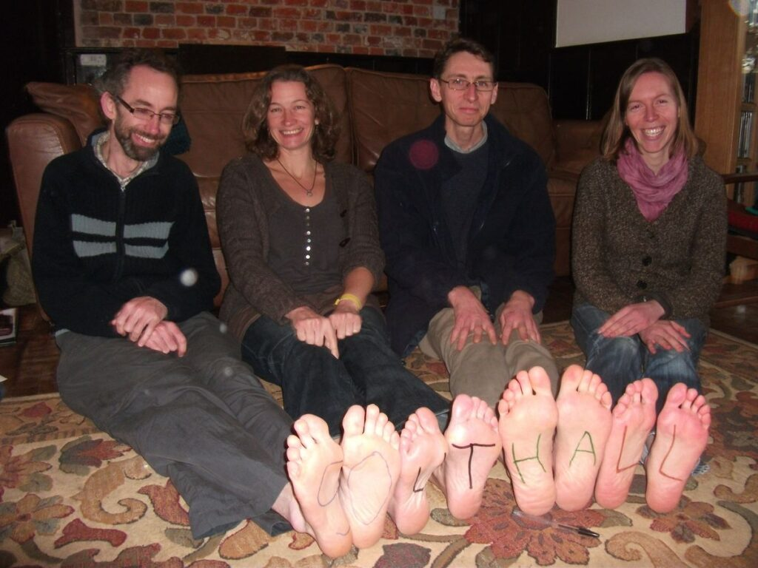
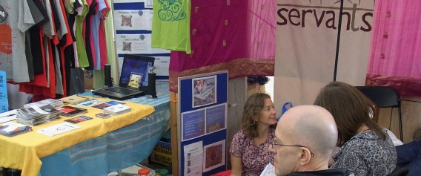
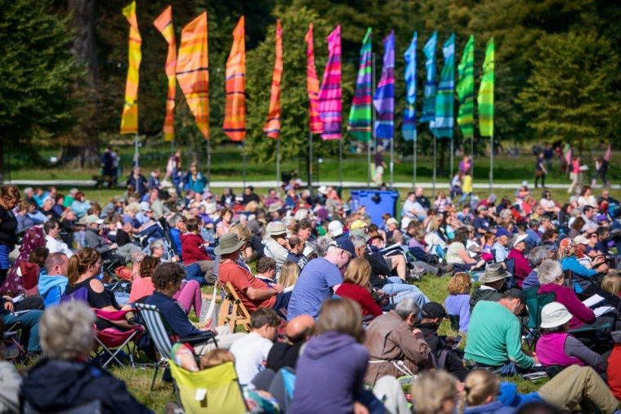

Metadata
zn_page_layout | default
zn_sidebar_select | default
zn_show_social | default
zn_zn_disable_subheader
zn_subheader_style | zn_def_header_style
zn-custom-layout | 0

