Servants Switzerland Newsletter
Author | Admin
Date | 2020-06-18 20:03:05
Categories | Articles Linking Teams Stories Switzerland

Servants Switzerland has just released its latest German-language newsletter.
Servants Switzerland has just released its latest German-language newsletter. It contains stories from Manila, India and Indonesia highlighting the work of the Servants teams in those places, and some of the responses to the COVID-19 pandemic in these poor urban communities.

Here is the contents of the newsletter in German.
Der aktuelle Newsletter von Servants vom Juni 2020
Themen:
Wenn sich deine Familie plötzlich verfünffacht
Ausgangssperre in Manila
Krise als Normalzustand (Indien)
Schulvorbereitung für Benachteiligte (Indonesien)
Lebensmittel für Schulfamilien
Ein Patenkind sagt Danke
Onesimo wappnet sich gegen Corona
No job, no money, no food
Nahe Begegnung mit dem Tod
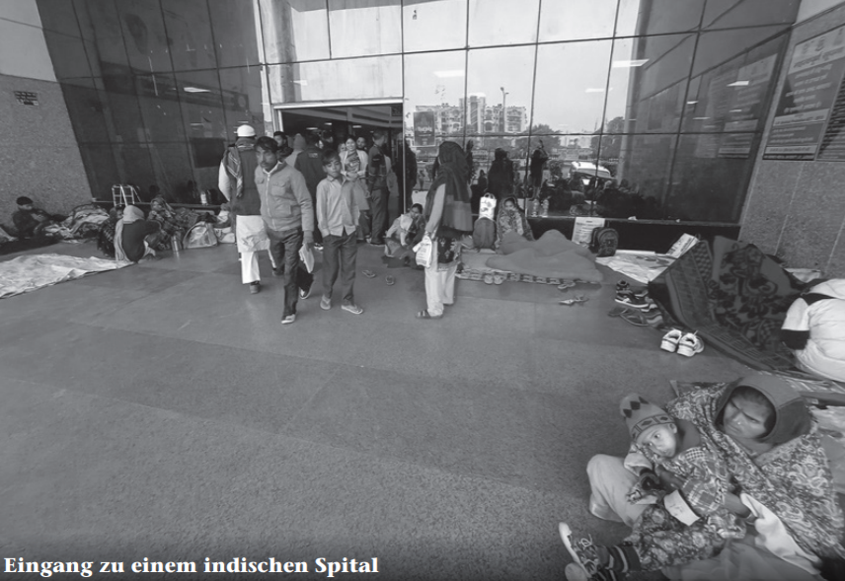
You can download the newsletter directly here.
You can also see this and past newsletters here.
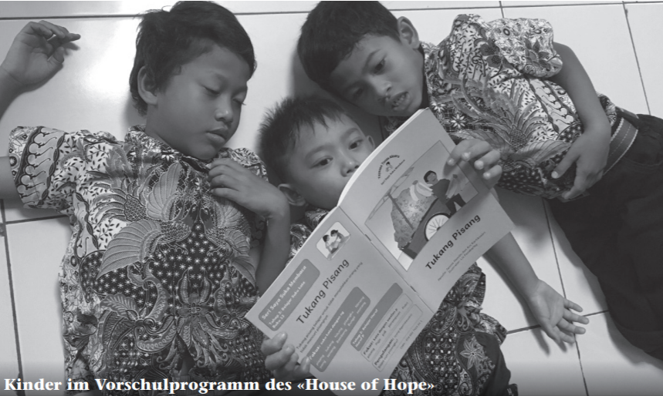

Metadata
zn_page_layout | default
zn_sidebar_select | default
zn_show_social | default
zn_zn_disable_subheader
zn_subheader_style | zn_def_header_style
zn-custom-layout | 0
zn_page_builder_status

