Servants Quarters Magazine
Author | Tom Wartenweiler
Date | 2015-03-03 14:50:13
Categories
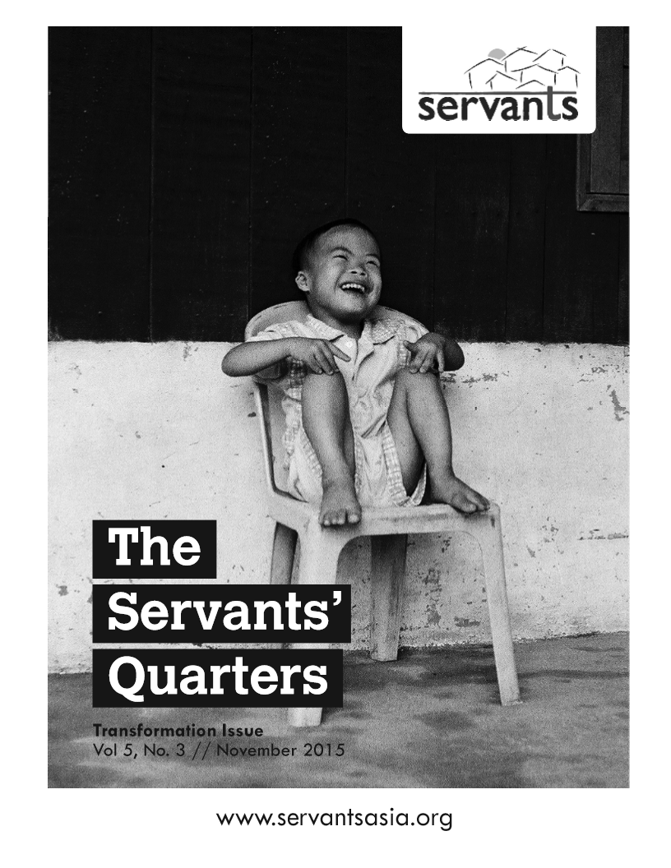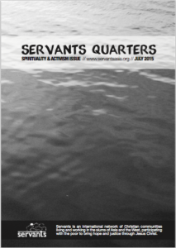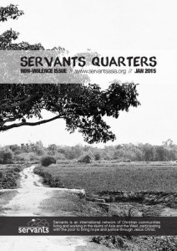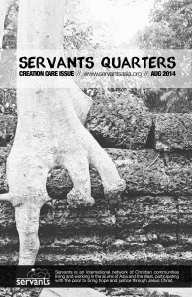Up until 2015, Servants published a quarterly journal called Servants Quarters. Each edition focused on one of our five principles or five values. These publications are filled with profound reflections, moving poetry, and inspiring art. While we no longer produce these, you can still read past issues in a pdf version below or by clicking on the images: Transformation Issue (November 2015), Spirituality & Activism issue (July 2015), Non-violence issue (January 2015), Creation Care issue (August 2014), Wholism issue (November 2013), Servanthood issue (March 2013), Celebration issue (December 2012), Beauty issue (July 2012). 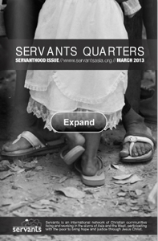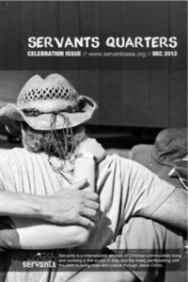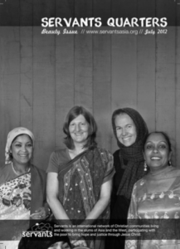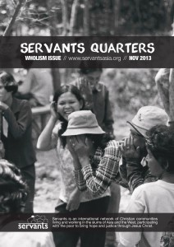

Metadata
zn_meta_elements | Array
zn_page_title_show | yes
zn_page_title
zn_page_subtitle
zn_zn_disable_subheader | no
zn_page_layout | default
zn_sidebar_select | default
zn_page_builder_layout | default
zn_subheader_style | zn_def_header_style
zn_page_override_boxed_layout | def
zn-custom-layout | 0

