Servants NZ Annual Hui
Author | Shannon Mawdsley
Date | 2020-09-01 19:24:01
Categories | Linking Teams New Zealand Past Events
The Servants NZ Annual Hui is a place where people gather to share stories, enjoy great company, be encouraged and inspired and explore nature. This year we are making time to lament the state of our world, especially the injustices which have been highlighted in this time of pandemic.Steve Tollestrup will speak and we will hear from T who is part of our team in India. The TASTE team who spent time in India in Jan/Feb this year will also be sharing some of their experiences and how this has impacted their lives. Come for the day ($30) or stay overnight on Friday and Saturday ($60) to make time to connect more deeply.
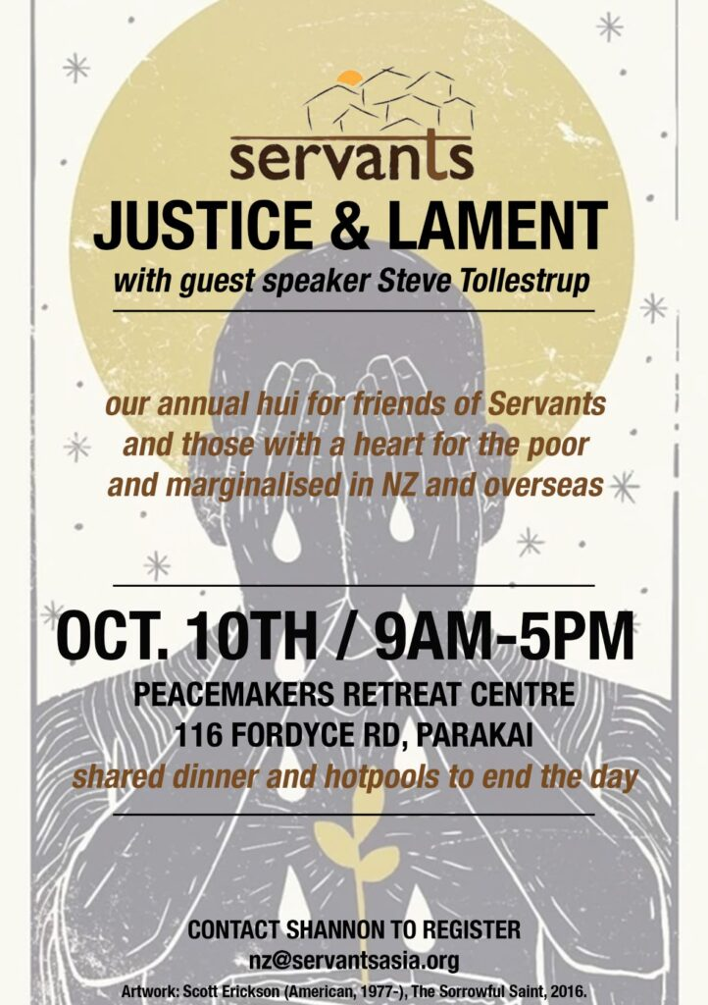

Metadata
zn_page_layout | default
zn_sidebar_select | default
zn_show_social | default
zn_zn_disable_subheader
zn_subheader_style | zn_def_header_style
zn-custom-layout | 0
zn_page_builder_status

