Retreat - Online?
Author | Shannon Mawdsley
Date | 2020-09-02 17:08:07
Categories | Articles Cambodia Linking Teams Philippines Stories
The Servants community conducted an Online Retreat, June 25-27 where we had a chance to hear the laments, joys, sufferings and hopes of every Servants field team. It was a bit strange for me to have an online retreat. At the same time I was thankful for the opportunity of connecting despite the distance and time differences.
We shared our current situations, the joys, sufferings, opportunities, and inconveniences that we are experiencing with this pandemic. Lots of plans and desires have changed. Everything has become out of control and full of uncertainties. But then, I am grateful to be a part of this retreat. It helped me to learn and embrace more of every blessing that has been given to me. I acknowledged things by practicing the examen where I could be my true self in the presence of my Maker.
We all have our own ordeals in life. We have our own unique joys and sufferings in different seasons. I was reminded that we are still growing in this special waiting process, even though we feel everything seems mundane. But during this period, our Maker is silently keeping and holding us gently, according to His will.
I feel like I am yarn with two knitting needles and there is someone who is holding me. He desires to make something with his gentle hands, with hope that this little yarn will be a beautiful creation after all the twists and turns. The yarn that will be used for a certain purpose in the future. Trusting the maker that everything is in his hands.
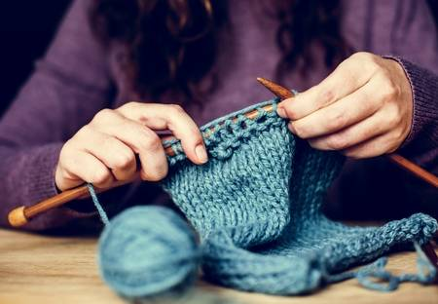
We are all invited to enjoy each season and encounter God in all these things. Taking time to pause, listen, surrender and trust in Him. That all of our thoughts, feelings, laments, desires and longings are all accepted in God. Doing the examen makes me notice how the Holy Spirit moves in daily life despite all of the challenges that we are experiencing.
It is a journey of finding God’s presence in the midst of our own storms. However, we are always invited to be still. Anytime. He is there. Always.
Silently waiting.
Seek Him.
Eunice Colangoy
(Eunice is currently living in the Philippines preparing to relocate to Cambodia with two other Filipina women, Carol and Myra).

Metadata
zn_page_layout | default
zn_sidebar_select | default
zn_show_social | default
zn_zn_disable_subheader
zn_subheader_style | zn_def_header_style
zn-custom-layout | 0
zn_page_builder_status

