Seminar: Beyond Our Walls
Author | C Dee
Date | 2023-02-23 04:52:53
Categories | Events Indonesia Past Events
You are invited to a unique opportunity to join a conversation with Yosiah and Anita, "Beyond Our Walls - Finding Jesus amidst the global poor."
The seminar follows the recent release of Anita's book "Beyond Our Walls: Finding Jesus in the Slums of Jakarta." Of course the webinar will include true stories of life in the slums of Jakarta. As indicated by the seminar title, it will also have a broader focus on how we as Christians respond to the poor anywhere in the world we might encounter them.
The seminar is part of the Soundings series hosted by Coracle, and will be facilitated by Ken Wettig, pastor at Early Church, staff at VMMission, and Coracle Community Minister. That's a lot of connections to diverse Kingdom-of-God initiatives all in one seminar!
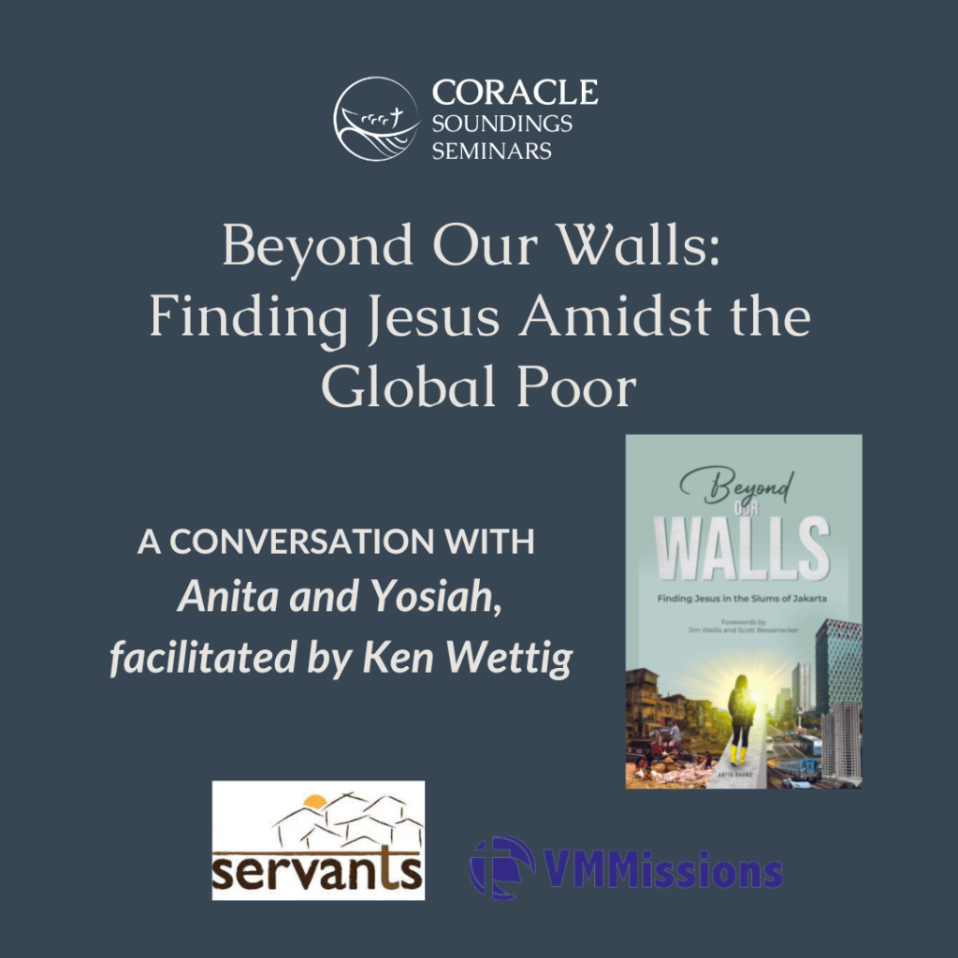

Details
The seminar will be held online using Zoom:
March 9th, 2023
12:30 - 1:30 pm ET.
Click here to check the correct time in your timezone.
For more information, see Coracle's event page, and to register click the button below. Simply fill out the details in the registration form, to be sent the Zoom link.
Register for "Beyond Our Walls" seminar

Metadata
zn_page_layout | default
zn_sidebar_select | default
zn_show_social | default
zn_zn_disable_subheader
zn_subheader_style | zn_def_header_style
zn-custom-layout | 0

