Reflections of life in Cambodia.
Author | Admin
Date | 2022-11-30 01:25:06
Categories | Articles Asian Voices Cambodia Current Immersion Teams Formation
by Myra Reyes
To be honest the hardest part to adjust to is team life. Sometimes I feel that I am married to the man that I didn’t choose. It’s like a marriage without a contract or a ceremony. I signed an agreement due to my faith, not with paper or a pen, but with the word of God and the “calling”.
In marriage I would need to give myself to a partner, including my time and energy. I need to consult him/her in every decision for the benefit of a strong household. So, in team life, it is like marrying a person that I didn’t choose, it just happens that they are ready and so am I.
But even though we are ready, there are still misfits and misunderstanding. Conflicts may arise without knowing how they exist or maybe we know they exist, but we just ignore them, so the harmonious relationships remain.
I am not yet married nor have ever been in a relationship but that’s how I can compare team life. I am losing something that I can’t pinpoint, but later I will try to find the freedom that I have when I am not in this knot. That freedom includes my space, my sense of ownership of my time and my freedom to do things of my own like going out without the need to say where I am going.
But in all the search of fitting together and freedom there is joy, contentment, and satisfaction after all the adversity. The works of God and His way of molding me to fit in the shape of His own likeness in our team is so unexplainable. Sometimes I think that there are no changes in my behavior, that I can’t see I am growing. I can barely see the difference from the past me to now. Through the help of outside sources like friends, mentor, Spiritual Director and neighbors, the Lord sends me the message of love and His way of nurturing me in his arms.
Making mistakes is another way of bringing joy to me. Not knowing everything is an adventure of finding how, where, when, who and what are the things that I should do and do not. It is a humbling experience to learn from the children how to properly pronounce the right word in Khmer.
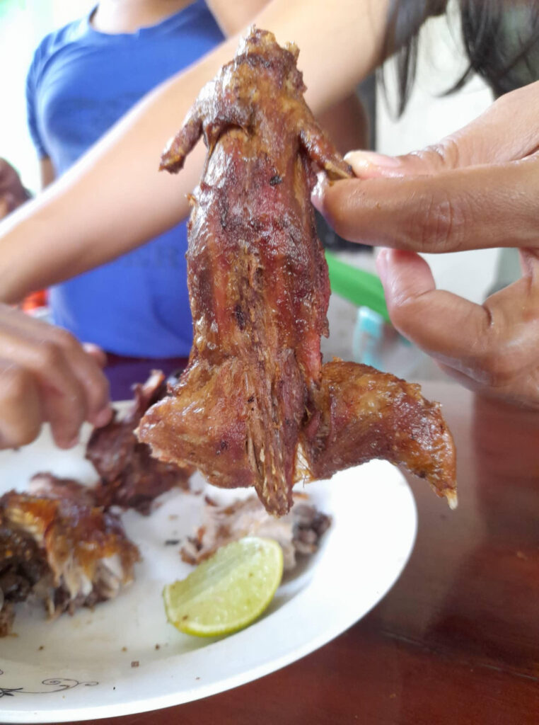
Mouse!
There is beauty of not knowing what I am eating until the last bite, before they can find the English word for it, “mouse” yes, it is yummy, like chicken. After hearing “mouse”, my mind plays the image of a big wet black rat with no hair, back in the NIA Road, in Quezon City. Our visitor day and night.
Finding places and riding a PassApp (ride hailing service) is another level of mistakes. Sometimes the map is right, but the PassApp driver has a better way to find the drop point, just drive and drive and drive. Or sometimes the drop point is right, but the place does not exist anymore. That happens a lot.
There is wisdom in finding places or spots where you can be you. In every mistake that I make I just laugh about it and make sure that I don’t commit another mistake, but I know that is impossible, so I will be making a box of laughter for all of these.
I sense that in all my down and high moments God is with me. He is present sending me a hug when I need it, complimenting me when I do a great job with the skills that I have, giving assurance that I have the qualities that I need to maintain my stability here.
Ephesians 3:14-19
¹⁴ For this reason I kneel before the Father, ¹⁵ from whom every family in heaven and on earth derives its name. ¹⁶ I pray that out of his glorious riches he may strengthen you with power through his Spirit in your inner being, ¹⁷ so that Christ may dwell in your hearts through faith. And I pray that you, being rooted and established in love, ¹⁸ may have power, together with all the Lord’s holy people, to grasp how wide and long and high and deep is the love of Christ, ¹⁹ and to know this love that surpasses knowledge—that you may be filled to the measure of all the fullness of God.

Metadata
zn_page_layout | default
zn_sidebar_select | default
zn_show_social | default
zn_zn_disable_subheader
zn_subheader_style | zn_def_header_style
zn-custom-layout | 0

