Rations and Relief
Author | C Dee
Date | 2021-05-25 18:53:24
Categories | Articles COVID-19 Pandemic Current Immersion Teams God at Work India Y Stories

Covid update - India
At last the number of daily new Covid cases in India is coming down – after peaking at around 400,000 per day two weeks ago, it’s now around 250,000. However the daily number of deaths remains high, around 4000 per day. All the official statistics are likely to be significantly less than actual cases and deaths, since many people do not get tested, and many deaths are not reported. The situation has been overwhelming.
Even though the cases are now dropping, many cities and states are still enforcing “lock down” in various ways, which means millions of people are not able to work, and have no income.

Government response
Recently the Supreme Court has ordered basic rations to be distributed to all migrant labourers who are stuck far from home – first the order related only to the region around Delhi, but yesterday it has been extended to the whole country. However, reports on the ground say this has not yet happened, and community organisations are stepping into the huge gaps.

Servants team in action!
The Servants team in India have been hard at work distributing rations in slums in their city, for the past two weeks. With the announcement on Monday that the lock-down is extended until 31st May, they are gearing up for more distributions this week. This update is from Yusuf, along with photos of the work they have been doing:
Here's an update on the ration distributions we've been doing over the last couple of weeks.
It's gone really well - we've distributed about 17.5 tonnes (or 3.5 African elephants' worth) of food to 1,700 families! A huge thanks to all of you, who made this possible, with donations from 40+ different people - a real crowdfunding effort! We have raised, and distributed, just over 1 million rupees. This is a summary of the numbers (I've spent a bit more out of my own funds to keep the ball rolling).
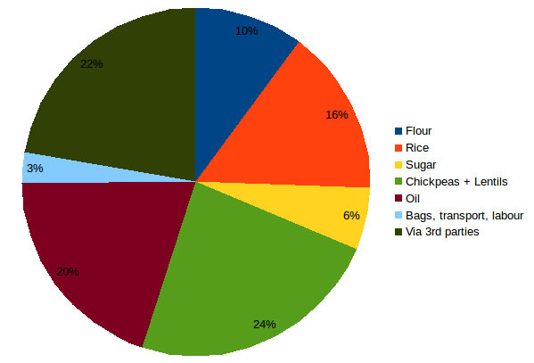
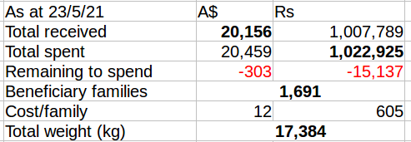
I also want to offer a huge thanks to my room-mate Jeshan, who has supervised many of the distributions beautifully. I was wrecked after carrying a single 50kg sack of flour but he knows the perfect technique and can do it all day long! And also a big thanks to many friends and neighbours - Shaheen, Mariyam, Sana, Sayra, Shehnaz, Mantasha, Nahid, Rakesh, Abdullah- who have offered their houses to be used as packing & distribution centres, and have done much of the hard work. Often people come for days afterwards asking if there's still rations left (This can be quite annoying, which is one of the reasons I haven't done any distributions from our house; but many of our friends have handled this graciously). Several of Jeshan's relatives, in Odissa, have also distributed rations.
Thankfully Covid cases are now declining in India - 'only' about 250,000 new cases per day at the moment. However, our state government has extended the lockdown till 31 May, compounding people's economic difficulties.

Please pray for the situation in India:
- for the millions of people who are infected with Coronavirus, and the millions who have lost loved ones
- for Jeshan’s mother, who has just tested positive and is quite sick (not critical)
- that the orders of the Supreme Court to provide rations to migrant labourers will be carried out effectively, to provide assistance to the most needy
- for the people of Gujarat (India’s west coast), recovering from recent severe cyclone Tauktae
- for the people of West Bengal, Odisha and Andhra Pradesh (India’s east coast) where 1 million people have been evacuated, and Cyclone Yaas is expected to make landfall today.
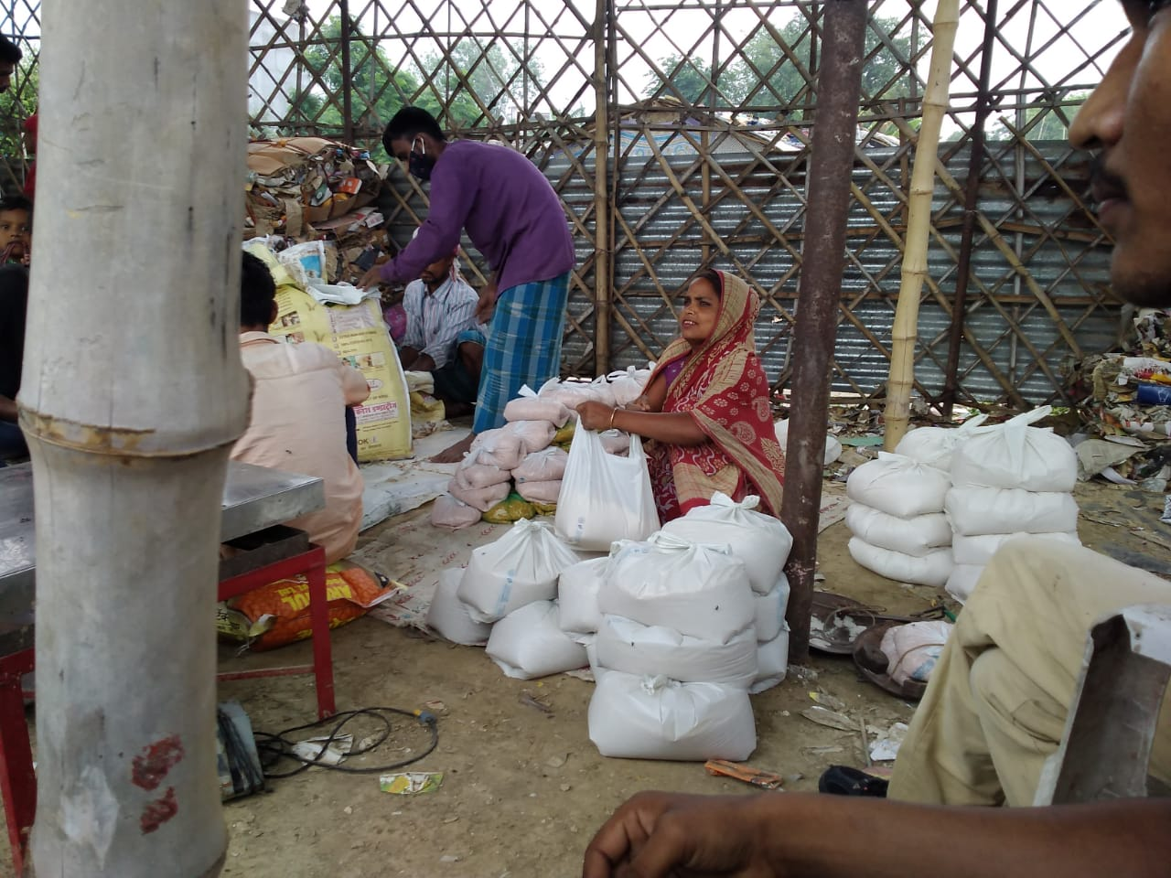
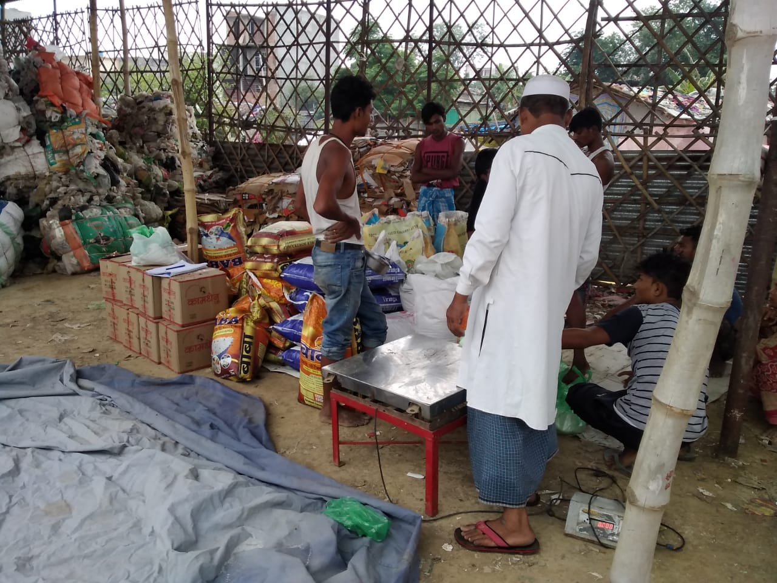
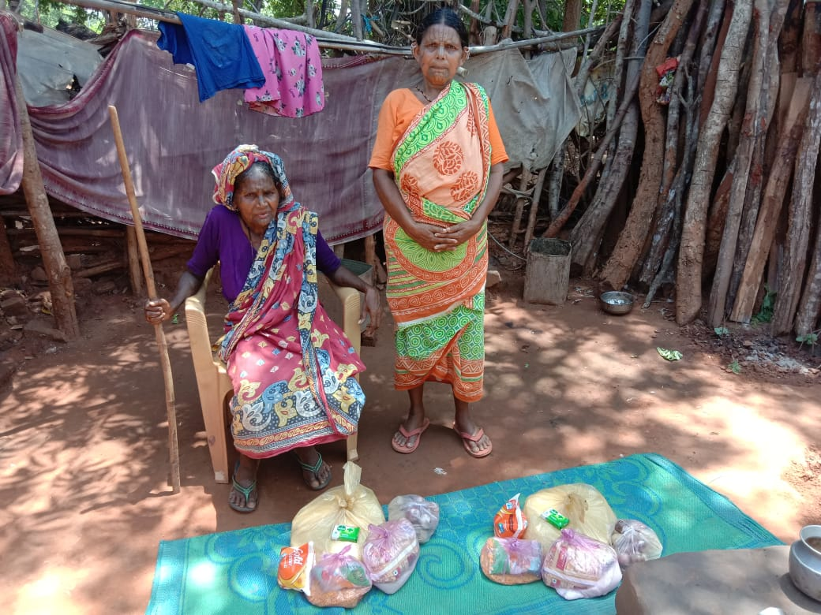
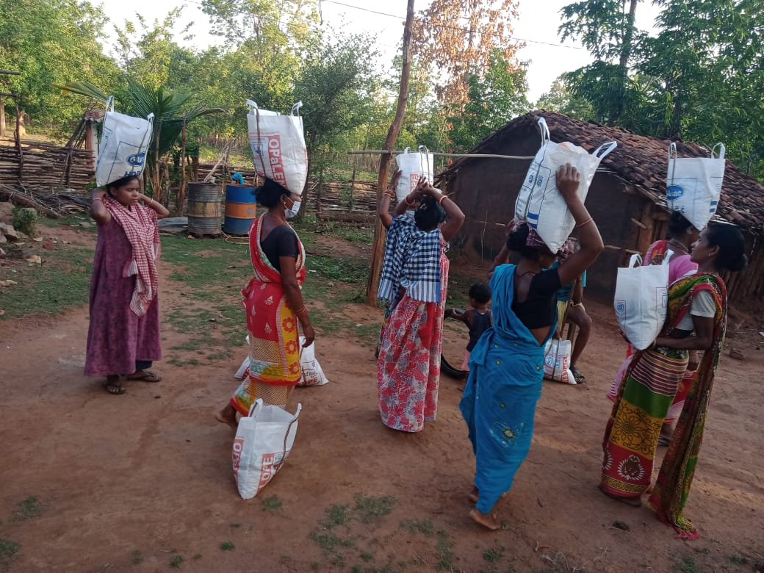
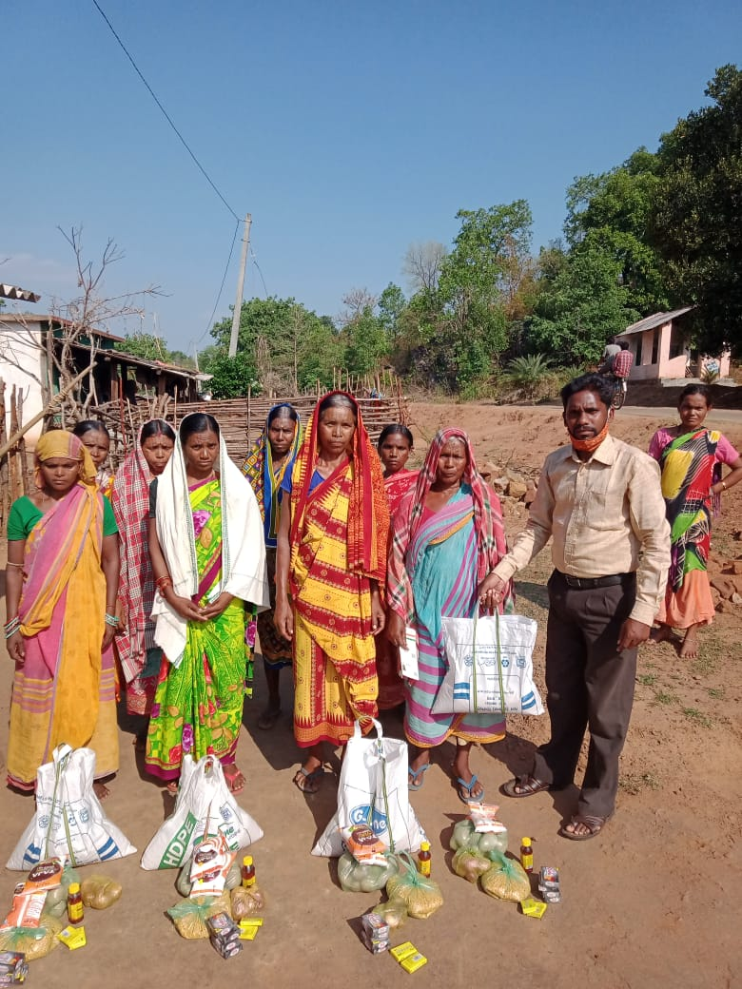
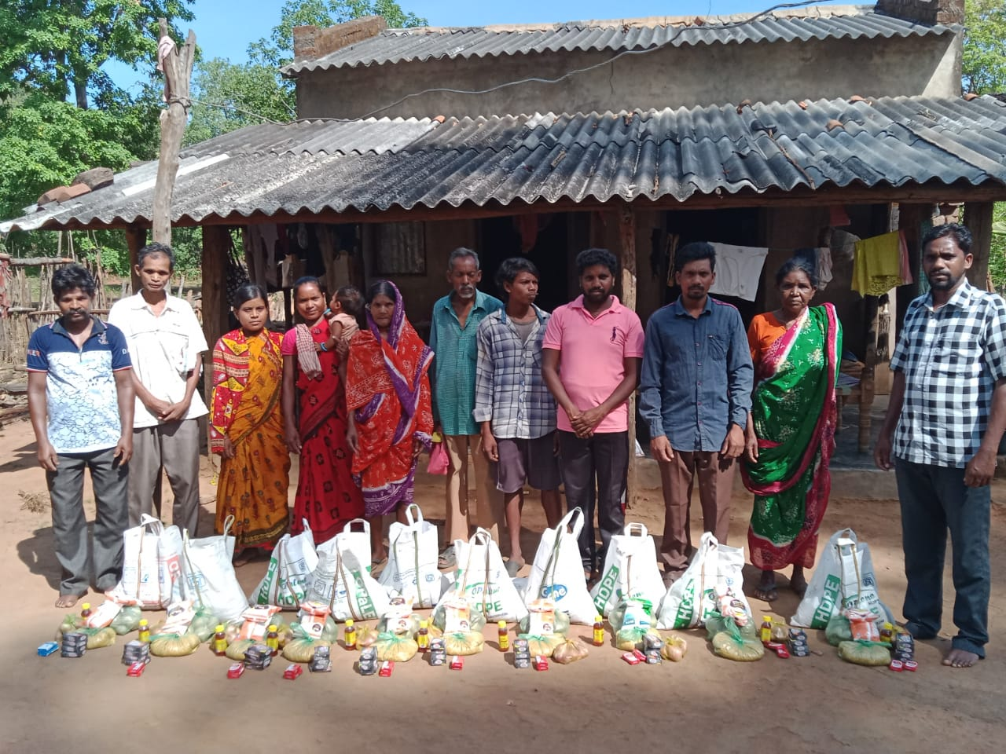
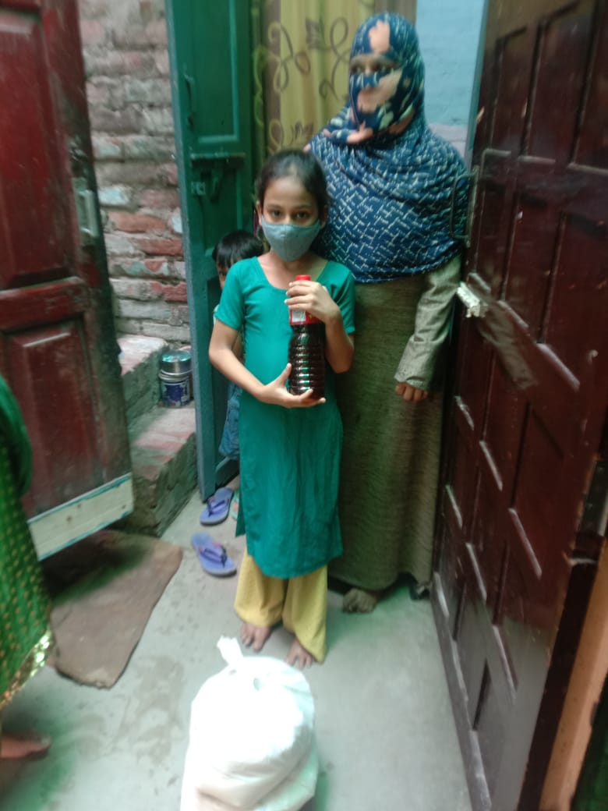
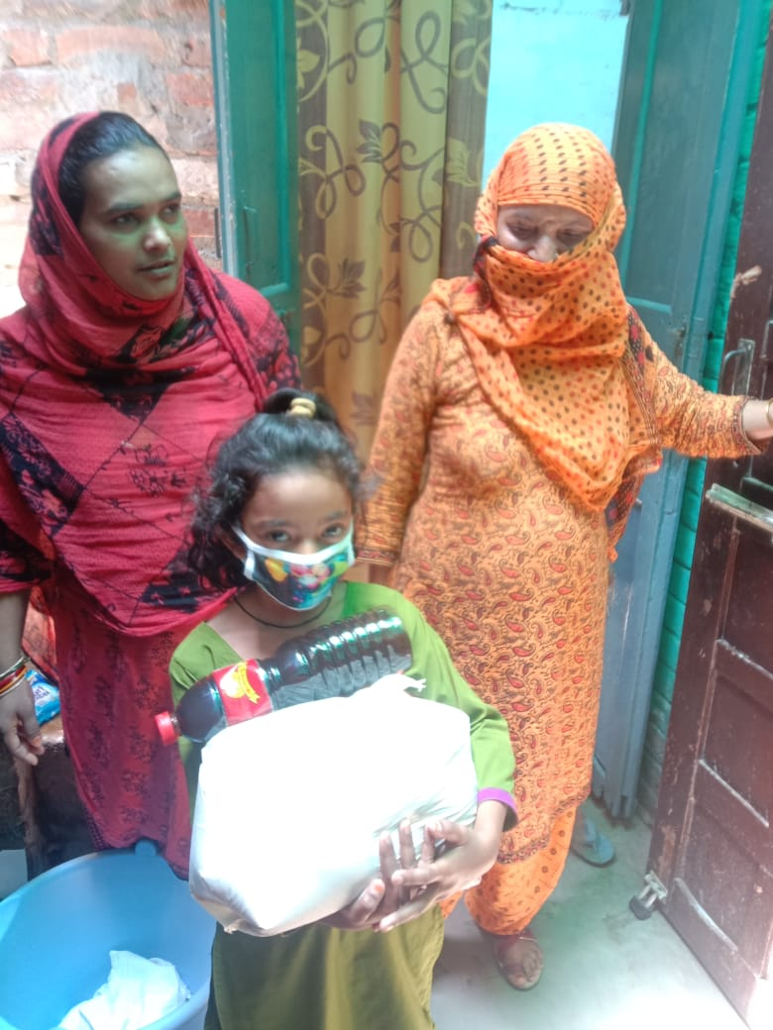
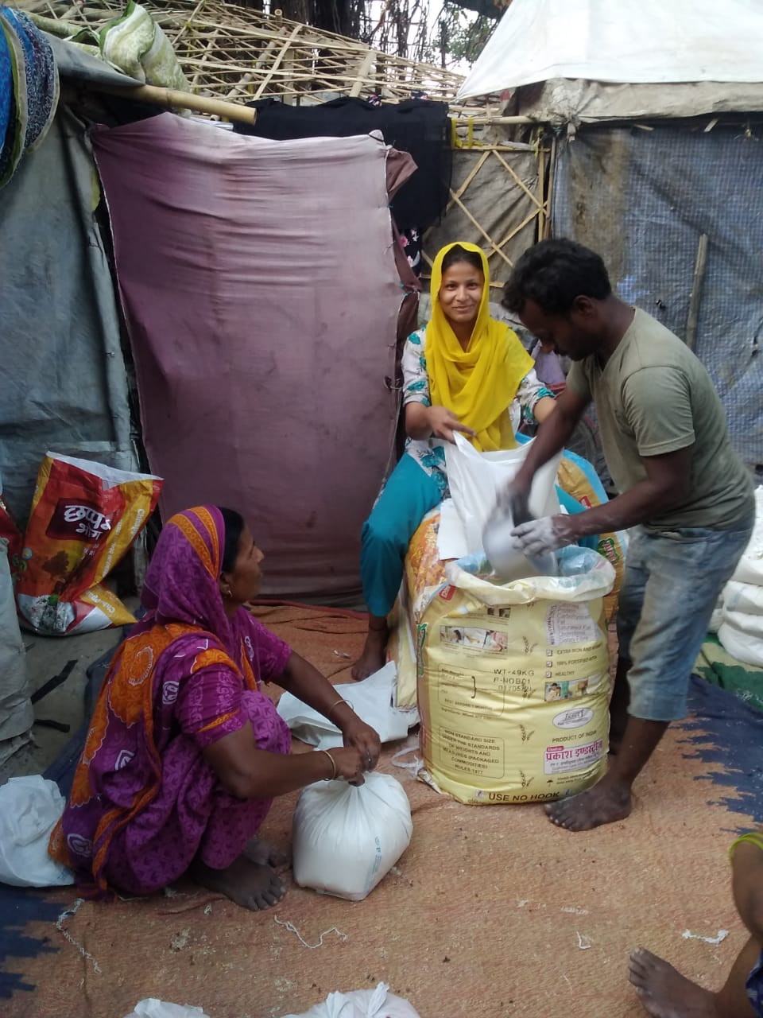
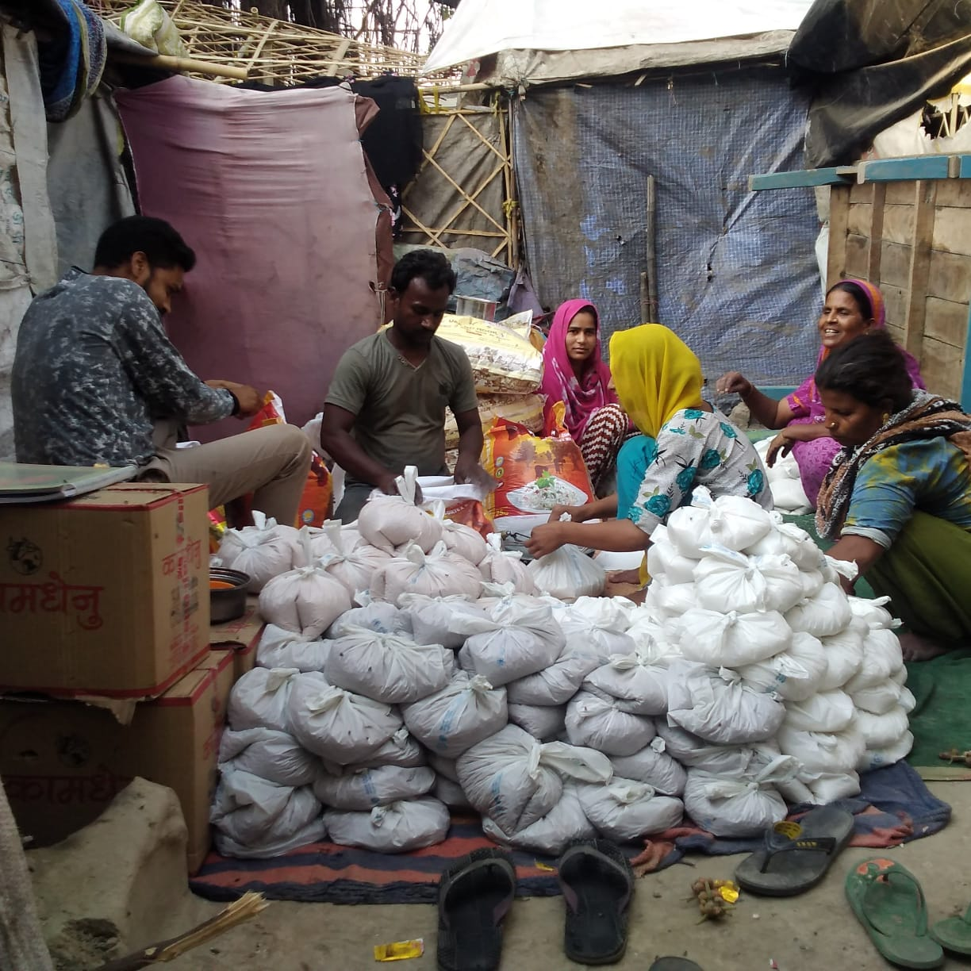
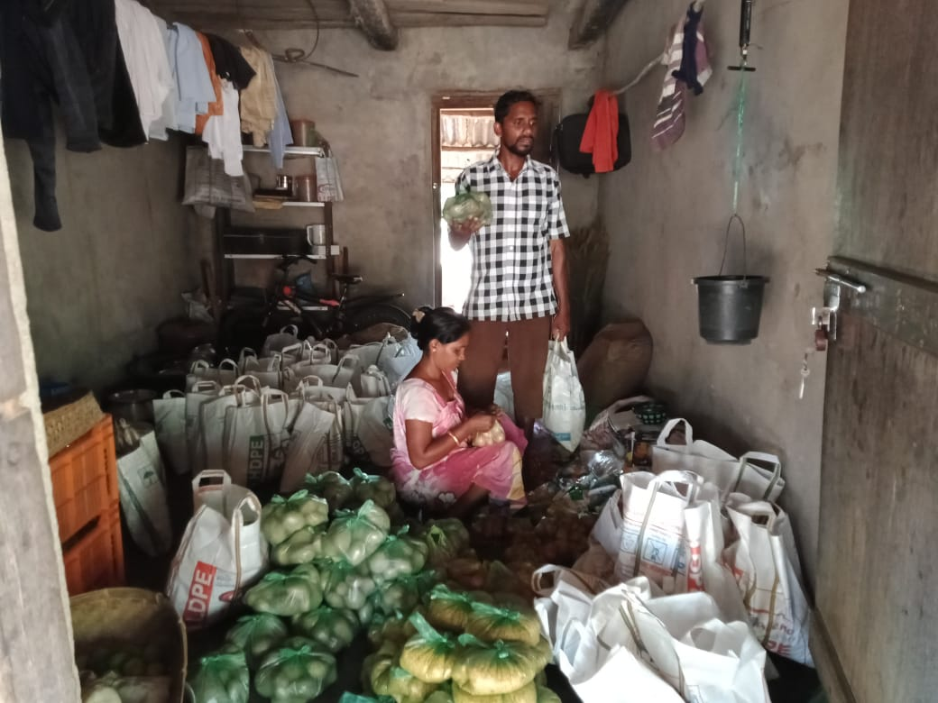

Metadata
zn_page_layout | default
zn_sidebar_select | default
zn_show_social | default
zn_zn_disable_subheader
zn_subheader_style | zn_def_header_style
zn-custom-layout | 0

