Praying the News
Author | C Dee
Date | 2020-05-28 03:05:44
Categories | Articles Stories

how privileged I am to have such friends, and hear such stories, to help me keep life in perspective, and keep living and praying for God’s kingdom coming
My friend G phones me from Delhi (Whatsapp voice only, as she’s almost out of internet data and has no money for a recharge) – it’s an interruption as I struggle to finish my essay on Micah 3, and I have no answers at all for her problems. She pours out her complaints, compassion and fears, criticising the inadequate government provisions for the poor during coronavirus lockdown, her own attempts to help people who are falling through the cracks, and fears about anti-Muslim discrimination and violence fueled by viral false news on social media. Her brother, recently married and now with a new baby, won’t have a job to go back to, as his employer has laid off all Muslims. I offer some emotional and spiritual coaching, encouragement to keep responding with love and goodness, to never become the evil we are fighting; in the end I push her to find something happy to tell me about, and she remembers her baby nephew smiling so beautifully at her.
I pray the conversation was in some way life-giving for her, and pray for her safety and knowledge of God’s loving presence. The conversation helps me be grateful for how comfortable and safe my own life is, and also how privileged I am to have such friends, who help me keep life in perspective, and keep living and praying for God’s kingdom coming.
As the news in Australia seems more and more trivial to me, in comparison with what’s happening elsewhere, I’m so glad to have friends in other places who keep me connected to a different perspective and scale of need. With the pandemic relatively under control here, the news is full of “return to normal” strategies, concern about our economy, and the latest murder and traffic accident (which is obviously devastating to the people involved, but not so vital to me).
Even if you aren’t hearing personal updates from friends and family living in poor neighbourhoods in distant places, and the biggest headlines aren’t the things closest to God’s heart, there is other news out there offering great opportunities to learn and pray:

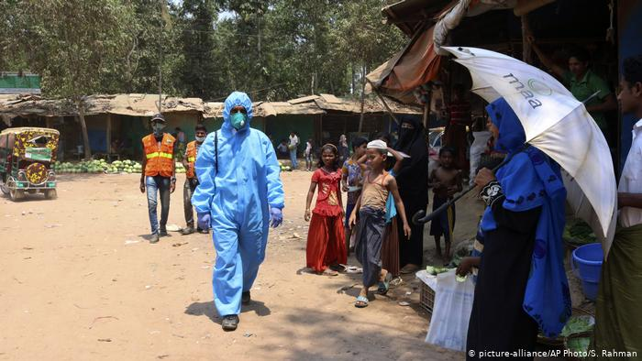
Coronavirus found in Rohingya refugee camp in Bangladesh, a very densely populated and under resourced make-shift city.
Lord have mercy on the refugees who are there seeking safety; grant wisdom to those making decisions; stretch our hearts to continue to care, in the face of such immense needs.

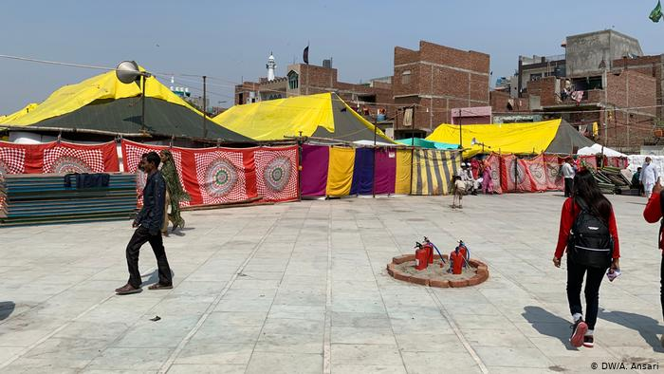
Increasing the tensions already in society – blaming the Muslims in India, and the indigenous peoples in other places.
Lord send your Spirit of compassion, forgiveness and grace, to dissolve the hate and fear in our midst.

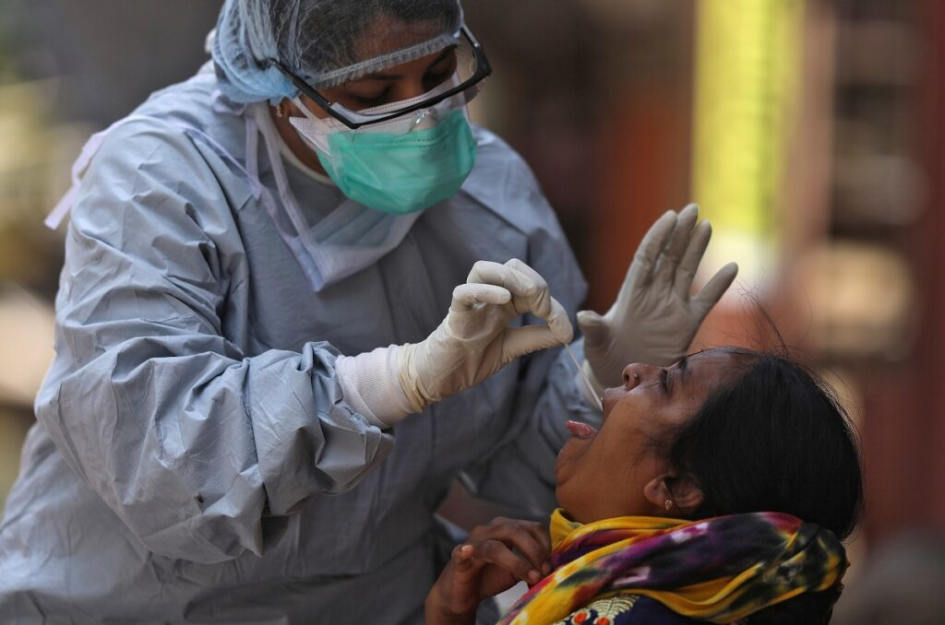
The pandemic spread first among the wealthy who travel, but now has spread to slums; The protective measures and treatment developed are most accessible to the wealthy -how can the poor practise physical distancing shut inside tiny homes on narrow alleys?
Jesus, may we listen to people’s situations and needs, not just tell them what to do.

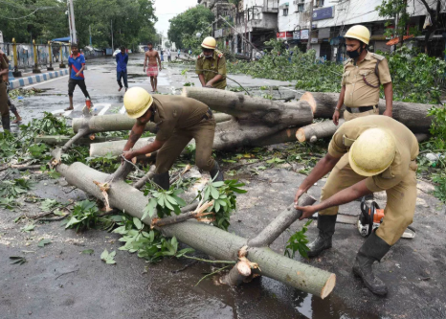
Lockdown didn't stop Cyclone Amphan from striking India and Bangladesh, leading to mass evacuations, and many people losing their homes.
Father comfort those who lost loved ones, and protect those who have lost their homes and possessions.

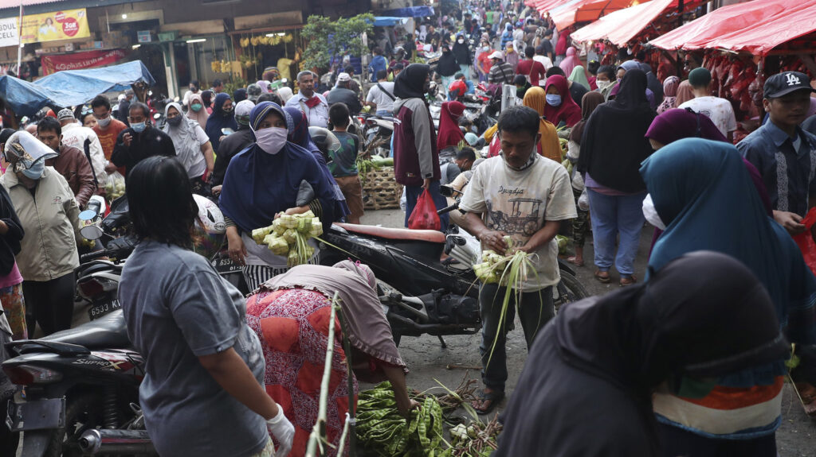
Eid-al-Fitr in Indonesia, and gravediggers doing overtime, but the statistics don’t reflect it.
Lord have mercy on us all, and grant us compassion and courage to meet the trials and challenges we face.

Metadata
zn_page_layout | default
zn_sidebar_select | default
zn_show_social | default
zn_zn_disable_subheader
zn_subheader_style | zn_def_header_style
zn-custom-layout | 0
zn_page_builder_status

