Poverty and Privilege
Author | Admin
Date | 2019-10-14 00:42:09
Categories | Articles India Y Stories
People are often surprised that I choose to live in a slum. Typically, after I explain why I have chosen this life for myself, people express admiration, but also concern for me, along two lines:
- How do you deal with the physical discomfort of living in a slum: the cramped space, noise & smells, intermittent electricity & water, etc?
- Don’t you need to think about your own financial security and future?
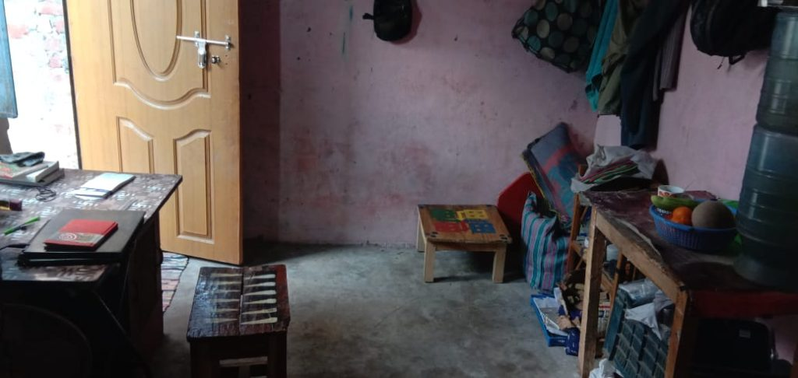
My room
Both questions are well intentioned. However, viewing poverty as physical hardship and privilege as money in a bank account barely scratches the surface. These obvious factors are merely the tip of an iceberg: 90% is underwater, out of sight and out of mind. This article examines some of what lurks under the surface of poverty and privilege, and goes on to ask two questions of my own:
- What is the ‘right’ level of poverty or privilege to live at?
- Can we relationally bridge the huge gulf that exists in our world between poverty and privilege?
Poverty as much more than physical discomfort
It is true that I encounter more physical inconvenience and discomfort than most Australians – or wealthy Indians – due to my choice to live in a slum. I live with two friends in a 3m X 4m room that is somewhat cluttered, making it hard to have time alone, especially with a stream of kids coming to play. I fill drinking water from a tap 100m away, often needing to wait in line for a minute or two. And yes, the electricity does go off at night occasionally, making it hard to sleep. While I’m blessed with a poor sense of smell, my hearing is acute enough, meaning that the frequent loud noises – music from wedding parties, fighting of dogs, the call to prayer, trains rumbling past – can be annoying.
Yet the physical discomforts I share are only a small part of the poor’s problems. I will never (hopefully) know what it’s like to experience domestic violence, or to be addicted to tobacco. I’ll never have to decide between my kids’ education and my parents’ healthcare. I’ll never need to go to a loan shark to help pay for a funeral. Nor will I experience the tension of trying to save money to put on a lavish wedding and maintain my family’s social standing.
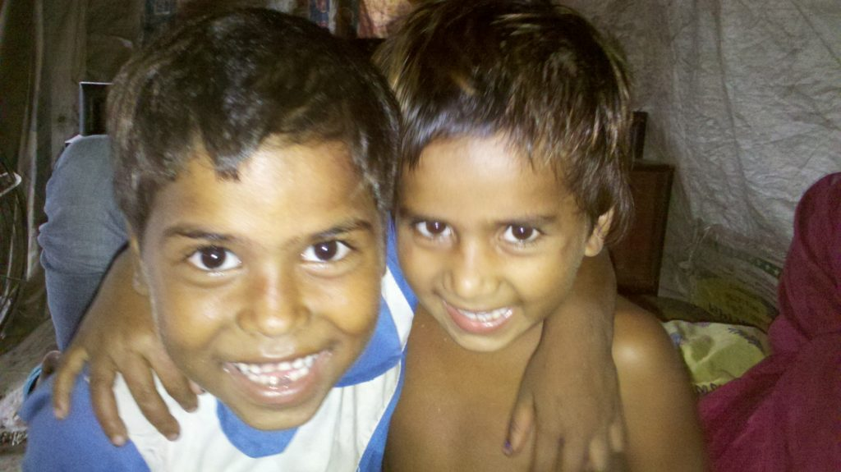
We often have kids visit us
Privilege as much more than money
It is true that I have less money than most Australians – and am deliberately eating into what money I do have. While I have more money than most Indians, even some of my Indian friends express concern at the fact that I’m not earning money.
Yet a high salary or money in the bank is only a tiny proportion of my privilege. I don’t have any fear of spending money, because I have wealthy family and friends who will always bail me out. I have an Australian passport, high test scores, white skin, and good English – meaning that I can slip into a well paid job whenever I wish. I am male, heterosexual and able-bodied. These dimensions of privilege will remain with me regardless of what money I do or don’t have.
A golden mean between poverty and privilege
So we’ve seen that there is a huge gulf between the haves and the have-nots in our world. Inequality is reaching obscene levels, with the wealthiest 26 people on earth owning as much as the poorest half of humanity. But the planet cannot sustain the lifestyles of the wealthy, nor can our consciences condone the ongoing prevalence poverty in an age of plenty. We need a new framework, like that offered by doughnut economics: the goal is for all of humanity to have lifestyles that meet our basic needs which allow us to flourish, without exceeding various planetary boundaries.
Living with simplicity and sufficiency is also vital spiritually. Proverbs 30:8-9 comes to mind: “Give me neither poverty nor riches, feed me that bread which is my portion. Otherwise, I may have too much and deny you, saying ‘Who is the Lord’, or I may become poor and steal, profaning the name of my God.”
So what is the ‘right’ level at which to live? There is no one-size fits all answer: one person’s necessity may be an unnecessary luxury for others. For instance, for me, a TV is not needed whereas my laptop is a key part of my life; I don’t have medical insurance but I do show myself[1] at a private hospital if need be. Here are a few questions I find helpful in placing a certain gadget or service along the spectrum from unhealthy luxury to life-giving necessity.
- Does it help me relate with God or others? Does it help me have fun?
- Would it be sustainable for everyone in the world to have this?
- If I did not have this, how would my life change, for the better or the worse?
Building bridges across the gulf
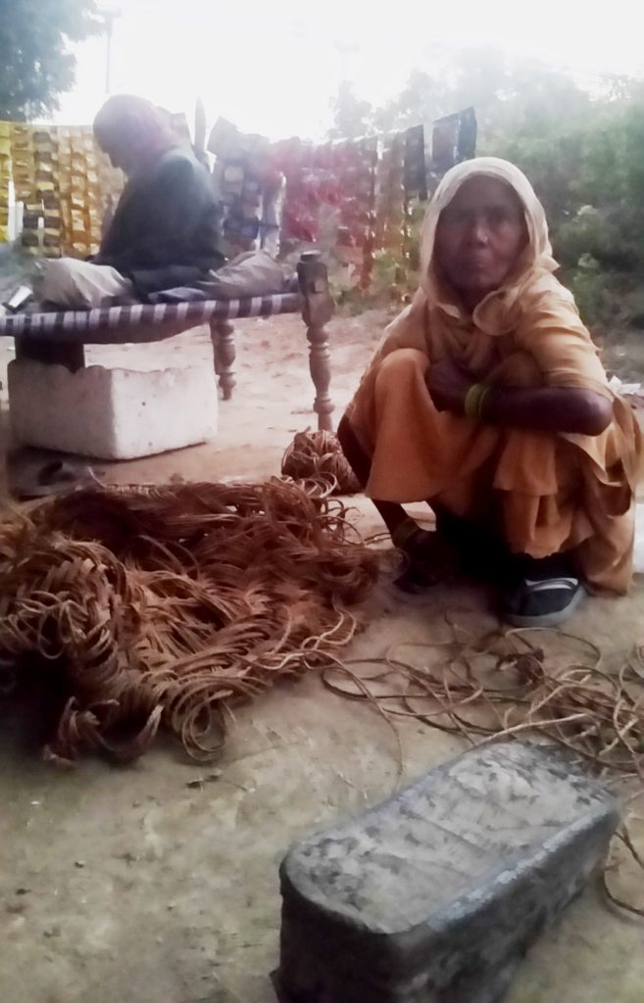
Most people in my community have to work hard just to survive.
While I try to live a life within the “doughnut” of simplicity & sufficiency, it’s clear that I remain privileged at many levels. Does this make my efforts at empathising with the poor’s physical discomfort a mere mockery, a cruel charade of their real poverty? Does it make our reluctance to use privilege for ourselves an infantile fantasy? I think not.
When we’re honest with ourselves – and our neighbours – that we’re not poor, the shared physical experiences open up a space to work together to solve physical, social, economic and emotional problems. Being present in the slum does not make me truly poor, but it does make me available for intervening in medical emergencies and domestic violence, it does facilitate forming relationships across the gulf between poverty and privilege, it does enable me to be more grateful for – and critical of – my privilege.
I cannot eradicate my privilege – and if I’m truly honest with myself, I don’t want to. What I can do is attempt to be conscious of my privilege, and use it for the benefit of others. There is a tension here, insofar as the extent to which I should use unjust privilege for a good cause: for instance, do I use my whiteness to help a friend be more likely to see a good doctor? I don’t have any easy answers here. But either option is better than exclusively using the privilege to benefit myself.
So there is a huge gulf between poverty and privilege: far deeper than the surface-level physical and financial indicators show. Yet there is hope for us who want to follow Christ in bridging that gap. Christ had the ultimate privilege, yet he took on life in mortal flesh, and even submitted himself to death on a cross. We are not Christ, but we can strive, in some small way, to live out lives of simple sufficiency while building relational bridges between the poor and the privileged.

[1]“show myself” is very logical Indian English for “see the doctor” – after all who is looking at whom?

Metadata
zn_page_layout | default
zn_sidebar_select | default
zn_show_social | default
zn_zn_disable_subheader
zn_subheader_style | zn_def_header_style
zn-custom-layout | 0
zn_page_builder_status

