Pandemic Politics & Prayers
Author | C Dee
Date | 2020-05-02 04:49:43
Categories | Articles COVID-19 Pandemic Philippines

"We aren’t going to die because of the Coronavirus, we are going to die of hunger", quintessential Filipino sarcasm quips the predicament of the poor.
“Hindi kami mamamatay sa Corona, mamamatay kami sa gutom.” We aren’t going to die because of the Coronavirus, we are going to die of hunger. With quintessential Filipino sarcasm, my former host-mom gave this exasperated aside the day the enhanced community quarantine over the entire Metro Manila area was announced. This is the current predicament of the poor summarized in her fatigue and sarcastic humor.
Many of the people living in our community, Barangays Holy Spirit and Commonwealth, are day-wage laborers. They’re vendors and drivers. They live hand-to-mouth. And because of the current suspension of public transit and restricted movement under the current ECQ, practically all of them are out of work and are struggling to feed their families. And now with Duterte exercising even more extraordinary powers, he has even threatened to kill anyone who doesn’t follow his orders. Our president is more concerned about murdering deviants than he is about providing mass testing and food relief. It may not be by this pandemic, but by bullets and hunger that bodies will be counted should this current trend continue.
The government response has been practically pitiful. Of course, excuses are made, like there being too many people an execution of relief a nightmare. But since every level of Philippine government rarely works well for the people who need it most, pandemic or no pandemic, how could we realistically expect any better during this unexpected crisis? Our local Barangay halls, the weakest and least-funded government sector, have been tasked with the brunt of providing relief. And while they do get funds from the City and National governments, local leaders have told us that the money is held by various hands, and miraculously, not all of it makes it to the people who actually need it. That’s politics for you.
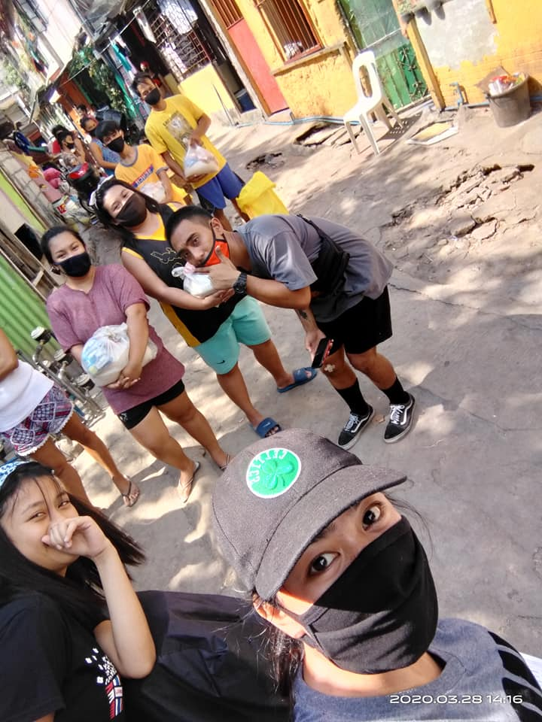
distribution team hits the alleys
As a team we’ve tried to do what we can. We’ve been partnering with our neighbors, friends, and local leaders throughout our Barangays to provide some food relief to families in need. We have what are called “Purok Leaders” (community representatives with the Barangay Halls) and Homeowners Association leaders that we’ve been partnering with in our relief projects. Usually, one of these local leaders oversees 200-300 families. And as we’ve been making our rounds through various neighborhoods, it’s become very apparent how ill-equipped and under-resourced our local community leaders are, despite their being the closest to the people our government is supposed to be serving. They deal with the complaints and sob stories. They have to give the excuses and explanations as to why relief from the government still hasn’t come.
And yet, amidst all of this, my neighbors still smile. It is painfully beautiful to witness the gift my fellow Filipinos have in smiling in the face of crisis and tragedy. Even under the worst of circumstances, they don’t forget how to crack a joke and laugh. During one of our relief trips, one beautiful little girl gave us a huge smile that covered nearly half her face when we handed her our simple bag of rice, instant noodles, and sardines. In these moments, I see the humanity that is so easily forgotten amongst the shanty houses and tiny alleyways of our community. The very image of God so thoughtlessly overlooked. And yet this is what has been happening over and over again for many lifetimes. Both here and in so many other places.
Even before all of this happened, I started reflecting on the story of Jesus feeding the 5,000 with just five loaves of bread and two fish that a little boy gave him. I felt like I’m that boy, having such little to offer but still begging Jesus to feed my people with what I have because they are hungry. I wrote these lines in my journal:
“This is all I have to give
I know it doesn’t look like much
But I’ll give it all to You”
This is my simple prayer. “Panginoon, pakainin Ninyo ang aking mga kapwa’t tao”. Lord, feed my people. I invite anyone who shares the faith that this simple prayer is heard to join me in it.

Metadata
zn_page_layout | default
zn_sidebar_select | default
zn_show_social | default
zn_zn_disable_subheader
zn_subheader_style | zn_def_header_style
zn-custom-layout | 0
zn_page_builder_status

