On-the-job learning for Urban Ministry
Author | C Dee
Date | 2021-03-19 00:30:20
Categories | Events Past Events

Apply by 1st April
These two great courses are starting soon, offered completely online, and designed for studying alongside your existing life and ministry commitments. They are part of the MATUL program (MA in Transformational Urban Leadership) at William Carey International University, which is a hands-on opportunity to study and be mentored while actively engaging in the work of Jesus in informal urban neighbourhoods - anywhere in the world.

BUILDING FAITH COMMUNITIES
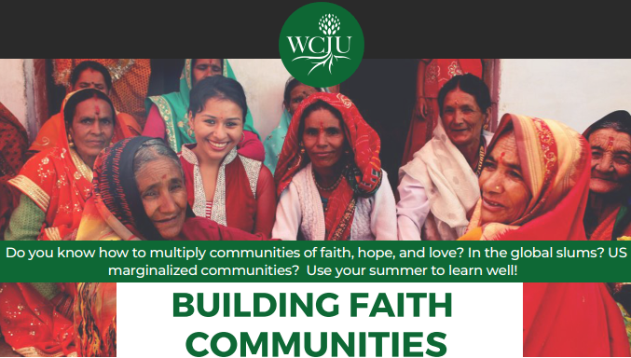
Do you know how to multiply communities of faith, hope, and love? In the global slums? US marginalized communities? Use your summer to learn well!
This 15-week online course applies a story-telling approach to the process of entering poor communities and developing holistic poor peoples' churches in ways faithful to the values and goals of the Kingdom of God. Entrance, proclamation, and discipleship are considered in relation to the processes of small-group formation and leadership development.
For more information, download the flier.

URBAN SPIRITUALITYhands-on opportunity to study and be mentored while actively engaging in the work of Jesus in informal urban neighbourhoods - anywhere in the world.
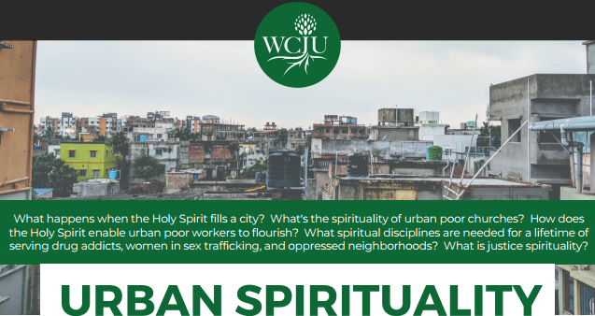
What happens when the Holy Spirit fills a city? What's the spirituality of urban poor churches? How does the Holy Spirit enable urban poor workers to flourish? What spiritual disciplines are needed for a lifetime of serving drug addicts, women in sex trafficking, and oppressed neighborhoods? What is justice spirituality?
This 15-week online course expands theologies of the Holy Spirit and his work among the urban poor. It emphasizes care and nurturing of workers, practical application of the spiritual disciplines, and communicating between diverse
understandings of the work of the Spirit.
For more details, download the flier.

Applications close 1st April
Questions? Email Emily at emily[dot]graham[at]wciu[dot]edu

Metadata
zn_page_layout | default
zn_sidebar_select | default
zn_show_social | default
zn_zn_disable_subheader
zn_subheader_style | zn_def_header_style
zn-custom-layout | 0

