New Zealand
Author | Jason Porterfield
Date | 2013-04-17 10:11:54
Categories

AOTEAROA NEW ZEALAND
This is where it all began. Birthed within our local churches, Servants now has a rich and diverse heritage in Aotearoa New Zealand, with membership spanning all generations. Over 30 years of living among Asia's urban poor has not only informed the nature of our involvement in Asia, but has also shaped expressions of the kingdom here 'at home'. In relationship with local churches and intentional Christian communities, Servants has shaped and been shaped by those seeking to follow Christ's call to costly discipleship within NZ. Around thirty people are part of the NZ team with many more in a looser network of partners and fellow travellers inspired by Jesus' journey to the poor. The purpose of the Servants NZ office is to support and encourage Kiwis working with Servants teams in Asia, and to be an advocate for the needs of their urban poor neighbours. We are also committed to promoting the Servants principles and values within our own contexts, seeking to encourage intentional Christian communities among the poor in NZ.

How you can be involved with Servants in NZ:
- Support us in prayer: sign up for our prayer newsletter, and join a Servants prayer group in your region.
- Support us on the ground: sign up to our contact database, attend upcoming events and join in with our community in your region, and invite Servants to talk about our principles and values with your church/community.
- Support us financially: contribute to our work within NZ and Asia.
- Become a 'Friend of Servants NZ': a community across NZ of those who identify with the Servants vision, principles and values.
- Join one of our new Servants teams in Asia: See our Asia teams page.
For more information about any of these opportunities, or simply to say gidday, please contact a member of our team on the details below:

Servants NZ Leadership Team
Servants NZ Leadership team is
- Shannon Mawdsley - Auckland
- Paul Mather - Wellington
- Anne Morrison - Dunedin
- Susan Jack -Dunedin
- Kristin Jack - Dunedin
- Francois Viljoen - Auckland
- Susannah Connolly - Auckland (Servants Elder)

We'd love to hear from you
For Contact Details see the "contact us" page. For details on financial support and donations, please see the Financial Partners page, or contact finance.nz [at] servantsasia.org
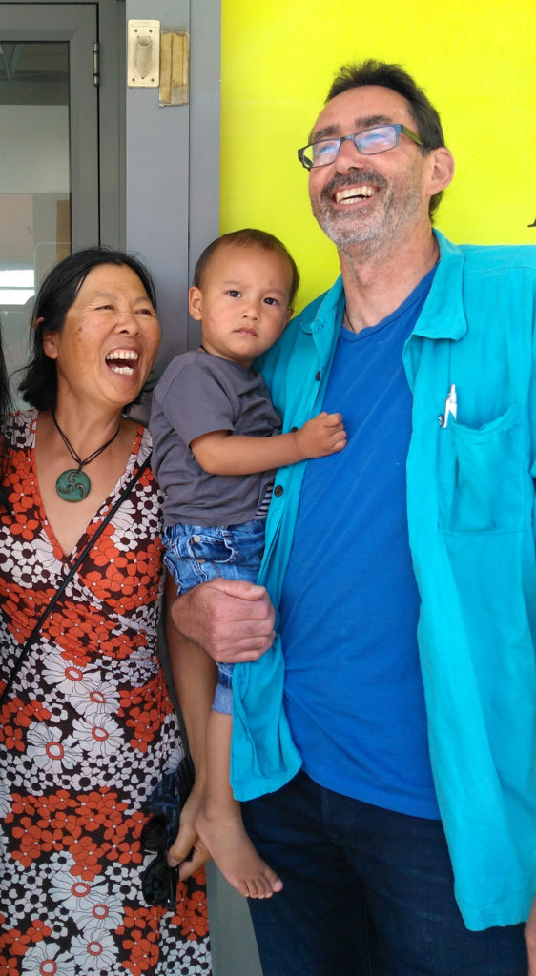
Paul and Wendy Hing-Mather
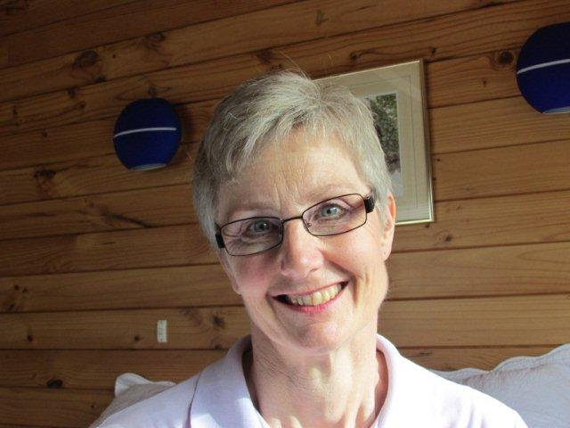
Anne Morrison
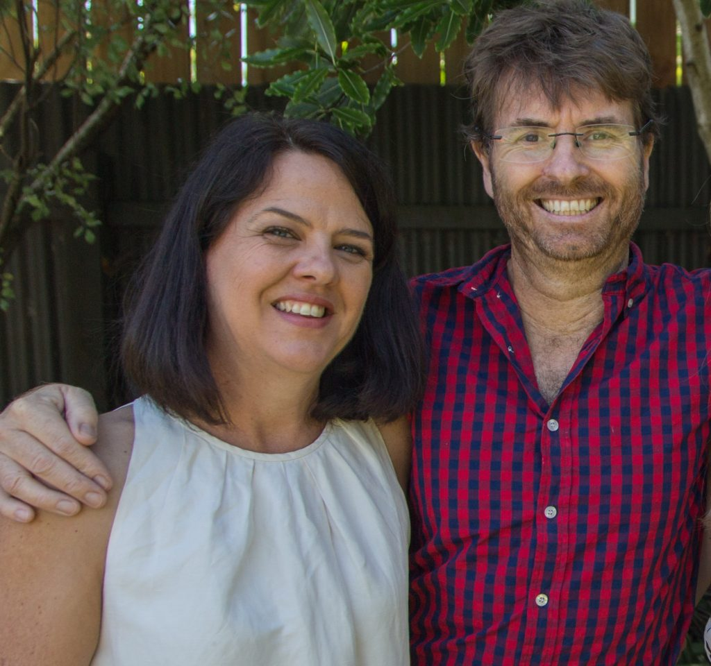
Susan and Kristin Jack

Metadata
zn_meta_elements | Array
zn_page_title_show | no
zn_page_title
zn_page_subtitle
zn_zn_disable_subheader | no
zn_page_layout | default
zn_sidebar_select | default
zn_page_builder_layout | default
zn_subheader_style | zn_def_header_style
zn_page_override_boxed_layout | def
zn-custom-layout | 0
zn_page_builder_status

