Meet the Sheep: Yusuf*
Author | Admin
Date | 2020-02-14 01:26:29
Categories | Articles Indonesia Stories
Here's a story from October, 2018 by Servants' Indonesian team
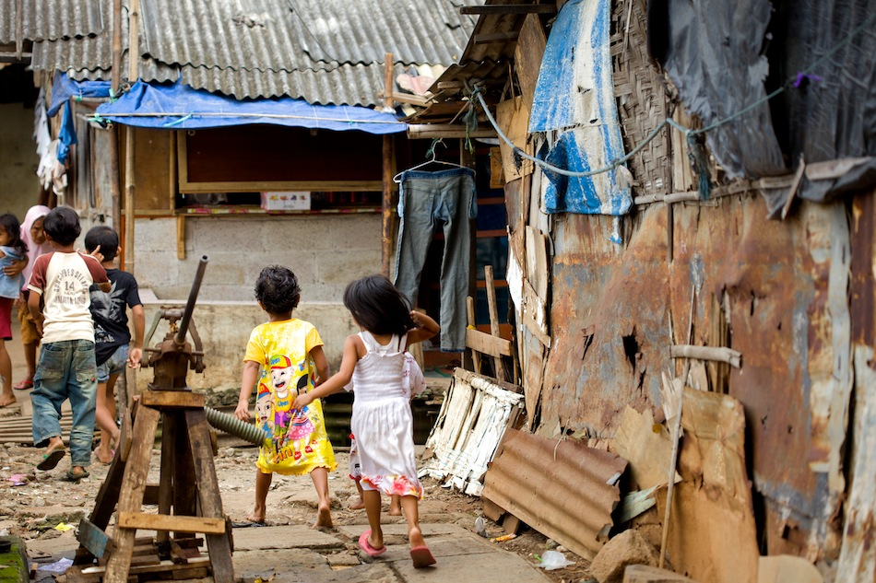
Today we went to Lapangan Satu (“Field One”) after lessons were over. We all rode our bikes, as the sun had dried up most of the mud already. Every time we go to Lapangan Satu, we are amazed at the continual expansion: new shacks built on top of trash, and single story homes turned into two-story. Six years ago there really was a field here, but now all that remains of the field is the name.
Yusuf has been coming to House of Hope for a year and a half. His mom has a loud and combative personality, very different than the quiet reserved stereotypical Javanese or Sundanese mom. At first, I did not like that, but since getting to know their family, I now really appreciate Mama Yusuf. She works hard, on top of the trash heap next to their house, searching for recyclables. Some mornings Yusuf doesn’t come to lessons because his mom is still working, and he doesn’t want to bike the journey to school by himself.
Last year their home was at a very low place - literally lower than all the others around it. In rainy season this meant constant flooding. From the back of the house they got flood water from the canal that runs through the neighborhood. From the front of the house they got runoff rain water from the trash heap, flooding their house with black, maggoty stinky water. This year they moved next door to a little higher ground. Rent costs $10 a month, paid to Mama Yusuf’s older sister.
Bapak ('Papa') Yusuf is a trash collector and so is Yusuf’s 16 year-old brother. They each get a monthly salary, probably around $70 each. Yusuf’s brother dropped out of school after grade 4. Will Yusuf follow those same footprints? He already skips school too often, and one day I fear he will just stop appearing.
When we took the field trip to the swimming pool two weeks ago, Yusuf loved it! He did the slides, but most of the time he just flopped around in the shallow edges of the pool- soaking up the water with joy all over his face. He was the last to get out, and that only because we had to go home.
Today as our boys played with his toys (some purchased, but many scavenged from the trash), Yanni and I tried to have a conversation with Mama Yusuf. The blaring TV soap opera created a large and obnoxious distraction- essentially making any real conversation impossible for me. What is the polite thing to do in such a situation? Ask them to turn off the TV? Or just struggle along trying unsuccessfully to tune out the TV?
Last time we visited their home, Simeon felt comfortable enough to want to use the bathroom. The “bathroom” is at the back of the house, literally built over the canal. A hole in the plywood floor serves as toilet, and as I held onto Simeon it was hard not to imagine him dropping into the disgusting water beneath us (it was definitely a big enough hole). It was a bonding moment for us with Mama Yusuf’s family, however; and a reminder of how children open doors (literally) that might otherwise be closed to us.
*Names have been changed to protect privacy.
Look out for the next installment, coming soon.

Metadata
zn_page_layout | default
zn_sidebar_select | default
zn_show_social | default
zn_zn_disable_subheader
zn_subheader_style | zn_def_header_style
zn-custom-layout | 0
zn_page_builder_status

