Meet our workers #2
Author | C Dee
Date | 2020-11-01 21:49:41
Categories | India Y Indonesia Past Events
How can you visit the slums of Indonesia and India, with no hand-sanitizer, flights or border crossings required?
On Nov 14th, there's a great opportunity to talk to some of our frontline workers by Zoom.
In July we hosted three amazing conversations, where supporters and other interested people met with a few of our workers online, to hear stories and ask questions. It was such a great time, we're keen to do it again.
Talk to either (or both) Rahma and her family in Indonesia, or Yoosuf in India (names changed for security reasons). They will share some stories and photos about their experiences responding to Covid and a bunch of other issues they've been dealing with over the last few months. You'll also be welcome to ask them any questions you want and to pray for them. Mark will facilitate both sessions.
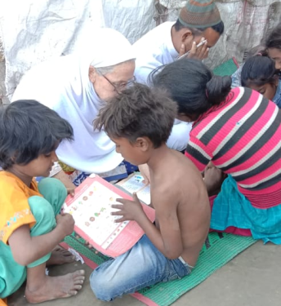
The times are:
Rahma and her family in Indonesia: Sat Nov 14th, 8am Jakarta time
(check your timezone)
Yoosuf in India: Sat Nov 14th, 10am India time
(check your time zone)
Please note times are local time in India or Indonesia - if you are in North America, it will be Friday evening. Click the 'check your time zone' link and type your city in the "add another city" space, to get the time wherever you are.
To book your place on the Zoom, e-mail Mark at events[at]servantsasia.org .

Metadata
zn_page_layout | default
zn_sidebar_select | default
zn_show_social | default
zn_zn_disable_subheader
zn_subheader_style | zn_def_header_style
zn-custom-layout | 0
zn_page_builder_status

