Lock-down Losses for Manila’s Children
Author | C Dee
Date | 2022-06-13 00:05:00
Categories | Articles COVID-19 Pandemic Philippines Stories
[Story contributed by Kathrin in Manila]

Pedro
I would like to introduce you to our 11 year old Pedro (name changed). He lives in Manila with his parents and a much older brother. Both of his parents are working and Pedro lives in a small concrete house. His grandmother is looking after him while his parents are gone. He is finishing Grade 5 this month in a public Elementary school. Since beginning of Grade 4 his classes are online because the government closed all school during the lock-down caused by the pandemic. After the lock-down was lifted the government didn’t reopen the schools. Only this March 2022 some schools returned to face to face classes with half of the pupils in each class.

Learning without a teacher
Pedro needs to answer weekly worksheets (modules) for all his subjects. There is not sufficient explanation or instructions from the teacher regarding new topics therefore his mother needs to help him with his worksheets. During this two years he had almost no personal interactions with his former classmates and teachers and not much physical exercise. His mother, a fearful lady, shared her anxieties with her son during the pandemic and now he is also afraid of many things, some very simple things like a swimming pool or a bike.

Friends?
When his mother is working, he entertains himself by playing internet games, watching YouTube videos, etc. He has discovered the animated world and the characters there are now so real that they are replacing his school friends. When he is alone he is talking to his animated friends like visible people.

Boredom, loneliness and Fear
Pedros’ assignments are getting more and more difficult each year. He lost interest in his classes and assignments and in answering the worksheets. His mother was starting to do them already in Grade 4 in order for Pedro not to be dismissed from school. In Grade 5 the family hired a tutor for Pedro on several days per week. Pedro has had almost no interaction with children of any age during this past two years. He has lost interest in learning and exploring new things. He is feeling lonely and bored, and fears anything he has not yet experienced.

Finding help
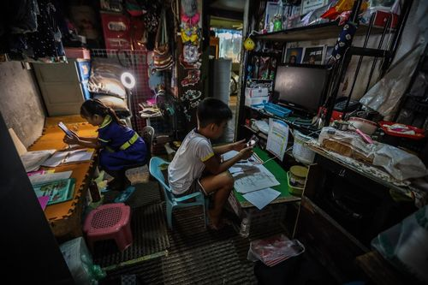
His mom called me and asked for help in April. Since May Pedro is now able to go to school two days each week because his mother insisted that he should be included in the physical attendance group. It would be good if Pedro could attend other physical activities with his peers and develop friendships. This month he will be in the music class of our community with other children. His mother wanted the advice of a child psychologist. She has already been waiting for an appointment for more than two months.

Grace
Another example of what life is like for the children of our community, is a 13 year old girl. Grace (name changed) finished Grade 6 in a private Elementary School with online classes and in the second year of the pandemic her parents moved her to a public High School with modules and some online classes. She has never seen her classmates and has no friends in this new school. Her parents are also both working.

Loss and fear
Her grandfather died during the first year of the pandemic. He was the one who brought her to school every day and picked her up again before pandemic. She misses him very much and she is afraid that she will die like him, an unexpected and sudden death. She has now a tutor who helps her with the modules, but the rest of the day she spends with her i-pad. Out of loneliness and boredom she is looking for friends in social media. Since February, children are allowed to leave their homes again, but they don’t know any more what could be done outside and who to meet.
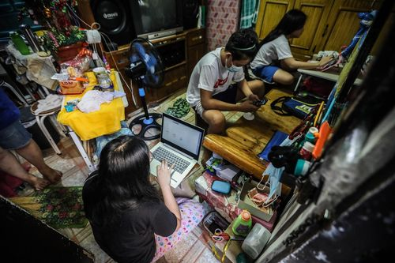

Lock-down Impacts
There are thousands of examples like Pedro and Grace in Manila. The direct health impacts of the coronavirus affected children the least. But in the long term they are the ones who suffer the most from its consequences. The lock-down and its implications affected the educational inputs and the development of children’s cognitive and socio-emotional skills. The purely online classes are creating children without the ability to express their needs, emotions and without interaction with others (classmates and teachers) on a personal level. They cannot compare themselves with others the same age to develop a healthy a self-esteem. They have almost no room to explore different things and this creates fear of unknown experiences.

The challenge to respond
We are challenged to help these children develop socio-emotional skills again, along with allowing them to physically meet and play, to develop friendship among their peers and to explore new things and get them into unknown adventures.

Metadata
zn_page_layout | default
zn_sidebar_select | default
zn_show_social | default
zn_zn_disable_subheader
zn_subheader_style | zn_def_header_style
zn-custom-layout | 0

