Life without a choice
Author | Admin
Date | 2019-10-31 01:47:05
Categories | Articles Asian Voices Philippines Stories
One day after I finished work, I suddenly decided to walk from the office in Cubao all the way to our team house in Barangay Holy Spirit for me to observe things on the way and to reflect on things as well. It took me almost 3 hours to get home.
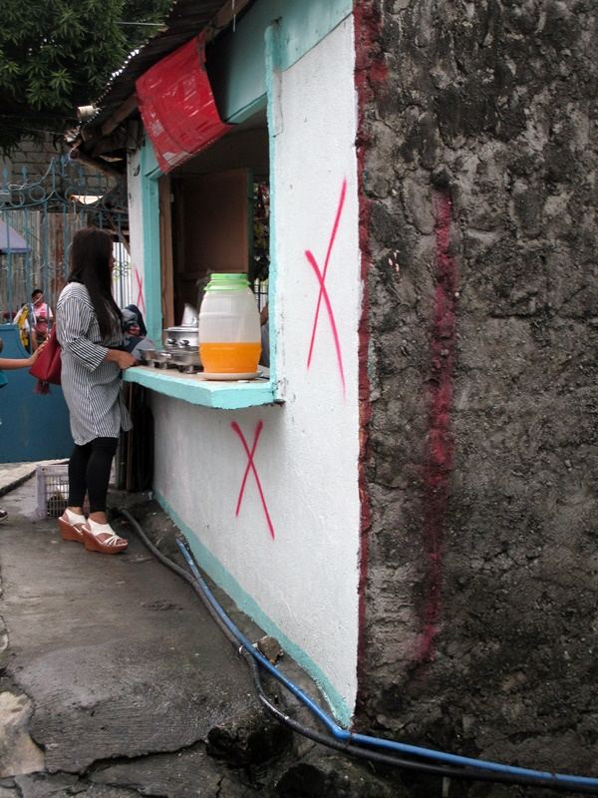
Marked for Demolition
The walk alone showed me a lot of realities and truths about this country. The Philippines Government recently implemented the law that demanded the clearing of all sidewalks from illegal vendors and structures that are beyond the line of the road. Most of those illegal vendors were just striving with the little income they made from selling their goods each day, so they could have food for their families. Because of this law, you could see some vendors carrying their goods just so they could sell and have some money to sustain their needs. I also saw a filthy man sleeping in the edge of a plant box along the Hi-way, no shelter and no bed, he seems hungry, alone and helpless.
It was really an eye opener, seeing those people on my way home. The realities on the street are different if you are just passing by in a nice air conditioned vehicle, or looking closely, walking alongside them. You could also see the hardship of the locals who wrestle with other commuters and wait for hours just so they could ride the bus or jeepneys to get home. These things are just some of the issues among the poor that they are facing and are just neglected by the powerful ones. Most of the oppressed people are just accepting the reality that they exist in this world without a choice.
It is hard, seeing people in that kind of situation. I felt helpless too when I saw them. It also made me realize that some people in the world are living with luxuries of life, some are just striving to survive each day and some of them are living their lives without a choice. It will be easy to see and feel their stories if we are open and brave to walk with them. This will help us realize the blessings we have and the things we are taking for granted.
These realities became a burden in my heart and it makes me pray for them. I don’t know what exactly their needs are, my prayer was just, “Lord, You know us fully well and You alone know what our heart cries. Be with us and be with them. Give them the strength to carry on their everyday lives. Intervene in their lives, make them see the love that You have for them.
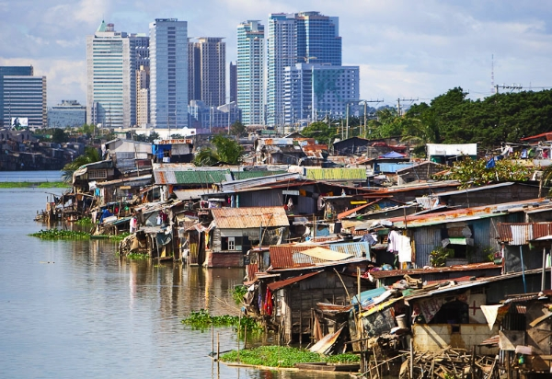
Slum and city.

Metadata
zn_page_layout | default
zn_sidebar_select | default
zn_show_social | default
zn_zn_disable_subheader
zn_subheader_style | zn_def_header_style
zn-custom-layout | 0
zn_page_builder_status

