Models for Making a Large Impact Part 2: Publisher and Pebble
Author | T Dee
Date | 2023-01-28 03:27:54
Categories | Articles Stories
Last week we considered two ways to strive for a large impact – being a philanthropist (giving away a large amount of money) or physicist (inventing useful technologies). But perhaps money and technology are not particularly effective in changing people’s attitudes and behaviours. This week we turn to two ways to try to influence a large number of people.

The Publisher: using mass communication for massive good
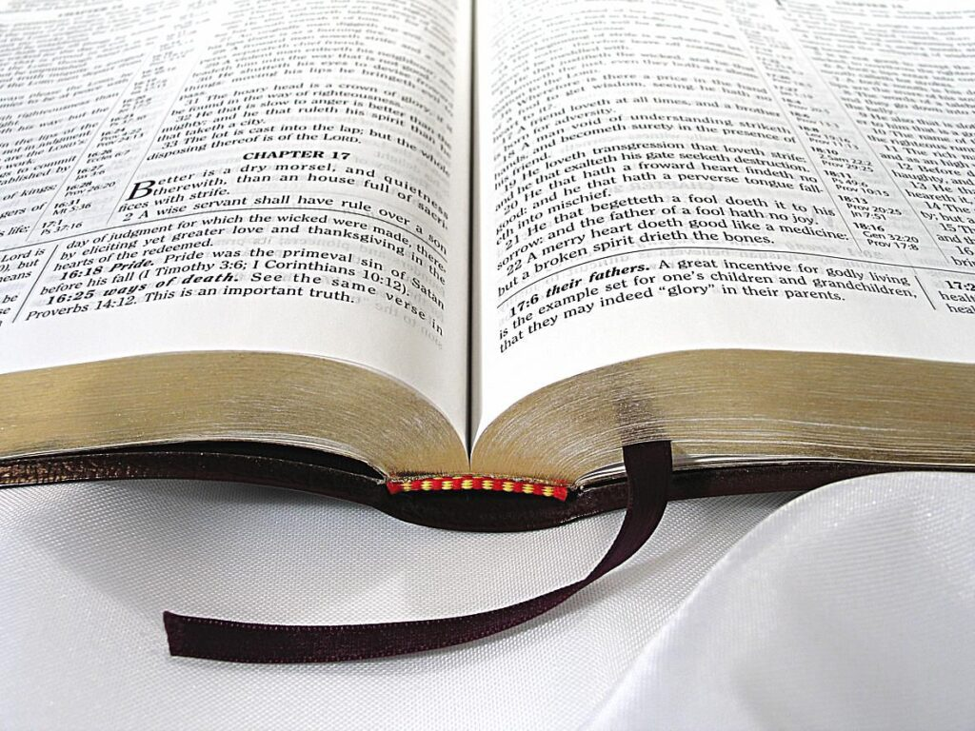
Rather than employing people to teach kids how to read, or developing technology to assist self-learning, another possibility is to motivate and mobilise a lot of other teachers through mass communication. Indeed, I have co-authored a book, Disruptive Literacy, trying to get more people involved in a literacy movement.
Writing books is an approach that many Servants folk have used to get the word out – from Viv Grigg’s classics to the more recent Beyond Our Walls: Finding Jesus in the Slums of Jakarta. Casting a broader net, the authors of the Bible (comfortably the world’s most-read book) have made a huge impact on human history. As with technologies, though, the impact of a book often transcends and sometimes contravenes the author’s intentions – I think Marx would have been turning in his grave at the sight of Stalin’s USSR!
Other forms of mass communication may be much more effective at reaching a large audience – I’m told that most people don’t read books these days! While I have declined to get on any social media platform except WhatsApp; several friends have advised me that I should be on Facebook, Twitter or YouTube if I really want to get a message out.
Social media may allow us to get a message out farther and faster than ever before. But it also means that we are competing to catch and hold people’s scattered attention amidst a sea of news and views.
Broadly, there are three main ways that mass communication can make an impact:
- Hands: Equipping people with better skills to achieve their goals.
- Head: Persuading people of better goals that align with their attitudes.
- Heart: Inspiring people to change their attitudes.
To continue with the literacy example, heart could mean a desire to serve the poor, head might mean an understanding of how important the skill of reading is, and hands might be a specific set of materials and methods that enables literacy to be taught swiftly.
In general, I’d suggest that having a large audience through books and social media can be helpful in the ‘hands’ and ‘head’ realm, but it is unlikely for someone to change their ‘heart’ because of something they read or watch. Instead, most attitudinal change comes through relationships.

The Pebble: a ripple effect

Another potential model for helping a lot of people learn to read is a ‘pass-it-on’ system. Suppose I teach two people how to read, and in return, they promise to teach two others in the next 6 months. In turn, each of these second-generation learners teaches a further two, and so on. In this sort of benign pyramid scheme, India’s 250 million illiterate people would become literate in 14 years.
Like the surface of a lake rippling outwards over a large area with the drop of a single pebble, we can have a large impact if those we touch in turn touch others. This idea has been popularized in the Hollywood movie, Pay it Forward, in which a school student helps someone and asks for it to be ‘paid forward’ rather than ‘paid back’.
The Pebble acts like the Publisher, in terms of seeking to get a message out. But she speaks to the heart not the head, targets the few not the many, focuses on quality over quantity, and trusts that the message will spread itself.
Perhaps the best example of this model is Jesus himself. Jesus only interacted directly with a few thousand people over his lifetime. Even within his inner circle of 12 disciples, he seemed to focus a lot of his energy on Peter, James and John. The deep impact Jesus had on his handful of disciples rippled outwards through space and time, changing the course of history. Rather than directly reaching billions through a divine megaphone, his message has spread primarily through word of mouth!
Of the roles discussed in this article series, this one – heart-level change through relationships – is perhaps closest to core Servants ethos. However, striving to change hearts is not easy. Even if we do, there is no guarantee that the ripple will stay strong, in the way we envisaged it. Arguably, most of us Christians have completely missed the point on much of Jesus’ message after this epic game of Chinese whispers across landscapes and languages, empires and epochs. Perhaps a divine megaphone would have some advantages over word of mouth after all!
Along with efforts at reaching lots of people – either directly through mass communication, or through a ripple effect – other approaches to having a large impact involve trying to change systems which shape people’s decisions. It is to this we turn next week, examining the role of the politician and the prophet.

Reflection Questions
Q1 - What do you think of the ‘hands, head, heart’ framework offered here? Think of a time when you have changed your attitudes or beliefs. What instigated the change?
Q2 - Why do you think Jesus chose to spread his message through word of mouth? Do you think he would choose the same strategy if he was alive today, with modern mass communication technologies available?

Metadata
zn_page_layout | default
zn_sidebar_select | default
zn_show_social | default
zn_zn_disable_subheader
zn_subheader_style | zn_def_header_style
zn-custom-layout | 0

