Models for Making a Large Impact Part 1: Philanthropist and Physicist
Author | T Dee
Date | 2023-01-21 02:53:09
Categories | Articles Stories
I am happy with the ways I’ve touched a few people’s lives in our slum. I've taught kids how to read, helped people to access their rights, and assisted patients in navigating the hospital system.
But I do sometimes feel overwhelmed by the scale of the need. For every person helped, there are ten more equally needy who I’m not able to reach, constrained by my limited time, energy and money. It feels that my work falls well short of Servants’ vision of ‘transformation of the urban poor and their communities’.
Is it possible to have a much larger impact? If so, how?
In this three-part article series, I discuss six possible models for making a big difference. Succumbing to the allure of alliteration, I'll label the six models: philanthropist, physicist, publisher, pebble, politician, and prophet. I examine what each approach would mean in the context of my current formal role: helping people become literate. I will present examples of people who embody each path to impact, and also examine challenges specific to each model.

The Philanthropist: earning to give
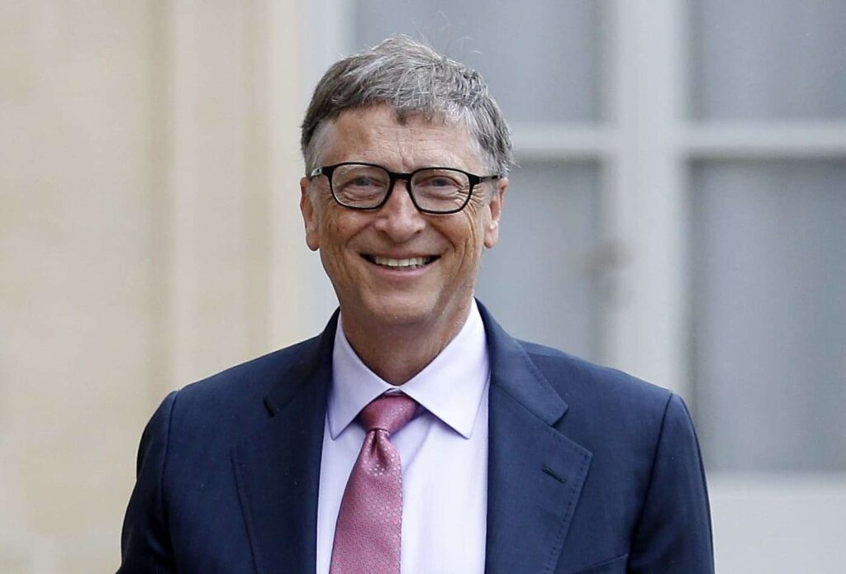
I can help a kid learn to read in about 30 hours, on average; using the one-on-one Global Dream approach. If I did nothing but teach literacy, then I could ensure 100 kids become literate each year – and 5,000 over my lifetime.
Now consider the earning to give approach. There are many people here who happily teach for Rs 50 (A$1) per hour. Since I can comfortably earn $30 per hour in Australia, and need only spend a small fraction of that on my own living expenses, I could employ 20 full time literacy teachers. This would enable helping 100,000 kids learn to read over my lifetime.
This is the power of earning to give. Considering the extreme global inequality in wages, a typical Westerner can earn enough to employ 10-50 people in the developing world.
This approach can be used for any number of goals. Want to share the gospel with a lot of people? Much better to stay in your corporate job and support 20 local village evangelists (who are arguably more fruitful than most foreign missionaries anyway). Want to distribute mosquito nets? There is no need to go to Africa yourself – just donate to Against Malaria Foundation which will do it for you very cost-effectively. Indeed, one of the most common criticisms of my choice to live in a slum with Servants is “why don’t you just earn money and donate instead”.
Earning To Give stems from a realpolitik theory of change: money speaks louder than words. If you want someone to do something, paying them is a highly effective way to get them to do it.
Earning To Give offers a lot of flexibility, which can be a huge positive. Suppose malaria is eradicated, or you decide that AI safety is a key concern: you can simply switch donations to a different cause, without needing to change your career.
However, the flipside of this flexibility is that people often lose track of their initial idealism and end up spending the money on themselves. We humans sometimes struggle to look to the end of our street to see the suffering there – let alone consider foreigners, foetuses, farm animals or future generations. To remain in places of power in order to earn for the powerless often tempts us to forget the very people we set out to serve.
If you seek to do a lot of good through a lifetime of earning to give, experience suggests that it is helpful to have a community of like-minded friends who can help hold you accountable to your commitments. Maybe it is worth making a public pledge, for instance, to tithe your income to effective charities.
What about earning to give at a much larger scale? While a typical Westerner could donate a million dollars over their lifetimes if they tried, some people donate in the billions. By some estimates, Bill Gates has saved millions of people’s lives through his philanthropy. Serious criticisms can be made of his foundation’s influence – for instance, in spruiking intellectual property and over-emphasising technology in public health – but it has unquestionably achieved a lot of good.
A more recent example of billionaire philanthropy has gone sour, with Sam Bankman-Fried’s crypto-exchange FTX collapsing followed by his arrest for fraud. While Sam had until recently been held up as an exemplar of the earning-to-give approach, his downfall perhaps offers a warning against the moral dangers of trying to maximise how much we earn.

The Physicist: new technology as a force for change
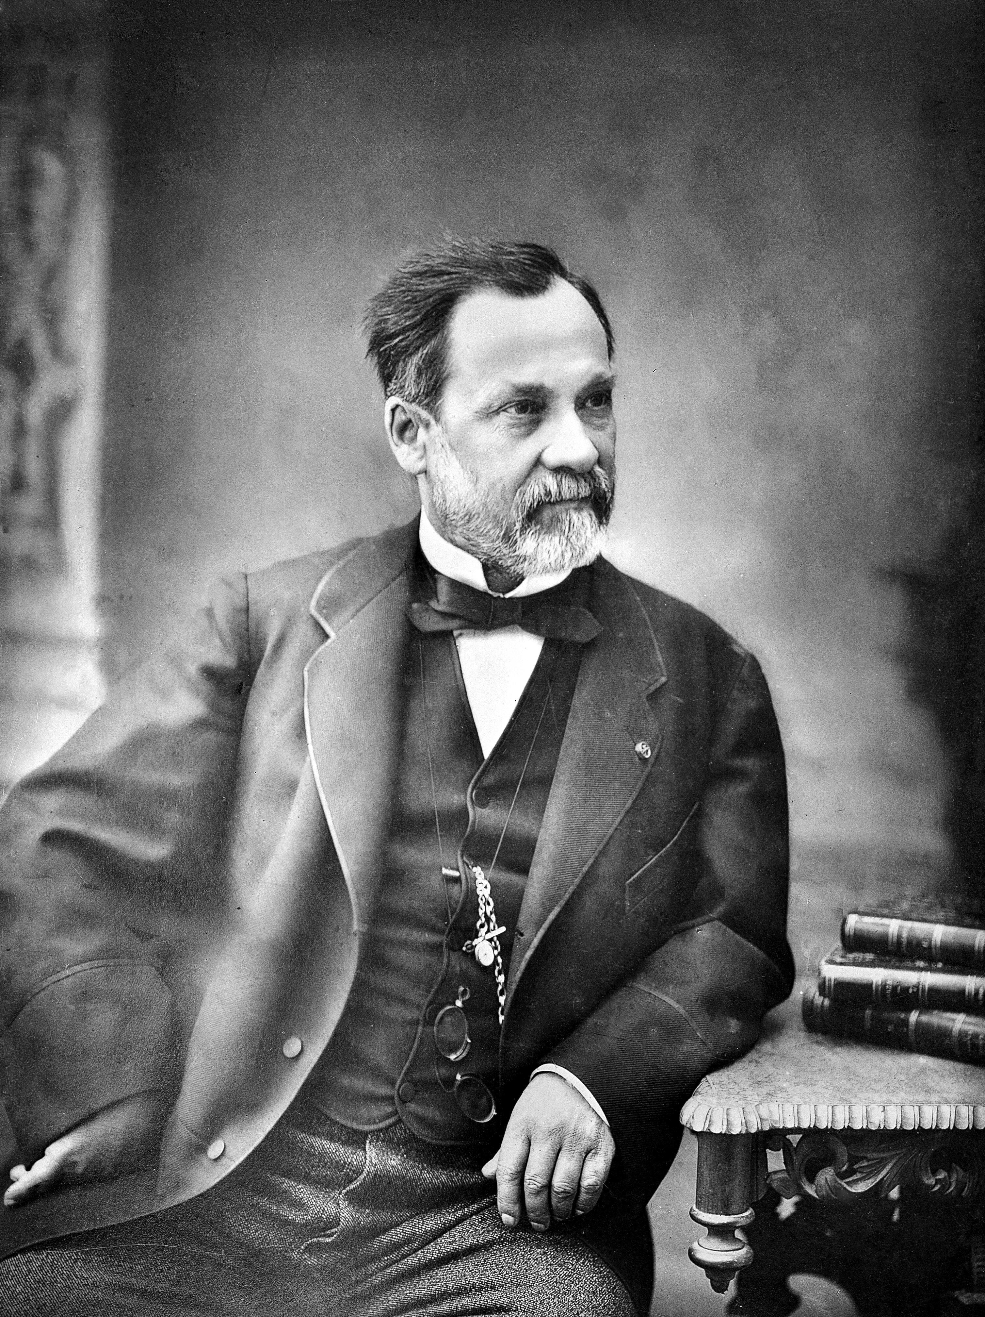
Another approach to the challenge of how to help more kids become literate would be to develop technology. Indeed, my organisation is working on an app consisting of a set of games and videos designed to help kids teach themselves how to read.
More broadly, new technology can make a huge impact on the world. Consider how many millions of lives have been saved by Louis Pasteur, who developed vaccines that ultimately led to the eradication of smallpox. Without Norman Borlaug’s contribution to the Green Revolution – a transformation of agriculture in the 1960s – hundreds of millions of people alive today may never have been born, or even have died in famines
On the other hand, it is very difficult to foresee the implications of a new technology. Once something has been invented, the inventor loses the power to put the genie back in the bottle. James Watt’s steam engine was a brilliant invention, but it did put us on the path to potentially devastating climate change. Perhaps most famously, some of the physicists who laid the groundwork for the development of nuclear weapons – such as Robert Oppenheimer and Albert Einstein – wished the weapons had never been invented.
A more common path to failure of aspiring altruistic inventors is the inability to develop a technology that's good enough to take off. Our efforts at a literacy app thus far fall into this category! For every Thomas Edison, there must be thousands of other wannabe inventors who never make the history books.
There are many more inventions yet to be made that will improve human well-being while reducing negative impacts on the natural world: from a highly effective TB vaccine to a cure for Alzheimer’s; from better batteries to nuclear fusion. However, the technologies we already have are largely sufficient for human flourishing, if only we used them wisely and equitably.
The next part of the series will examine two more roles, which focus more on influencing individual humans’ attitudes and behaviours – the publisher and the pebble.

Reflection questions
Maximising net positive impact is the most important thing in life from a utilitarian point of view: ‘the greatest good for the greatest number’. But there are several other perspectives we should consider:
Deontology: A ‘do no harm’ philosophy. The focus is not on the net consequences of your actions but rather following universal moral rules, such as ‘don’t lie’ and ‘don’t kill’.
Virtue Ethics: Focuses on your attitudes and intentions rather than your actions or their consequences. Perhaps best encapsulated by Mother Teresa’s line: ‘do small things with great love’.
Q1: Which of these three philosophies are most appealing to you – intellectually or emotionally? How do you think we should act under moral uncertainty, not knowing for sure which theory is right?
Q2: How much do you donate; and to what causes? How do you make these decisions?
Q3: If you were to make an invention, what would you like it to be? Can you think of potential negative consequences of that technology too?

Metadata
zn_page_layout | default
zn_sidebar_select | default
zn_show_social | default
zn_zn_disable_subheader
zn_subheader_style | zn_def_header_style
zn-custom-layout | 0

