Lament for India
Author | Admin
Date | 2021-05-04 21:26:12
Categories | Articles COVID-19 Pandemic Linking Teams New Zealand Poetry Stories

From Karen Matthias in New Zealand
O God In Otautahi Christchurch we enjoy a sparkling autumn day and blue skies
We take deep breaths of clean air with strong lungs
But our sisters and brothers in India are under a heavy cloud
Hundreds of thousands of people right now are unwell with COVID-19
And thousands are struggling to breathe any air at all
They need oxygen cylinders, they need beds in ICU
They need comfort in this time of great trouble and anxiety
This world has so many inequalities and injustices that have led to this situation in the world and India
Like the fact that we have more vaccines than we need in NZ while people in India have run out
Where are you God?
Show your face.
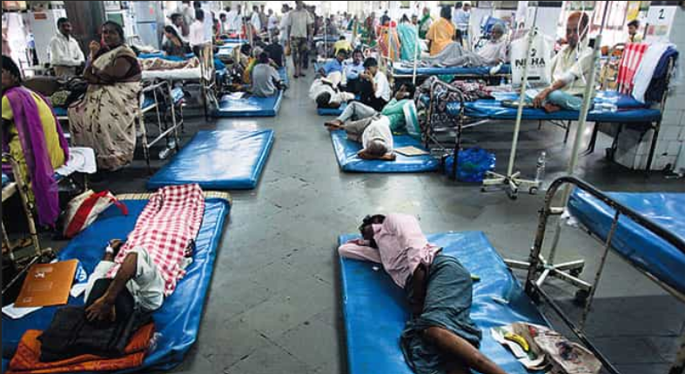
God, as well as those who are sick, we know that the poorest people can’t earn their daily wages.
People need rice, lentils, tea and bread and a way to pay their rent
Migrants are returning on expensive journeys back to their villages
Old people are sheltering and fearful
Middle aged people are queuing for food supplies and COVID tests and vaccines
Children who have missed school for a year are bored in their tiny houses
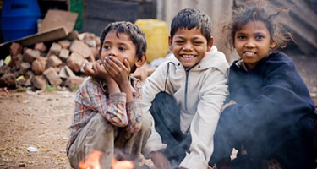
In case you had forgotten God,
India is a land of colour and chaos and the home of billion people made in your image
Millions of people in India seek God each day and find God each day
But now they are fearful and they don’t know where God is.
Where are you God?
Now what?
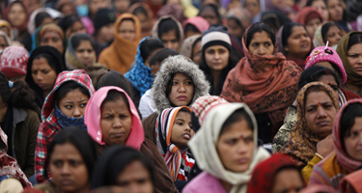
God you know our tender sad hopes on this luminous autumn evening
You have not forgotten India and you have not forgotten us
Your mercies are new every morning
You are the creator behind flat whites, children in generous libraries and beaches
You are the creator behind chillie paneer, rickshaws and festivals
People in India bear your image as we do here in Addington tonight
May fathers, children, grandparents and sisters know that they are beloved
May we also know that you are with us always
May the COVID deluge in India end as abruptly as it started
May all the earth share resources and show compassion And so we keep circling around and back to you and your unending love
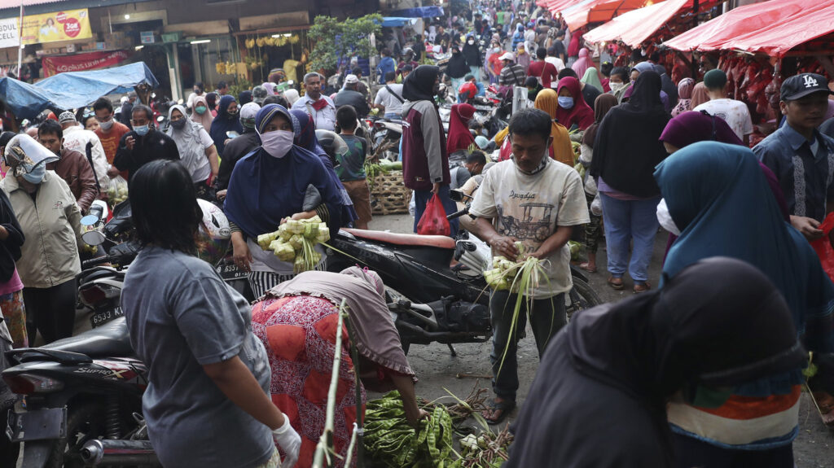

Metadata
zn_page_layout | default
zn_sidebar_select | default
zn_show_social | default
zn_zn_disable_subheader
zn_subheader_style | zn_def_header_style
zn-custom-layout | 0

