Kids Camp and God's Kingdom
Author | C Dee
Date | 2019-05-02 23:11:49
Categories | Articles God at Work Philippines Stories
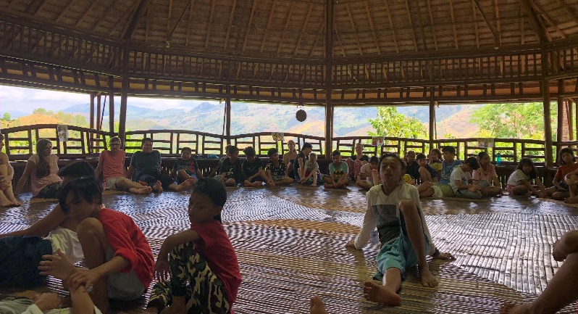
This was my (Tim’s) first time attending our Kids Camp at Sakahang Lilok (a zero-waste, alternative energy retreat center and organic farm a couple hours out of Manila, Philippines). I wasn’t really sure what to expect, nor even sure of how many kids would be attending. In the weeks leading up to the camp, it seemed like there wasn’t a lot of interest in joining the camp and we started to feel like we would only have a few campers this time around.
Lo and behold, when it was time to start Kids Camp, we had over 60 campers in attendance! While it certainly felt overwhelming at times, we were glad that we could accommodate so many children – we were worried at first that we might have too many people for Sakahang Lilok to handle, but thankfully things worked out in the end. Our hope throughout the camp was to have times of intentional sharing so we could know what was going on in the kids’ lives and so that they could also gain deeper friendships with each other. We focused on the life of David and used his stories to share about how God wants a relationship with us and how we can have good relationships with each other, much like David and Jonathan. Of course our time was also filled with the usual excursions like swimming in the river, playing camp games and even a rap battle during our bonfire where we discovered that some kids in our community really have a talent for rapping! Something for us to explore in the near future….
One special camp story is about a group of four boys from a neighborhood called “Riverside”. We decided to give leadership roles to these boys since they had just attended a youth camp also at Sakahang Lilok right before Kids Camp, and we knew that they would need something “extra” to keep them engaged. On top of that, these boys have a bit of a reputation for being troublemakers; they don’t seem to have great relationships with their families and are often left to themselves – in an urban poor environment, that leaves young teenagers prone to all kinds of unhealthy decisions. Some parents even tell their kids to stay away from them for fear of the boys becoming a “bad influence”. Sure enough, we did have some challenges in keeping the boys on task and involved, and I myself got pretty tired constantly making sure they weren’t wandering off on their own too much. But, despite the challenges, there were many moments we saw these boys throw themselves into the thick of various activities. Each of them is perfectly capable of being the life of the party (if they so choose to be). And considering how drastic a change it is to go from constant unstructured time and independence to the structure of a camp schedule, these “Riverside Boys” did pretty well. We hope to build off the momentum of Kids Camp and continue to foster meaningful relationships with these boys.
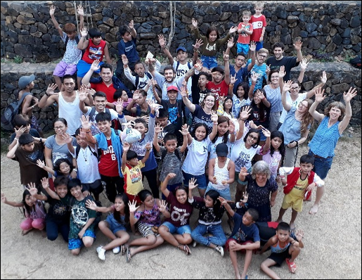
While it's a privilege to be able to take kids like our Riverside Boys to a place like Sakahang Lilok where they can be free of the pollution and garbage they've grown accustomed to, while also learning about alternative energy and sustainable living, we ultimately long to see more of our world like this. Things like Kids Camp and Sakahang Lilok are great glimpses of what could be, and ultimately, show us what the coming Kingdom of God will be like. We hope that, together with our community in Holy Spirit Baranguay, we can all see more of what this looks like together.

Metadata
zn_page_layout | default
zn_sidebar_select | default
zn_show_social | default
zn_zn_disable_subheader
zn_subheader_style | zn_def_header_style
zn-custom-layout | 0
zn_page_builder_status

