Justice Groups
Author | Jason Porterfield
Date | 2013-04-16 11:26:22
Categories

Creative World Justice Groups: Join Us As We Work For Justice
[sharethis]
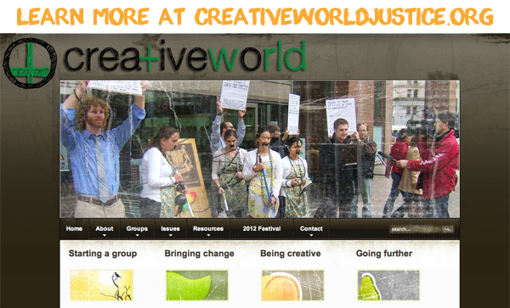In Canada, England and the U.S, Servants has established groups that meet regularly to work for the transformation of unjust situations around the world. We use creativity (no more boring letter writing campaigns!) to raise awareness and work for change.
For example, in Vancouver we meet on Tuesday nights at 6.30pm and begin by sharing a potluck meal together. This is followed by a meeting that alternates weekly between creatively focusing on our relationship with God, the God of Justice, and planning creative actions to bring about justice to situations primarily in Asia.
We particularly focus on Asia where two thirds of the world’s poor live. Current areas of activity include Burma, Cambodian slum clearances, migrant maids in Singapore, the global food crisis and trafficking.
Our inspiration is Jesus, who used creativity to challenge oppressors and encourage the oppressed. Our vision of justice is the Biblical vision of restoration of right relationships between God and each other.
Why not start a chapter of Creative World Justice in your city? We can provide you with ongoing resources as we grapple with issues, and our prophetic actions for advocacy will be that much more effective when combined with efforts of like-minded groups around the world. Contact us if you would like to join or start a group of your own.

Metadata
zn_meta_elements | Array
dsq_thread_id
zn_page_title_show | no
zn_page_title
zn_page_subtitle
zn_zn_disable_subheader | no
zn_page_layout | default
zn_sidebar_select | default

