Inside Edge: Thankful in all circumstances
Author | Admin
Date | 2020-07-08 03:04:00
Categories | Articles Stories
[This reflection taken from the Inside Edge - to subscribe to receive this free newsletter by e-mail, use the sign-up box at the foot of this page, or sign up here.]
Rejoice always, pray continually, give thanks in all circumstances; for this is God’s will for you in Christ Jesus.
[1 Thess 5:16-18 (NIV)]
Perhaps most of us have been doing better at “pray continually” than we usually do, but it’s certainly a difficult season for giving thanks in all circumstances.
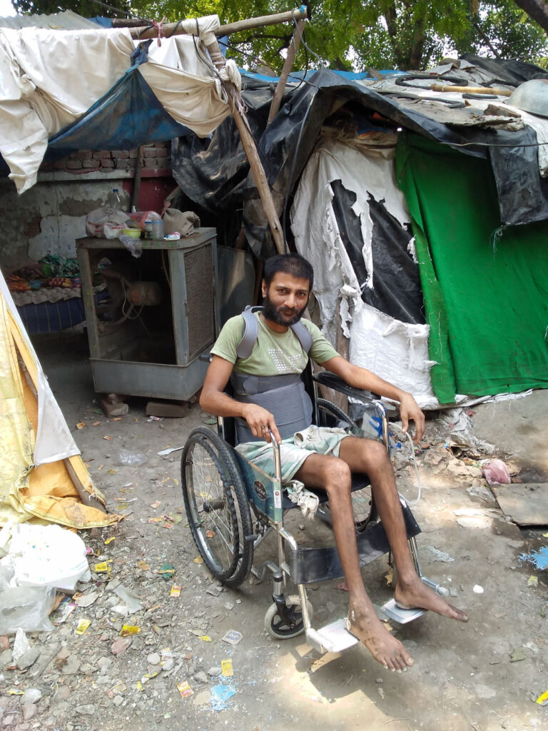
Some of the circumstances we find ourselves in, or witness others enduring, are plainly horrible. We are certainly not thankful for the circumstances which cause such physical and emotional suffering – painful symptoms endured, death in isolation from family and friends, lost income, chronic hunger, and false news increasing prejudice against persecuted minorities. We are called to alleviate the circumstances (and change or dismantle the systems) that cause such suffering.
But we are still called to be thankful in all circumstances, and that’s not easy. Here are five ways to be thankful, despite whatever circumstances we or our loved ones are enduring:
1. This too shall pass – thankfully, whatever we endure this side of eternity is ultimately only temporary (check out Matt 6:20-21/ Luke 12:33-34 about treasure in heaven, and 1 Cor 3:11-15 about building for eternity);
2. God is present – whatever we experience, God is present within and around us, working for good; even when we feel most alone, Jesus is with us (Matt 28:20) and Holy Spirit guides us (John 14:26);
3. God is beyond – thankfully God is also above and beyond whatever is happening around us; no matter what earthly thing crumbles and falls (global economy, law and order, even dearest human bonds) the great I AM remains;
4. Vulnerability – thankfully we don’t have to pretend everything is fine when it’s not; we can offload our raw emotions, process our doubts and grieve our losses with God, who knows us inside out, still loves us unconditionally, and isn’t destabilized by our distress;
5. Pray and help – take whatever practical actions you can to help others in need, and pray for those who are struggling; every effort to benefit others joins us with God’s will in the world – what a privilege to be on God’s team!
What helps you continue to give thanks, in your current circumstances?
Cathy


Metadata
zn_page_layout | default
zn_sidebar_select | default
zn_show_social | default
zn_zn_disable_subheader
zn_subheader_style | zn_def_header_style
zn-custom-layout | 0
zn_page_builder_status

