India Team On-Line
Author | C Dee
Date | 2022-09-01 03:45:17
Categories | Events India Y Past Events
It's time for another live video update from the India team - their lives, relationships in the neighbourhood, other local involvements, and hopes for the future.

Save the date: Saturday 24th September
Jeshan* did a great job keeping things going for the India team while the foreigners were all in their home countries. Now the team is slowly re-gathering, with Ruby*, Yaqoob* and Yusuf* having arrived in early July, and others due back in the coming month.
Would you like to hear more about the work in education and basic literacy and numeracy? Or perhaps you're more interested in the efforts to improve health care access for the poor, and support people with TB? There's also a lot happening in the area of helping the poor get proper ID documents, bank accounts, government pensions and other entitlements. Perhaps what's most exciting is the team of people from the local neighborhood who are doing much of the day-to-day work on all of these.
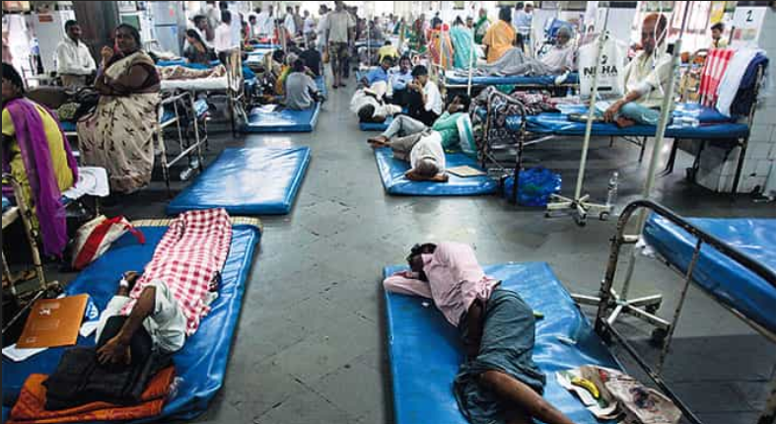
Overcrowding in public hospitals means many patients don't receive urgently needed medical attention. (Image courtesy of Hindustan times).
Please join us for about an hour on Saturday 24th September, 6pm Australian Eastern time.
That's 9am London, 1:30pm India, 3pm Jakarta, 4pm Manila, and 8pm New Zealand. To check the time in your region, click here. Our apologies to friends in the Americas, where this is 2-5am - please let us know if you would like to see a recording.
We look forward to seeing you for this live video update call! To join us, or to request a link to the recording afterwards, please write to events[at]servantsasia.org.

Metadata
zn_page_layout | default
zn_sidebar_select | default
zn_show_social | default
zn_zn_disable_subheader
zn_subheader_style | zn_def_header_style
zn-custom-layout | 0

