'I know that You can do everything...'
Author | Admin
Date | 2019-07-29 20:42:09
Categories | Articles Asian Voices India Y Indonesia Internships Stories
(Reflection contributed by Abraham from Indonesia, who recently spent 4 months in India)
"I know that You can do everything, and there is no plan for You to fail.” Job 42:2 TB
This is a piece of Job's speech to God, and this verse encouraged me to come back to India for the second time, for a longer time than last year.
I am very grateful for God's call to me the first time in 2011. He said "I will send you to India." This time is my second time to visit, and longer than before. I'm experiencing many new things. The trip started with very cold weather, and now the weather is very hot. I have never been anywhere before with weather like this. I was affected by Delhi belly / diarrhea for a long time, because of my stomach adjusting to food and drinking water here.
The first 3 weeks, I tried to live with a local family. It felt very difficult with all the differences in habits, language, cleanliness. But I try adjusting and surviving. But because the family also has a very complicated problem between the family members who live there, it was like me being in a trap with their problem and it really makes me give up. I then decided to stay with the team mates here, but still had good relationships and communication with the family.
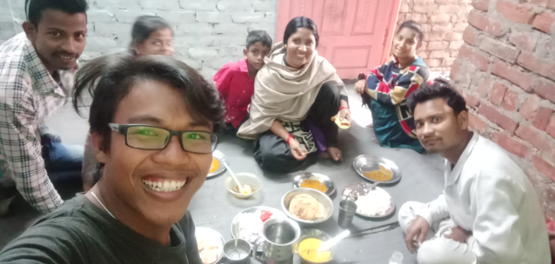
Me and Khan family
I decided to stay with my team mate (Australian) and his NGO office mate, Himanshu (he is Indian) we shared a place to live together. H is a Hindu, but he is very open minded. I feel the life of a good cultural crossing through them.
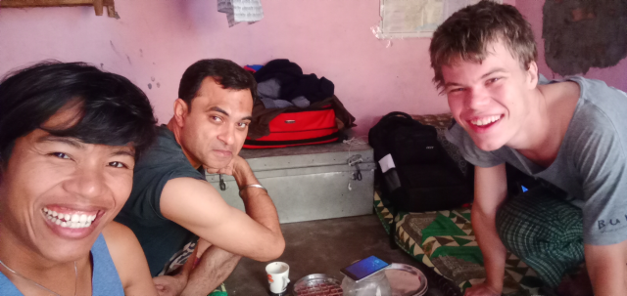
Me and house-mates
From my team mates I studied Hindi; they taught me very well. When I meet local people, I can communicate with Hindi, even though my Hindi isn't so perfect.
My main activity here is learning Hindi, for approximately 1.5 hours every day with team-mates, then visit local families, and accompany my team mate when teaching children beside the railway. I can play, teach some words, songs, and count even though I am speaking Bahasa Indonesia hahaha. I am happy to see them happy.
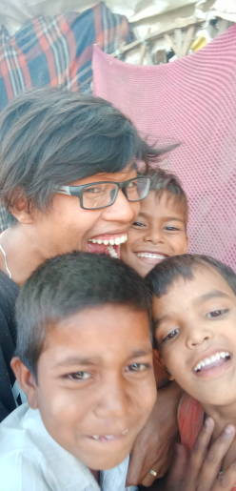
Me and some kids in railway
I learned more about culture, language and food here. Slowly but surely I have adapted very much to all existing situations. Even to the problem of diarrhea lol.
Crossing cultures is not easy, both verbally and non-verbally, our ways or habits meeting with other people's habits here. When I experience things that are sometimes strange or interesting, there I learn more. Moreover, Indian culture is very diverse and broad, much like Indonesia is. Different provinces have different ways of culture, language, and food etc.
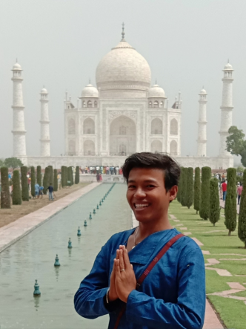
When I was in India, I felt so much support both with the team, friends, and family in Indonesia also with the team there, in India. I'm very grateful for that. And keep praying for me now that I'm back in Indonesia.
I also hope you enjoy what is currently alive. God bless you abundantly.

Metadata
zn_page_layout | default
zn_sidebar_select | default
zn_show_social | default
zn_zn_disable_subheader
zn_subheader_style | zn_def_header_style
zn-custom-layout | 0
zn_page_builder_status

