House of Hope: Start of a new school year
Author | Admin
Date | 2019-08-22 18:33:17
Categories | Articles Indonesia Stories
On July 3rd House of Hope in Jakarta opened its doors to new and returning students for the 2019-2020 school year. This is the seventh year that we have been serving children in the community. What started as an informal time of coloring pictures and playing games has grown into House of Hope, with three different groups of students coming Monday through Friday.
We have fifteen returning kindergarteners, aged five and six. This group meets early morning. These students already know their letters and are learning to put them together into syllables (ba, bi, bu, be, bo). As this is their second year in our program, the kids are more confident and comfortable in school— quite the contrast to when they started a year ago! By the time they graduate from our kindergarten, most of them will be able to read quite well. It is a beautiful privilege to watch these children learn to read.
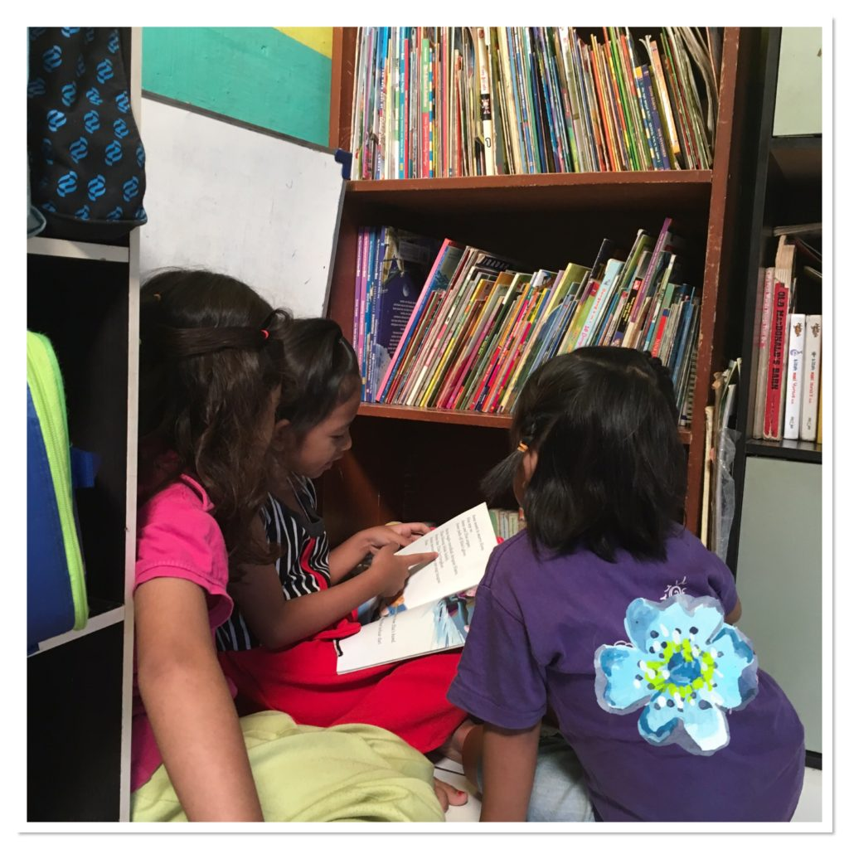
After the first group heads home, the new kids arrive. This year we had twenty new students (ages four and five). Many of these new kids do not even know how to hold a pencil, cannot name colors, and do not know any letters or numbers. At first, many of the moms accompany their children in the classroom but soon the children are brave enough to have their moms wait outside. We start lessons with a time of singing and often read a story.
It is always a lively group of moms waiting on our street, a fun time for them to enjoy chatting with friends and neighbors. One of our neighbors runs a small store out of her house, selling sugary drinks, fried snacks, and all sorts of other packaged snacks. We joke that she runs the school canteen.
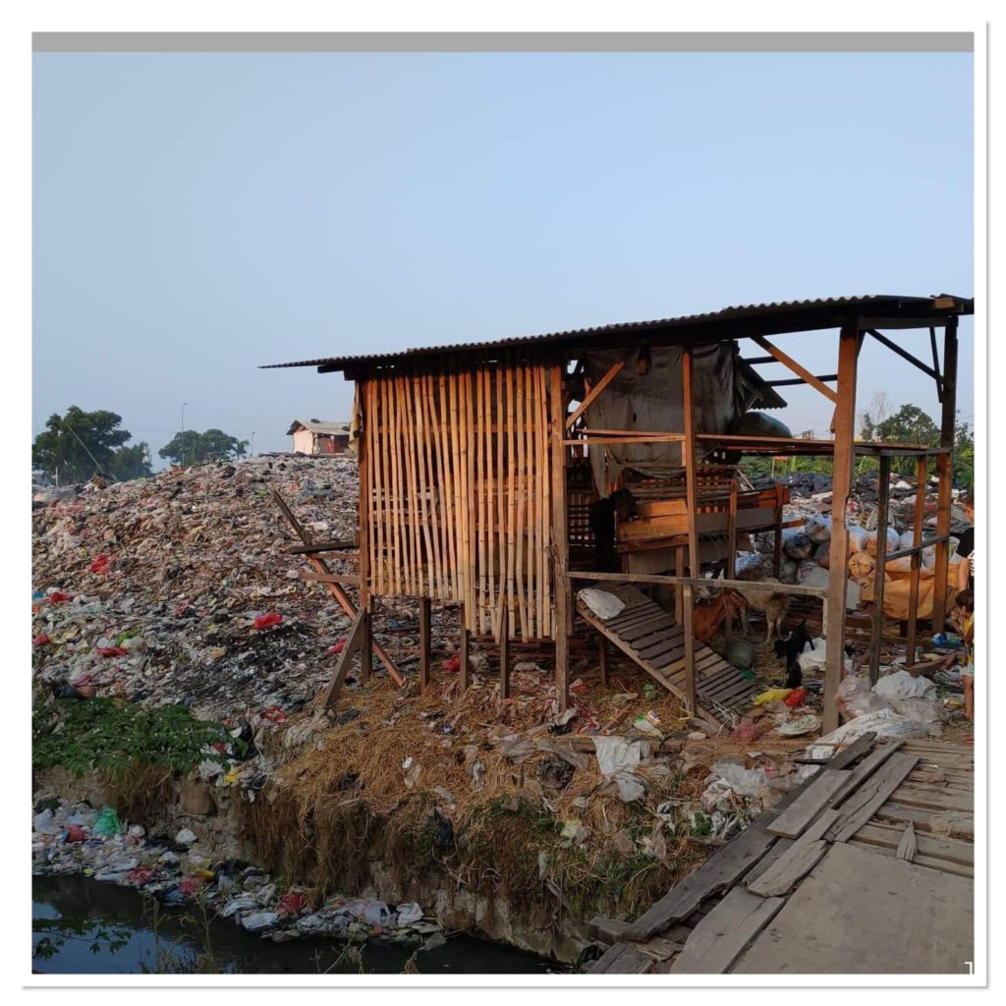
School always ends with the kids eating a multivitamin and giving the teachers high-fives.
After a short lunch break, the elementary kids start arriving (aged 7-12). Most of these students attend school in the morning and come to us for after-school lessons. A few of our faithful students have already dropped out of elementary school, for a variety of reasons (family troubles, lack of support from parents, lack of money, bullying issues, etc...). Before starting lessons they spend time playing: Rummikub, Dutch Blitz, keeva blocks, duplo legos, dominoes, and UNO are some of the favorites. When it is time for lessons, we break into different classes and study reading, math, or English depending on the day.
We know that the needs in our community are immense. We hope that through House of Hope these precious kids will have a better chance to succeed in school and have a brighter future. But even more than that, we hope that at House of Hope each student can feel safe and loved— that they may experience Christ’s love through us.

Metadata
zn_page_layout | default
zn_sidebar_select | default
zn_show_social | default
zn_zn_disable_subheader
zn_subheader_style | zn_def_header_style
zn-custom-layout | 0
zn_page_builder_status

