Hot off the Swiss press
Author | C Dee
Date | 2020-10-11 19:31:58
Categories | Articles Linking Teams Stories Switzerland

The latest Swiss newsletter has just been published, with a host of hopeful stories emerging despite very difficult days.
Servants Switzerland has just released its latest newsletter (in Swiss-German). It contains stories several stories from the Servants Manila team, as well as local partner organisations Onesimo and Lilok. Not surprisingly, several stories unfold around the impacts of coronavirus and the measures to attempt to control the pandemic. In the coming weeks, we will publish English translations of some of these stories here on our website (type your email address in the "subscribe" box on the right, to receive notifications of new posts).
But there's other news too ... here's the table of contents:
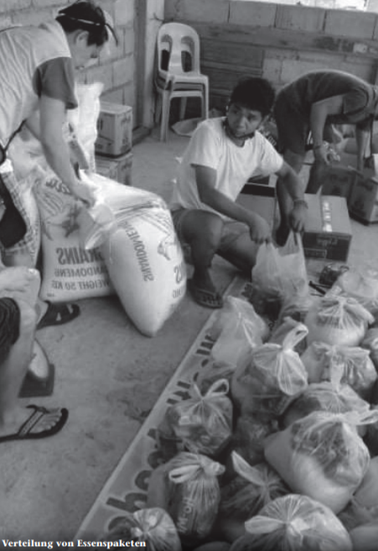
Ein Tropfen im Ozean
Nichts ist selbstverständlich
Eine gute Seite der Pandemie
Besinnungstage an einer Privatschule
Folgen der Pandemie
Wenn Träume schmerzen
An Corona werden wir nicht sterben – aber am Hunger!
Unberechenbares Leben als Chance
Lilok im Lockdown
Generalversammlung von Onesimo Jugend online
Onesimo im Lockdown
Denkmäler der Schmach
Versiert im Schubladisieren
Rita Beer: ein Geben und Nehmen
Read or download the newsletter here.

Metadata
zn_page_layout | default
zn_sidebar_select | default
zn_show_social | default
zn_zn_disable_subheader
zn_subheader_style | zn_def_header_style
zn-custom-layout | 0
zn_page_builder_status

