Holding Joy and Suffering
Author | C Dee
Date | 2022-03-11 20:00:00
Categories | Events Past Events

Webinar with Scott Bessenecker
Join Servants Elder, Scott Bessenecker, to enter into some deep waters for a conversation about holding both joy and suffering. For all of us who yearn to be and bring good news in places of suffering, this conversation is core to our vocation. Scott will present words of wisdom from his vast experience with InterVarsity then will be joined by a few friends for a time of insightful discussion.

Event Details
The webinar is hosted by William Carey International University. See event details on their website.
Date & Time: Thursday 31st March, 1pm-2:30pm, PDT
Check the date and time in your time-zone: click here
Register: Fill out this online form, to register and receive the link to join the webinar.

Watch the Recording
This event is now past, but you can watch the recording of the webinar:
https://vimeo.com/698398693
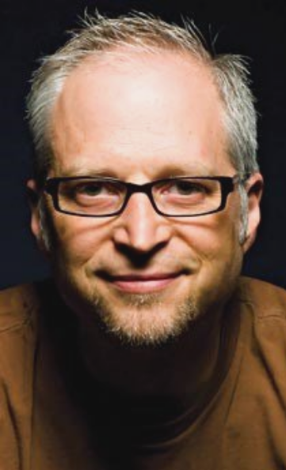

More about Scott
Scott is the Director of Global Engagement & Justice for InterVarsity Christian Fellowship and author of several books, including The New Friars: The Emerging Movement Serving the World's Poor. He sends students each year on short-term experiences around the world to explore the intersection of the Christian faith with justice. You can follow some of Scott’s thoughts on his blog.

Metadata
zn_page_layout | default
zn_sidebar_select | default
zn_show_social | default
zn_zn_disable_subheader
zn_subheader_style | zn_def_header_style
zn-custom-layout | 0

