God’s Heart for the Poor... in Scripture
Author | Anna
Date | 2011-01-03 13:33:09
Categories | Articles Orientation
If there was any doubt about God's heart for the poor, widows, orphans and foreigners then consider this sampling of scripture. A good way to start 2011 - by meditating on God's heart for those who are at the bottom of the heap in our world....
Exodus 22:21
"You must not mistreat or oppress foreigners in any way. Remember, you yourselves were once foreigners in the land of Egypt."
Exodus 22:22-23
"Do not take advantage of a widow or an orphan. If you do and they cry out to me. I will certainly hear their cry."
Exodus 23:3
"And do not slant your testimony in favor of a person just because that person is poor."
Exodus 23:6
"In a lawsuit, you must not deny justice to the poor."
Exodus 23:11
". . . but let the land be renewed and lie uncultivated during the seventh year. Then let the poor among you harvest whatever grows on its own. Leave the rest for wild animals to eat. The same applies to your vineyards and olive groves."
Exodus 30:15
"When this offering is given to the Lord to purify your lives, making you right with him, the rich must not give more than the specified amount, and the poor must not give less."
Leviticus 19:10
"It is the same with your grape crop—do not strip every last bunch of grapes from the vines, and do not pick up the grapes that fall to the ground. Leave them for the poor and the foreigners living among you. I am the Lord your God."
Leviticus 23:22
"When you harvest the crops of your land, do not harvest the grain along the edges of your fields, and do not pick up what the harvesters drop. Leave it for the poor and the foreigners living among you. I am the Lord your God."
Leviticus 25:35
"If one of your fellow Israelites falls into poverty and cannot support himself, support him as you would a foreigner or a temporary resident and allow him to live with you."
Deuteronomy 15:7
"But if there are any poor Israelites in your towns when you arrive in the land the Lord your God is giving you, do not be hard-hearted or tightfisted toward them."
Deuteronomy 15:10
"Give generously to the poor, not grudgingly, for the Lord your God will bless you in everything you do."
Deuteronomy 15:11
"There will always be some in the land who are poor. That is why I am commanding you to share freely with the poor and with other Israelites in need."
Deuteronomy 24:14
"Never take advantage of poor and destitute laborers, whether they are fellow Israelites or foreigners living in your towns."
Deuteronomy 27:19
"Cursed is the man who withholds justice from the alien, the fatherless or the widow."

1 Samuel 2:8
"He lifts the poor from the dust and the needy from the garbage dump. He sets them among princes, placing them in seats of honor."
Job 20:10
"His children must make amends to the poor; his own hands must give back his wealth."
Job 22:8-10
"You probably think the land belongs to the powerful and only the privileged have a right to it! You must have sent widows away empty-handed and crushed the hopes of orphans. That is why you are surrounded by traps and tremble from sudden fears."
Job 29:11-13
"All who heard me praised me. All who saw me spoke well of me. For I assisted the poor in their need and the orphans who required help. I helped those without hope, and they blessed me. And I caused the widows' hearts to sing for joy."
Job 30:25
"Have I not wept for those in trouble? has not my soul grieved for the poor?"
Job 31:16-23
"Have I refused to help the poor, or crushed the hopes of widows? Have I been stingy with my food and refused to share it with orphans? No, from childhood I have cared for orphans like a father, and all my life I have cared for widows. Whenever I saw the homeless without clothes and the needy with nothing to wear, did they not praise me for providing wool clothing to keep them warm? If I raised my hand against an orphan, knowing the judges would take my side, then let my shoulder be wrenched out of place! Let my arm be torn from its socket! That would be better than facing God's judgment. For if the majesty of God opposes me, what hope is there?"
Psalm 12:5
"I have seen violence done to the helpless, and I have heard the groans of the poor. Now I will rise up to rescue them, as they have longed for me to do."
Psalm 72:4
"Help him to defend the poor, to rescue the children of the needy, and to crush their oppressors."
Psalm 72:12
"He will rescue the poor when they cry to him; he will help the oppressed, who have no one to defend them."
Psalm 82:3
"Give justice to the poor and the orphan; uphold the rights of the oppressed and the destitute."
Psalm 82:4
"Rescue the poor and helpless; deliver them from the grasp of evil people."
Psalm 113:7-8
"He raises the poor from the dust and lifts the needy from the ash heap; he seats them with princes, with the princes of their people."
Psalm 140:12
"I know that the Lord secures justice for the poor and upholds the cause of the needy."
Psalm 146:9
"The Lord protects the foreigners among us. He cares for the orphans and widows, but he frustrates the plans of the wicked."
Proverbs 14:31
"He who oppresses the poor shows contempt for their Maker, but whoever is kind to the needy honors God."
Proverbs 19:17
"If you help the poor, you are lending to the Lord—and he will repay you!"
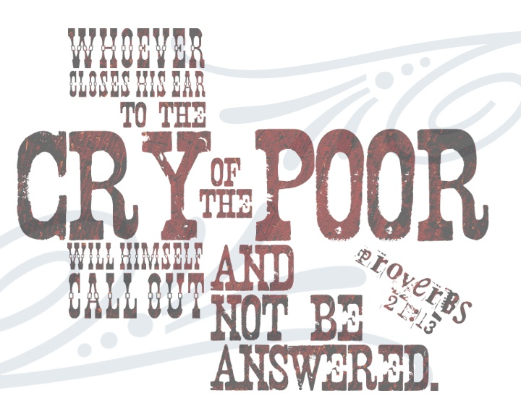
Proverbs 21:13
"If a man shuts his ears to the cry of the poor, he too will cry out and not be answered."
Proverbs 22:22
"Don't rob the poor just because you can, or exploit the needy in court."
Proverbs 29:7
"The godly care about the rights of the poor; the wicked don't care at all."
Proverbs 29:13
"The poor and the oppressor have this in common—the Lord gives sight to the eyes of both."
Proverbs 29:14
"If a king judges the poor fairly, his throne will last forever."
Isaiah 1:17
"Learn to do right! Seek justice, encourage the oppressed. Defend the cause of the fatherless, plead the case of the widow."
Isaiah 11:4
"He will give justice to the poor and make fair decisions for the exploited.The earth will shake at the force of his word,and one breath from his mouth will destroy the wicked."
Isaiah 25:4
"But you are a tower of refuge to the poor, O Lord, a tower of refuge to the needy in distress.You are a refuge from the storm and a shelter from the heat."
Isaiah 32:7
"The scoundrel's methods are wicked; he makes up evil schemes to destroy the poor with lies, even when the plea of the needy is just."
Isaiah 58:6-7
"No, this is the kind of fasting I want: Free those who are wrongly imprisoned; lighten the burden of those who work for you. Let the oppressed go free, and remove the chains that bind people. Share your food with the hungry, and give shelter to the homeless. Give clothes to those who need them, and do not hide from relatives who need your help."
Isaiah 61:1
"The Spirit of the Sovereign Lord is upon me, for the Lord has anointed me to bring good news to the poor. He has sent me to comfort the brokenhearted and to proclaim that captives will be released and prisoners will be freed."
Jeremiah 5:28
"They are fat and sleek, and there is no limit to their wicked deeds. They refuse to provide justice to orphans and deny the rights of the poor."
Ezekiel 16:49
"Sodom's sins were pride, gluttony, and laziness, while the poor and needy suffered outside her door."
Ezekiel 22:29
"The people of the land practice extortion and commit robbery; they oppress the poor and needy and mistreat the alien, denying them justice."
Amos 2:6
"This is what the Lord says: 'The people of Israel have sinned again and again, and I will not let them go unpunished! They sell honorable people for silver and poor people for a pair of sandals.'"
Amos 5:11-12
"You trample the poor, stealing their grain through taxes and unfair rent. Therefore, though you build beautiful stone houses, you will never live in them. Though you plant lush vineyards, you will never drink wine from them. For I know the vast number of your sins and the depth of your rebellions. You oppress good people by taking bribes and deprive the poor of justice in the courts."
Zechariah 7:10
"Do not oppress widows, orphans, foreigners, and the poor. And do not scheme against each other."
Matthew 5:3
"God blesses those who are poor and realize their need for him, for the Kingdom of Heaven is theirs."
Matthew 6:2-3
"When you give to someone in need, don't do as the hypocrites do—blowing trumpets in the synagogues and streets to call attention to their acts of charity! I tell you the truth, they have received all the reward they will ever get. 3 But when you give to someone in need, don't let your left hand know what your right hand is doing."
Matthew 19:21
"Jesus told him, 'If you want to be perfect, go and sell all your possessions and give the money to the poor, and you will have treasure in heaven. Then come, follow me.'"
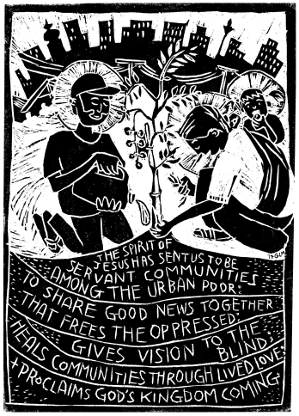
Luke 3:11
"John replied, 'If you have two shirts, give one to the poor. If you have food, share it with those who are hungry.'"
Luke 4:18
"The Spirit of the Lord is upon me,for he has anointed me to bring Good News to the poor. He has sent me to proclaim that captives will be released, that the blind will see, that the oppressed will be set free."
Luke 14:13
"Instead, invite the poor, the crippled, the lame, and the blind."
Luke 14:21
"The servant returned and told his master what they had said. His master was furious and said, 'Go quickly into the streets and alleys of the town and invite the poor, the crippled, the blind, and the lame.'"
Luke 18:22
"When Jesus heard his answer, he said, 'There is still one thing you haven't done. Sell all your possessions and give the money to the poor, and you will have treasure in heaven. Then come, follow me.'"
Luke 19:8
"Meanwhile, Zacchaeus stood before the Lord and said, 'I will give half my wealth to the poor, Lord, and if I have cheated people on their taxes, I will give them back four times as much!'"
Acts 9:36
"There was a believer in Joppa named Tabitha. She was always doing kind things for others and helping the poor."
Acts 10:31
"He told me, 'Cornelius, your prayer has been heard, and your gifts to the poor have been noticed by God!'"
Romans 15:26
"For you see, the believers in Macedonia and Achaia have eagerly taken up an offering for the poor among the believers in Jerusalem."
2 Corinthians 9:9
"As the Scriptures say, 'They share freely and give generously to the poor. Their good deeds will be remembered forever.'"
Galatians 2:10
"Their only suggestion was that we keep on helping the poor, which I have always been eager to do."
James 1:27
"Pure and genuine religion in the sight of God the Father means caring for orphans and widows in their distress and refusing to let the world corrupt you."
James 2:5
"Listen to me, dear brothers and sisters. Hasn't God chosen the poor in this world to be rich in faith? Aren't they the ones who will inherit the Kingdom he promised to those who love him?"

https://vimeo.com/102755305

Ways you can Respond
Might God be calling you to live and work among the poor in Asia? Find out more about JOINING A TEAM.
Perhaps you will hear God through the voices of the poor? Consider doing an INTERNSHIP.
Not sure? Watch our introductory 5-MINUTE VIDEO to find out more.

Metadata
zn_meta_elements | Array
zn_zn_disable_subheader | no
zn_page_layout | default
zn_sidebar_select | default
zn_page_builder_layout | default
zn_show_social | default
zn_subheader_style | zn_def_header_style
zn-custom-layout | 0

