From compassion to Fruitful Service
Author | C Dee
Date | 2020-08-01 08:13:30
Categories | Articles Stories
The fact that you're reading this probably means you're already convinced that following Jesus involves loving neighbours, and that praying for people leads to action, and claiming to "believe" is nonsense without living in accordance with the things you think and say.
God looks on our hearts, and is absolutely delighted with our passion to reach out, to serve, to speak and be good news to those who most need it. Even so, feeling passionately a sense of call to the poor and marginalised doesn't miraculously become actual relationships and actions, ... and springing into action doesn't guarantee success. If our heart remains true to God's vision and call, we need to listen and learn in order to do the good we hope to do, not just burn out while perpetuating or increasing others' suffering.

Therefore ...
Whether you are an experienced veteran of ministry among marginalised people, a beginner tentatively finding your way, or even a curious on-looker, here are some great opportunities coming up for on-line learning.

at The People's Seminary
I recently participated in a brilliant webinar series called "Healing for Personal and Social Transformation", with Servants Elder Bob Ekblad and others connected to his ministry Tierra Nueva. The upcoming offerings are looking just as dynamic - a very practical mix of street-wise, socially aware and Bible-rooted.

1. Mental Health: Therapeutic and Jesus-informed Accompaniment
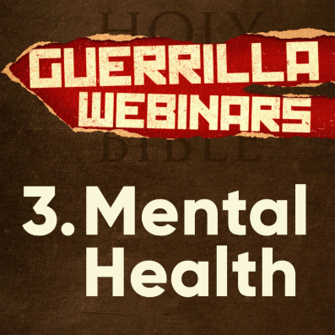
Our world is witnessing a spiritual and psychological emergency of mental health issues, dual diagnoses, self medication and self harm. This course aims to equip us to see mental health sufferers as an under-reached people group waiting to hear Jesus' message of healing and liberation.
We will combine therapeutic and theological ideas to address the individual, social, biological, and spiritual roots of mental illness. We aim to provide participants with a general understanding of mental health labels so we can accompany people as they get to know Jesus who gives us our authentic adopted title. We will teach how to accompany people prophetically, pastorally, and therapeutically in their journey to freedom.
11 Sessions: Mondays, 11:30 AM - 1 PM (PST), September 14 - November 23. Click the image above for more details, and to register.

2. Ministry at the Margins
Our Certificate in Transformational Ministry at the Margins (CTMM) is designed for those already serving (or feeling called to pioneer work) amongst poor and marginalized communities. In this training we seek to deliberately bring together Word, Spirit, and Street perspectives (see video), in order to encourage and further equip practitioners wanting to live and share a liberating and empowering gospel in poor, marginalized, and under-reached communities.
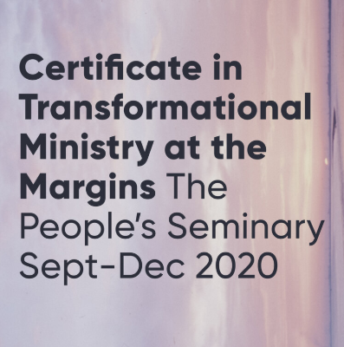
We are now offering Module One of our Certificate in Transformational Ministry at the Margins (CTMM) over fifteen weeks beginning September 8 as a weekly training via Zoom.
The course weaves together five key themes related to ministry on the margins:
- God’s identity and mission—and ours
- Healing and holistic liberation—biblical foundations and principles
- Social prophetic mission—justice, advocacy, and peacemaking
- Word on the street—preparing and leadings transformational Bible studies
- Practical reflection—how does this work in my life and ministry?
The teaching will be done by Bob and Gracie Ekblad, with help from other Tierra Nueva staff and collaborators from around the world.
15 Sessions: Tuesdays, 12:00 - 1:30 PM (PST), September 8 - December 15. Click above image for more details and to register.

3. Recovering: From Brokenness and Addiction to Blessedness and Community
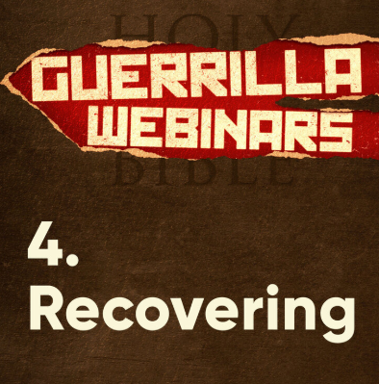
This Guerrilla Webinar course will examine the widespread phenomenon of addictions and attachments—not only related to drugs and alcohol—that threatens to steal away our created purpose in Jesus.
It will help students explore the root causes of addiction; the danger of attaching our passions to anything other than God; the general failure of Church and society to help people through their pain; and the invitation Jesus makes to live together in holistic freedom. Jesus’ antidote to the pain and isolation that leads to addiction is Beatitude Community with him and with each other. We will look at how the Beatitudes speak to our deepest human condition and offer us hope to overcome our attachments and disordered desires.
10 Sessions: Thursdays, 12:00 - 1:00 PM (PST), September 17 - November 19. Click above image for more details and to register.

at the Institute for Urban Movements
Viv Grigg, the founder of Servants and author of books which have drawn many people to join us over the years, is now teaching at the Institute for Urban Movements, within William Carey International University. Three modules of the MA in Development Studies are being offered online during the fall term (ie September - December).

DON'T DELAY: Registrations are due by 10th August

1. Biblical Theology in an Urban Context
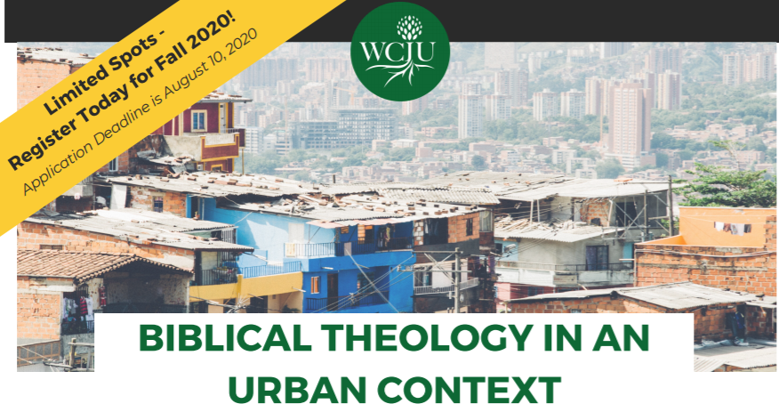
Click image for more details and to register for the course
This 15-week online course builds a Biblical theology overview that connects the motif of the Kingdom of God to issues of poverty, oppression, community development and church growth in urban poor communities.
Topics include: Storytelling as Theology | Transformational Conversations Model of Urban Theology | Land & Jubilee | Exile & Nation Building | Gospel Living & Incarnation Models | Racial Reconciliation & Justice Activism | Acts as an Economic Community Model | Kingdom of God Model | Movement Models

2. Urban Spirituality
Click image for more details and to register for the course
This 15-week online course expands theologies of the Holy Spirit and his work among the urban poor. It emphasizes care and nurturing of workers, practical application of the spiritual disciplines, and communicating between diverse understandings of the work of the Spirit.
Topics include: Spirit-Centered Theology | Spirituality of Suffering | Cross-Cultural Spirituality | Indigenous Spirituality | Evangelical Spirituality | Dealing with the Occult | Justice Spirituality | Family & Singleness Spirituality | Spiritual Disciplines of Urban Poor Apostolic Orders

3. Theology and Practice of Community Economics
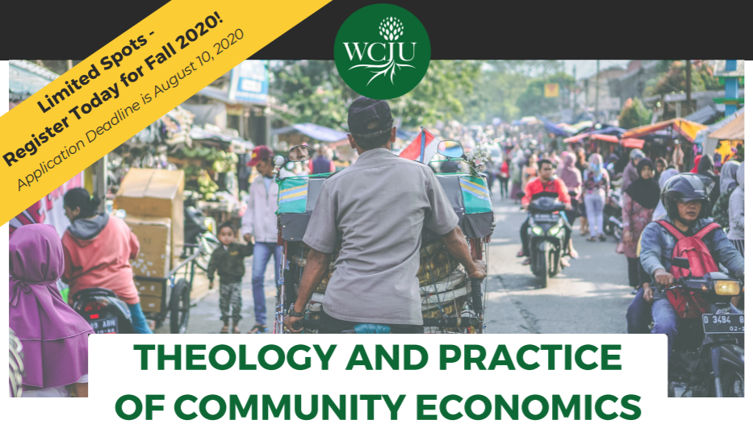
Click image for more details and to register for the course
This 15-week online course is an exploration into the biblical theory and practice of community economics for the urban poor. Special emphasisis givento cooperatives, micro-enterprises, and entrepreneurship for asset building and economic recovery in the wake of COVID-19.
Topics include: Self-Help Savings Groups | Entrepreneurship | Economic Theology | Microfinance | Cooperative Economics | Development Economics | Global Economic Systems | Poverty Analysis | Urban Economic Theories

Metadata
zn_page_layout | default
zn_sidebar_select | default
zn_show_social | default
zn_zn_disable_subheader
zn_subheader_style | zn_def_header_style
zn-custom-layout | 0
zn_page_builder_status

