Forum 2017
Author | David Prieb
Date | 2017-03-14 16:55:03
Categories | Articles God at Work
Highlights from the Servants Forum, as told by Lois (Current Field Team Mentor, and Elder Emeritus). Some names are changed for security reasons.
Who was there:
About 90 of us plus 12 children - all teams there (7 adults from Indonesia, 9 from India, 6 from Manila, 1 from Phom Penh, 5 from Vancouver, and a number from Lilok, Onesimo, Servants Philippines as well). And linking (aka home) teams all represented.

We were definitely among the ''old-timers' - along with some others that have been around for a while: Efren & Becky Roxas, Rachel Hauser, Rose and Danny Pecio, Tim McCowan, Chris & Christine Schneider, Paul & Wendy Hing-Mather, C&M D, Joshua Palma, Susannah & Andrew Connolly, Viv Grigg ... and four of the five current Elders came and contributed from their strengths: Scott Bessenecker (US), Juliet Kilpin (UK), Bob Ekblad (US), Irene Alexander (Aust), Susannah C (NZ). (Adi Leason couldn't attend as he is still being pursued in court by the NZ Govt. for the damages he inflicted on a spy-satellite structure years ago!)

Another 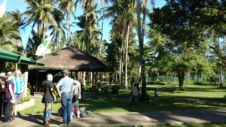great aspect was that four families had a second generation person there - T and O of the D family, all four Mather 'children' and a grandchild, Leslie Thiel, Isabelle Schneider. And there was a group from Urban Expression, UK; Juliet Kilpin came with 6 young adults who had grown up in UE families in East London etc - they ran the children's programme, and stayed on in poor neighbourhoods afterwards .. so it was encouraging to have a strong youth voice present ...
Nevertheless, we did miss people who have previously been a central part of Servants - Kristin & Susan Jack, Jono Ryan, Charles & Rita Ringma, Hugh & Sue Davies, Greenfields, Thiels, Schmidts, Idina, Daniel R,... and of course Helen. It was rather poignant to realise as we arrived in Manila that it was 5 years almost to the day that she had so suddenly died. We all still miss her.
.
Forum itself ...
was good, and refreshing. It was significant to have the 3 daily prayer times in the main stream of the event, and not sidelined to a different small room: RH from the L-Team led morning prayers, I led midday and Peter 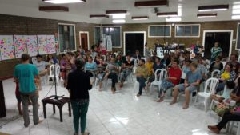led an evening examen. There were updates on the immersion teams and opportunities to pray for them, thoughtful input on different topics from the elders, a wide range of workshops, and "Where are we up to with diverse sexualities?" was aired without needing to name "Servants position" on it. Each morning bibliodramas featured based on the four chapters of Ruth and presented by local folk - just excellent. YP from the J-Team did a great job leading sung worship.
Fewer field teams these days:
Our immersion teams (aka field teams) now are Manila, L-Team, Vancouver, and Jakarta - and all in good heart. Issues of sustainability are with us as always. D's are back in Asia with T (21) and O (15) ...They have just done 3 years in Brisbane. And new folk are arriving this year to join the Manila team as they relocate to being in closer proximity in Barangay Holy Spirit neighbourhood. You can pray for the K-team, as they undergo some transitions and uncertainties.

Endings
Two of the current three ICT are ending their time in leadership: David Prieb completed 3 years, Daniel Wartenwieler 2 years. Daniel and family are returning to Switzerland (as have Tom and Ashley and family recently). Cathy D continues as International administrator with various people taking on various tasks in support.

We gave thanks for seeds well sown in Phnom Penh and Southall. The Bryces continue on as seconded Servants with Interserve in PP, (and Nay and Craig are also there, of course), but Servants itself is no longer a presence. Rachel Bee, Peter, Leslie Thiel, and Patrick (Swiss intern) spoke to 20 or so slides from Southall's last celebration day, and a message from Daniel was read. We lingered at a photo of the Southal crew at its greatest numbers, stood and honoured them in silence followed by a round of applause. It is just great to acknowledge all the scattered Servants folk over the years who are now living the same values and calling in other parts of UK and the world. It is part of Servants charism, I think, to be broken and scattered (See more on this below). Y-Team too has closed after a couple of pioneering years; One member is back in Y on her own account, and Monica, married now to Malcolm who works for Red Cross, is living in Geneva, and hasn't resigned (awaiting further instructions!).
.
So - a 'third order, The Servants' Dispersion, Servants' network, Servants Scattered, Centrifugal Servants, Servants' Edges .... ?
There is a persistent idea emerging that would somehow gather all of us dispersed and scattered people who have been immersed in a team or touched by family, and friends, or who nearly "went", or visited often, and who currently try to "live Servants" in other contexts and places around the world - in order to keep us connected more intentionally: with news, and prayer, and shared liturgies and celebrations, principles and values, being a virtual community even... and maybe gatherings from time to time. What do you think? Does this resonate at all? Another watch-this-space.
We hope to see everybody again, for your next Servants Forum!
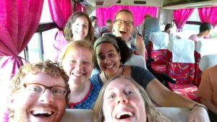

Metadata
zn_page_layout | default
zn_sidebar_select | default
zn_show_social | default
zn_zn_disable_subheader
zn_subheader_style | zn_def_header_style
zn-custom-layout | 0
zn_page_builder_status

