Following Jesus - first step
Author | C Dee
Date | 2019-12-25 20:09:28
Categories | Articles Stories

As I pondered what Christmas is really about, it suddenly occurred to me that it’s our starting place in how to follow Jesus.
I hope and pray that screen time won’t be a big part of celebrating Christmas for you, so this will be brief.
As I pondered what Christmas is really about, it suddenly occurred to me that for us who claim to follow Jesus, Christmas is like “Step 1”. It’s our starting place in how to follow Jesus.
How did Jesus begin? As part of God’s amazing plan for the restoration of all things, his first step was being born among us, becoming one of us. He entered into our broken world among imperfect people, right in the middle of everything that needed restoring.
For me to follow Jesus, my first step is to enter into life in the nitty gritty of the world, in the beauty and desolation of people’s lives. Unlike Jesus, I didn’t make a choice about when and where I was born. However the time and place of my birth have given me a lot more choice than Jesus had, about where and how I live the rest of my life. Having the luxury of choice, I chose to “vote with my feet” many years ago, by moving in with some of the people of this world who are being excluded, exploited and left behind – Muslims in slums in India.
I have heard the Incarnation described as the “scandal of the particular”: the awesome universal infinite God, choosing to be limited by time and space, entering into a particular place among certain people for a few years. I am one person, and I can’t do everything or be everywhere, but step one in following Jesus is to connect with the “particular” people and issues and places in the world around me.
The incarnation is just the beginning of the story, and following Jesus will involve many more steps, which eventually include death and resurrection. In my own story, relocating to an Indian slum precipitated many more steps of following Jesus in the specifics of the lives of our friends and neighbours there.
Now as we celebrate Christmas, let’s reflect on how we’re doing with our first step. Am I immersing myself in the world, among the people and issues dear to God’s heart? Am I present in places most in need of God’s restoration, and does my presence nurture faith, love, grace, peace, and hope?
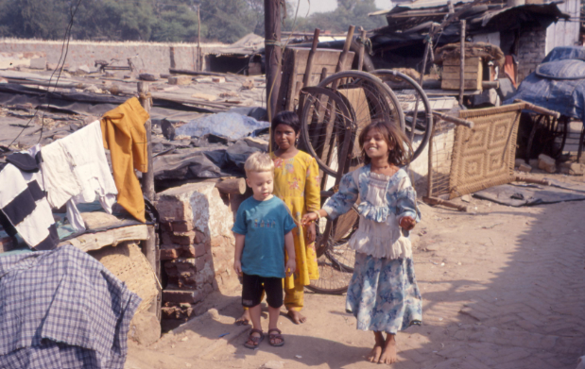
Our son in the alley with friends - learning hopscotch? or a Bollywood move?

Metadata
zn_page_layout | default
zn_sidebar_select | default
zn_show_social | default
zn_zn_disable_subheader
zn_subheader_style | zn_def_header_style
zn-custom-layout | 0
zn_page_builder_status

