Five Models of Wholism
Author | C Dee
Date | 2022-02-22 01:39:08
Categories | Articles Stories
We'd love to hear your thoughts and comments on these reflections from Yusuf* in India.
Many Christians are in agreement that God’s mission – and hence, the mission of the church – is wholistic. The key biblical themes of Shalom and the Kingdom of God are wonderfully rich and deep concepts, which defy being narrowed down or excessively simplified. They entail both physical and spiritual redemption, for both individuals and whole societies (indeed the whole of creation – see Romans 8:22).
One of Servants’ five principles is wholism. It’s worth quoting at length: “We want to see the good news of Jesus proclaimed in word, deed and power. We have a God who is working to renew all things and to restore wholeness of life to all creation. Our lives amongst the poor call us to care for individuals, families and communities, as well as for the structures and systems of human society and the environment on which we all depend. We work for justice, proclaim God’s grace, and lift all things to Him in prayer.”
While most theologians are broadly in agreement about the importance of holding together these themes, how best to do so in practice brings up many questions. Below I explore five models of how these themes can be held together; discussing their biblical basis, practical merits, as well as potential difficulties.¹
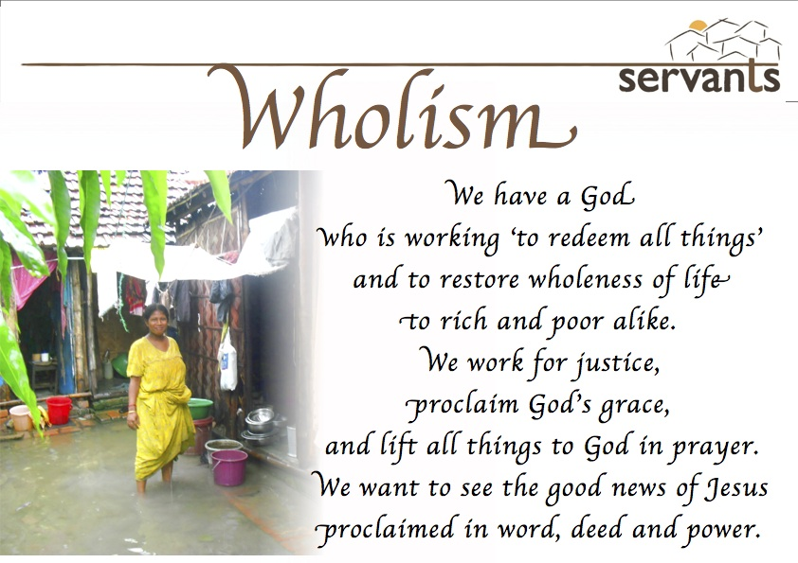

1. The Body of Christ:

Evangelism and Social Action as Separate yet Equal
In 1 Corinthians 12, Paul provides us a beautiful image of Christians working together as part of the church, playing distinct yet equally important roles, in accordance with our giftings and contexts. In his words, ‘there are a variety of gifts, but the same Spirit; there are varieties of services, but the same Lord, and there are varieties of activities; but it is the same God who activates all of them in everyone.’ (v4-6). In this model, no individual or organization can try to express the breadth of God’s kingdom in their work, but is free to specialize in whatever aspect they wish – so long as this specialization doesn’t engender arrogance towards others working on different issues; or working on the same issue in different ways.
This pluralist approach has many merits, including the healthy recognition of our humanly limits that we cannot possibly do everything at once. There are also ‘efficiency’ benefits from building up knowledge, skills and connections in our area of specialization, rather than trying to be a ‘jack of all trades’. On the other hand, it carries a danger that, in focusing exclusively on some area of God’s mission, we may inadvertently do harm in other areas – for instance, Western missionaries having a high carbon footprint through frequent flights.
It also might be argued that certain biblical imperatives apply to us not just as the church overall, but also to us as individuals. This might include passages which make Christians of different theological persuasions uncomfortable, such as ‘Do not worry about tomorrow’, and ‘Go and make disciples of all nations’. A further pitfall of this approach is that there are sometimes co-benefits to working on multiple issues or in multiple ways simultaneously, which a narrow specialization can miss. For instance, my work teaching children literacy helps me build relationships, an important prerequisite for any effort to help bring deeper change.

2. Feeding the Five Thousand:

Compassionate social action as a prerequisite for evangelism
One of the common ways to hold together different strands of the Kingdom is to view compassionate social action as a necessary prerequisite of, and vehicle for, evangelism. In contexts of great poverty, people understandably give top priority to their immediate needs – and until these are addressed, people have little scope to genuinely engage spiritual questions. As the saying goes, ‘how can a hungry man believe in the gospel?’ – the implication being that, once we feed them, they can and will. Many great Christian evangelists were also educationists, feeling that the spread of literacy was a prerequisite for people to be able to read and understand the bible for themselves. Further, helping people with their material needs can open doors, reduce hostility and give us a platform to share the gospel. Key scriptures for this model include Jesus’ miraculous healings and feeding of thousands, which attracted many people to his message.
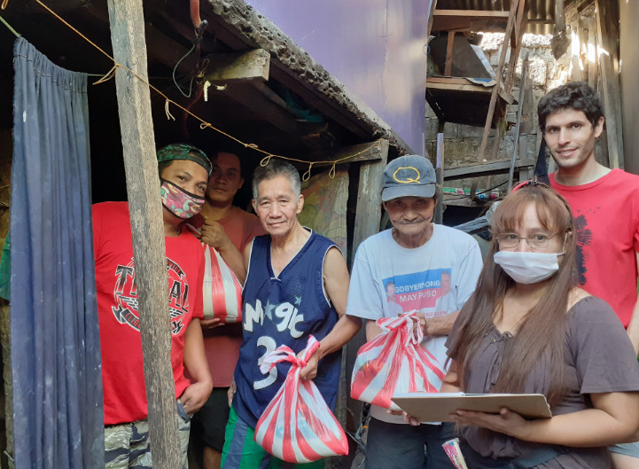
However, this model suffers many drawbacks. Firstly, it can marginalize the social action as simply a ‘means’ to an end, rather than being an important end in and of itself. Secondly, even when done with the best of intentions, it can communicate a distorted message, ‘if you believe in Jesus you will gain material benefits’, leading to the Rice Christians phenomenon.
Finally, this model can suffer from severe power imbalances which distort the gospel’s radical ‘first shall be last’ message. If the missionary has all the money to run the social actions as they wish, and has a monopoly on the Truth, then people are reduced to ‘beneficiaries’ passively receiving material benefits and spiritual truths. Jesus, in my reading of the gospels, had genuine concern for people’s material well-being, as expressed through healing and feeding, and did not use his acts of compassion as an opportunity to proselytize. Instead, when people were so impressed by his miracles that they wanted to crown him king, he slipped away (John 6.15). If we as missionaries have, wittingly or unwittingly, distorted people’s expectations and led them to conflate following Jesus with material wealth, then maybe it is time for us too to leave! Indeed, some mission practitioners like to keep evangelism central but flip this model on its head, instead viewing social change as flowing on from evangelism.

3. ‘Go and Make Disciples’:

Evangelism as a prerequisite for social change.
This model is espoused by Viv Grigg, among others.² Viv is an inspirational, prophetic, catalytic leader who has spent decades working for and with the urban poor internationally. Viv contends that poverty is not just a lack of material resources, but better understood when including spiritual dimensions. One of the key factors keeping people trapped in poverty is sin – both individual sins of the poor (e.g. alcoholism, domestic violence), and societal sins of the powerful (e.g. low education and healthcare budgets, lack of labour rights). Viv argues that it is unrealistic to achieve material or social change without first addressing spiritual issues; coming to faith in Christ, he argues, is incredibly empowering and leads the poor to lift their heads, imagining and working towards a better future. In a similar line of thought, my friend Johannes, observing the futility of my social and legal arguments to persuade a Muslim family against forcing their 15-year-old daughter to get married, commented: “Without a common basis of faith, your worldview is too different from theirs for there to be constructive dialogue on social issues.” An important passage for this perspective is Mark 2:1-12, where Jesus first forgives a paralytic’s sins and then heals him.
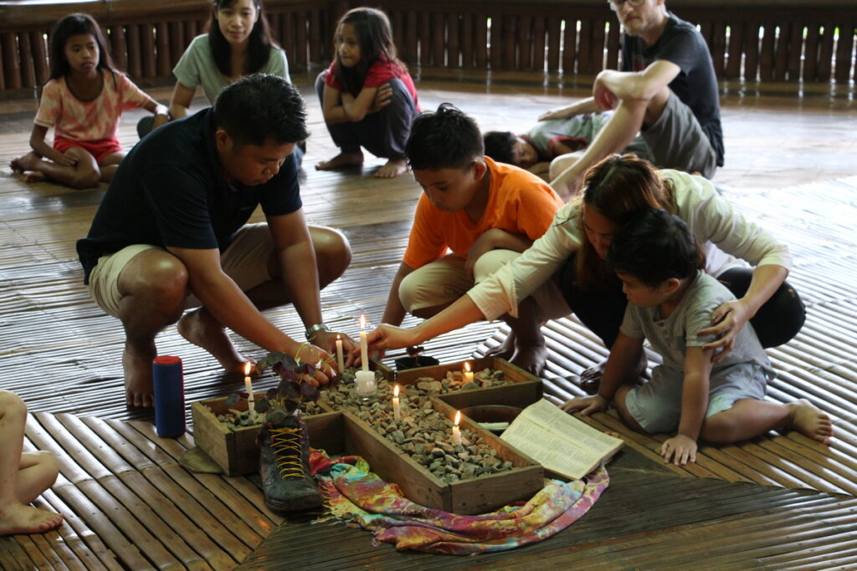
While this approach – putting evangelism first and expecting social change to flow from that automatically – has merits, there are serious empirical questions about its axiomatic assumptions. Over the past few decades, a huge number of people have been lifted out of poverty around the world without this being preceded by an ostensible spiritual change – and this material/social transformation has occurred at the greatest rates in some countries, like China, which remain overall staunchly non-Christian. Conversely, anecdotal experience shows that often people convert to Christianity without a drastic change in their material and social circumstances. In such a context, other practitioners have espoused different ways of uniting material, social and spiritual transformation.

4. ‘Who do you say I am?’:

Radical social action as a platform for sharing the gospel.
This is a model espoused by Mick Duncan³, among others. Mick views Jesus’ mission as incredibly radical and ‘upside-down’ in its approach to simplicity, justice, forgiveness and love. If we faithfully live according to Jesus’ message, our lives will be shockingly countercultural, provoking curiosity. This, he argues, is the chance for us to share the gospel, revealing the motive and source behind our attitudes and actions. In Mick’s case, his choice to live in a squatter community in Manila and his direct involvement of the poor in decision-making provided him an on-ramp to share the gospel. This model has many merits. We see that Jesus himself was often responding to people’s questions rather than lecturing them uninvited. It’s also true that actions speak louder than words; unless we live in Jesus’ radical way, our words will ring hollow. A central passage for this model is John 13:35: ‘By this everyone will know that you are my disciples, if you love one another.’
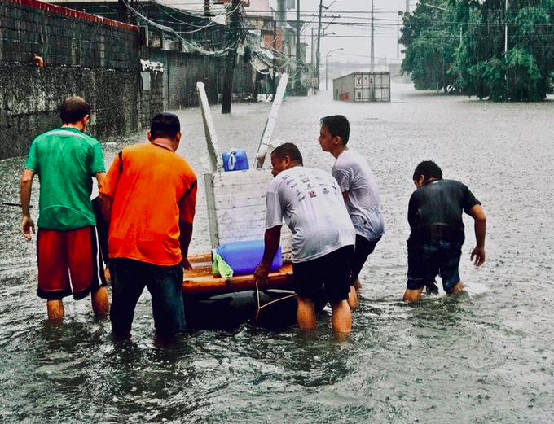
While this is an appealing approach, it also faces some challenges. In my experience in India, people are sometimes willing to dismiss my unusual actions as the quirkiness of a foreigner; viewing my faith as foreign and irrelevant to them. If we only ever wait for questions rather than proactively explaining ourselves, people may also make assumptions about our actions, which are often incorrect – for instance, some people believed my parents to be spies! Finally, this approach remains potentially egocentric, as the emphasis is on me and my actions as an ambassador of Christ – not on the ways God is already at work in the community, long before I arrived.

5. What Would Jesus Do:

Evangelism and Community Development as Processes not Programs
This model is espoused by Dave Andrews⁴, who, quoting from Stuart Mathison, argues that formal programs of evangelism and social work cannot be mixed without doing significant damage to both goals of social and spiritual transformation; but posits that informal processes of community development can (and must) mix the desire for spiritual and social change. Dave lived in an impoverished informal settlement in India, and helped form a community group to work together on social issues. Though non-Christians, this group used common-sense and consensus to reach solutions that were surprisingly Christ-like. Christians have no monopoly on Jesus; those who haven’t even heard his name can sometimes put us to shame – as Paul says, the law is written on the hearts of Gentiles (Rom 2.15). After some problems with the police were resolved peacefully, having invited the cops for a cup of tea instead of attacking the police station with bricks, Dave told the group that they were (inadvertently) using Christ’s way. Later, when the slum was threatened with demolition, people asked themselves ‘What Would Jesus Do’. Dave told them the story of the persistent widow; and the community took up a petition to the city council and ultimately, through a lot of perseverance, gained land in compensation. Through the process, the community enjoyed both a spiritual and a social transformation.
Dave encourages a constructivist approach to both community development and evangelism. Rather than viewing the community as essentially deficient, requiring outside resources and wisdom to guide it into material prosperity and spiritual truth, this approach looks at the strengths of the community and the ways that God has already been working there, before the missionary arrived. I’m inspired by this model, but it does lead me to wonder – how does this meld with a theology of failure? In other words, if the efforts for land rights were unsuccessful, what conclusions would people draw about the way of Jesus? We follow a Messiah who went to the cross. While we believe in the resurrection – that Christ’s way will win in the end – the Saturday of mourning and apparent failure can stretch for aeons.

Conclusion
The table below summarizes the five models discussed above.
Model/Metaphor | Key passages | Description
The Body of Christ | 1 Cor 12 | We have a variety of gifts and are called to various different roles, while respecting and celebrating each other’s calling.
Social action tills the soil -> Evangelism plants the seed | Mark 1 | By doing good deeds and helping people materially, we open their hearts to hearing the Gospel.
Evangelism is foundational -> social transformation flows on | Mark 2:1-12 | When people accept the Gospel, their social and material lives will also be transformed.
Our radical acts -> people’s curiosity -> proclamation of gospel | John 13:35 | Our counter-cultural lives of justice and compassion prompt people’s questions and allow us the opportunity to share the Gospel.
Collaborative problem-solving with the community -> exploration of Christ’s way | Luke 4:16-21 | By working together with the community to help resolve social and economic problems, we can nudge them to consider how Jesus might tackle this situation. When people see the power of Jesus’ way, they are attracted to his person.
If you were hoping to get clear, decisive answers by reading this article – I’m sorry! But I hope that, through prayer and discussion, through action and reflection, we can find powerful, effective and faithful ways to work towards God’s kingdom coming in all its wholeness.

What's Your Model?
I look forward to hearing your thoughts in the comments below – which of these models most resonate with you? What is your experience of trying to hold together the different strands of action and proclamation, of social, economic and spiritual changes?
1 Note that, while I’m describing various models as having been espoused by different Christian leaders, I have immense respect for each of them. Any exploration of the difficulties of a model is not a criticism of them! I am young and relatively inexperienced in how best to work towards God’s kingdom wholistically. I’m not intending to rank these different models against each other; indeed many of the models can work well together.
2 As described during a webinar on 16 Nov 2021.
3 Mick Duncan, Costly Mission (Urban Neighbours of Hope, 2007). More details on our Books page.
4 Unpublished paper: Wholistic Mission, Personal Evangelism and Social Justice.

Metadata
zn_page_layout | default
zn_sidebar_select | default
zn_show_social | default
zn_zn_disable_subheader
zn_subheader_style | zn_def_header_style
zn-custom-layout | 0

