First Kids' Camp After Lockdowns
Author | Admin
Date | 2022-09-01 18:56:24
Categories | Articles COVID-19 Pandemic Philippines Stories
When the Lockdown was announced in Manila the adults and children couldn’t meet in person any more. Our Pastor introduced Zoom to us and after some weeks everyone had this app on their cellphone or laptop. This meant we were able to celebrate our worship services and fellowships online.
After four months we decided to gather the children from our neighborhood through an online Kids' Club. We started with weekly meetings and these fellowships became more and more popular because the kids couldn’t leave their homes and were bored without classes. A little later the public schools started with online lessons too and the children were getting used to cellphones and laptops. In December 2020 we celebrated an online Christmas with 30 children with a surprise meal delivered to their doors. When the restrictions for kids were reduced at the end of 2021 we realized face-to-face weekly meeting weren’t possible because the children were living too far from each other. Because of this we continued with the online Saturday classes but decided to have a Kids' Camp at the Tanay Farm during the summer school break.
Pouring rain endangered our first Kid’s Camp after the Pandemic
“What should we do, Benito?” This was my question to the Kid’s ministry leader of our church on the night before the camp after heavy rain fell for the whole day and with bad weather forecast for the following days. We were planning to bring 22 children and 18 leaders to Lilok Farm in Tanay for the long awaited Kid’s Camp. It had been cancelled for two years because of the pandemic. It was high time to meet the children face to face and allow them to get to know each other away from the Zoom screen. I only wanted to cancel the camp if we would put the children in a dangerous situation. I knew it could be slippery there and a camp with continuous heavy rain isn’t fun at all. 5am departure time, only some hours left to decide. We prayed for better weather and decided to cancel the camp if it was still raining by 4am. Around one hour after our prayer the rain stopped and it stayed dry till morning. I expected text messages from mothers telling me that their child wouldn’t join because of the weather. Nothing happened and we decided to meet with three vehicles at two different meeting places. One of the vehicles wasn’t okay and the driver decided to leave it behind. But now how would we get those 11 people to the Lilok Farm? A father of a camper is a car dealer and he had just prepared a big van for sale. He was willing to bring them to the farm and pick them up again. With one hour delay we all left Manila for our long-awaited camp.
It only drizzled during the two days in Tanay and on Sunday even the sun didn’t forget us despite the bad weather forecast. Fifteen minutes after we left the rain started again.
Relationships grew during the many online fellowships
This divine guidance had a big impact on me, but also the engagement of the leadership team who did very well in guiding and leading the children during the camp. The children were very engaged in the sessions and played with each other in the times between. They followed the rules and had no time to quarrel or to complain. Their desire for interaction, play and fun was extremely high. The energy built up during the pandemic had an outlet now. Especially among the girls nice friendships started. Several kids had their first overnight stay in an unknown place without their parents or another family member. Two kids arrived with big anxieties and some counseling during the camp helped them to continue. I’m very happy that the parents entrusted their children to us in spite of the bad weather forecast. More than half of the children were not from our church families. In the past two years of online teaching trust and respect was able to develop and grow towards the teachers. I’m also excited about our senior leadership team who is able to integrate more and more new leaders. The camps are always a place to practice leadership and give room to creativity and team spirit. All of the participants (children ad leaders) would like to repeat the camp and stay longer.
“What should we do, Benito?” We will continue to trust and respect each other and practice family with the children as part of our church.
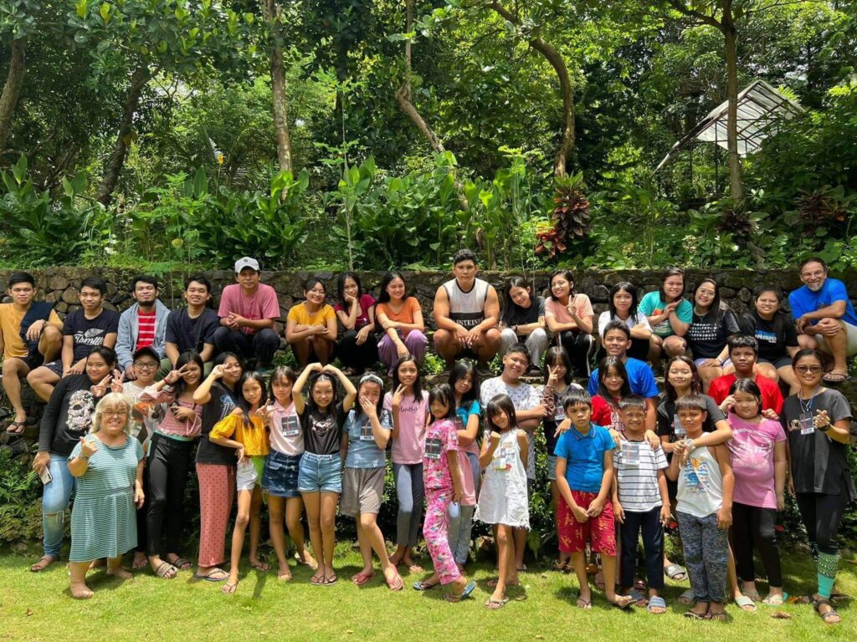

Metadata
zn_page_layout | default
zn_sidebar_select | default
zn_show_social | default
zn_zn_disable_subheader
zn_subheader_style | zn_def_header_style
zn-custom-layout | 0

